CAMRA festival update - November
08/11/2026 by Harri Knight-Davis
Campaign

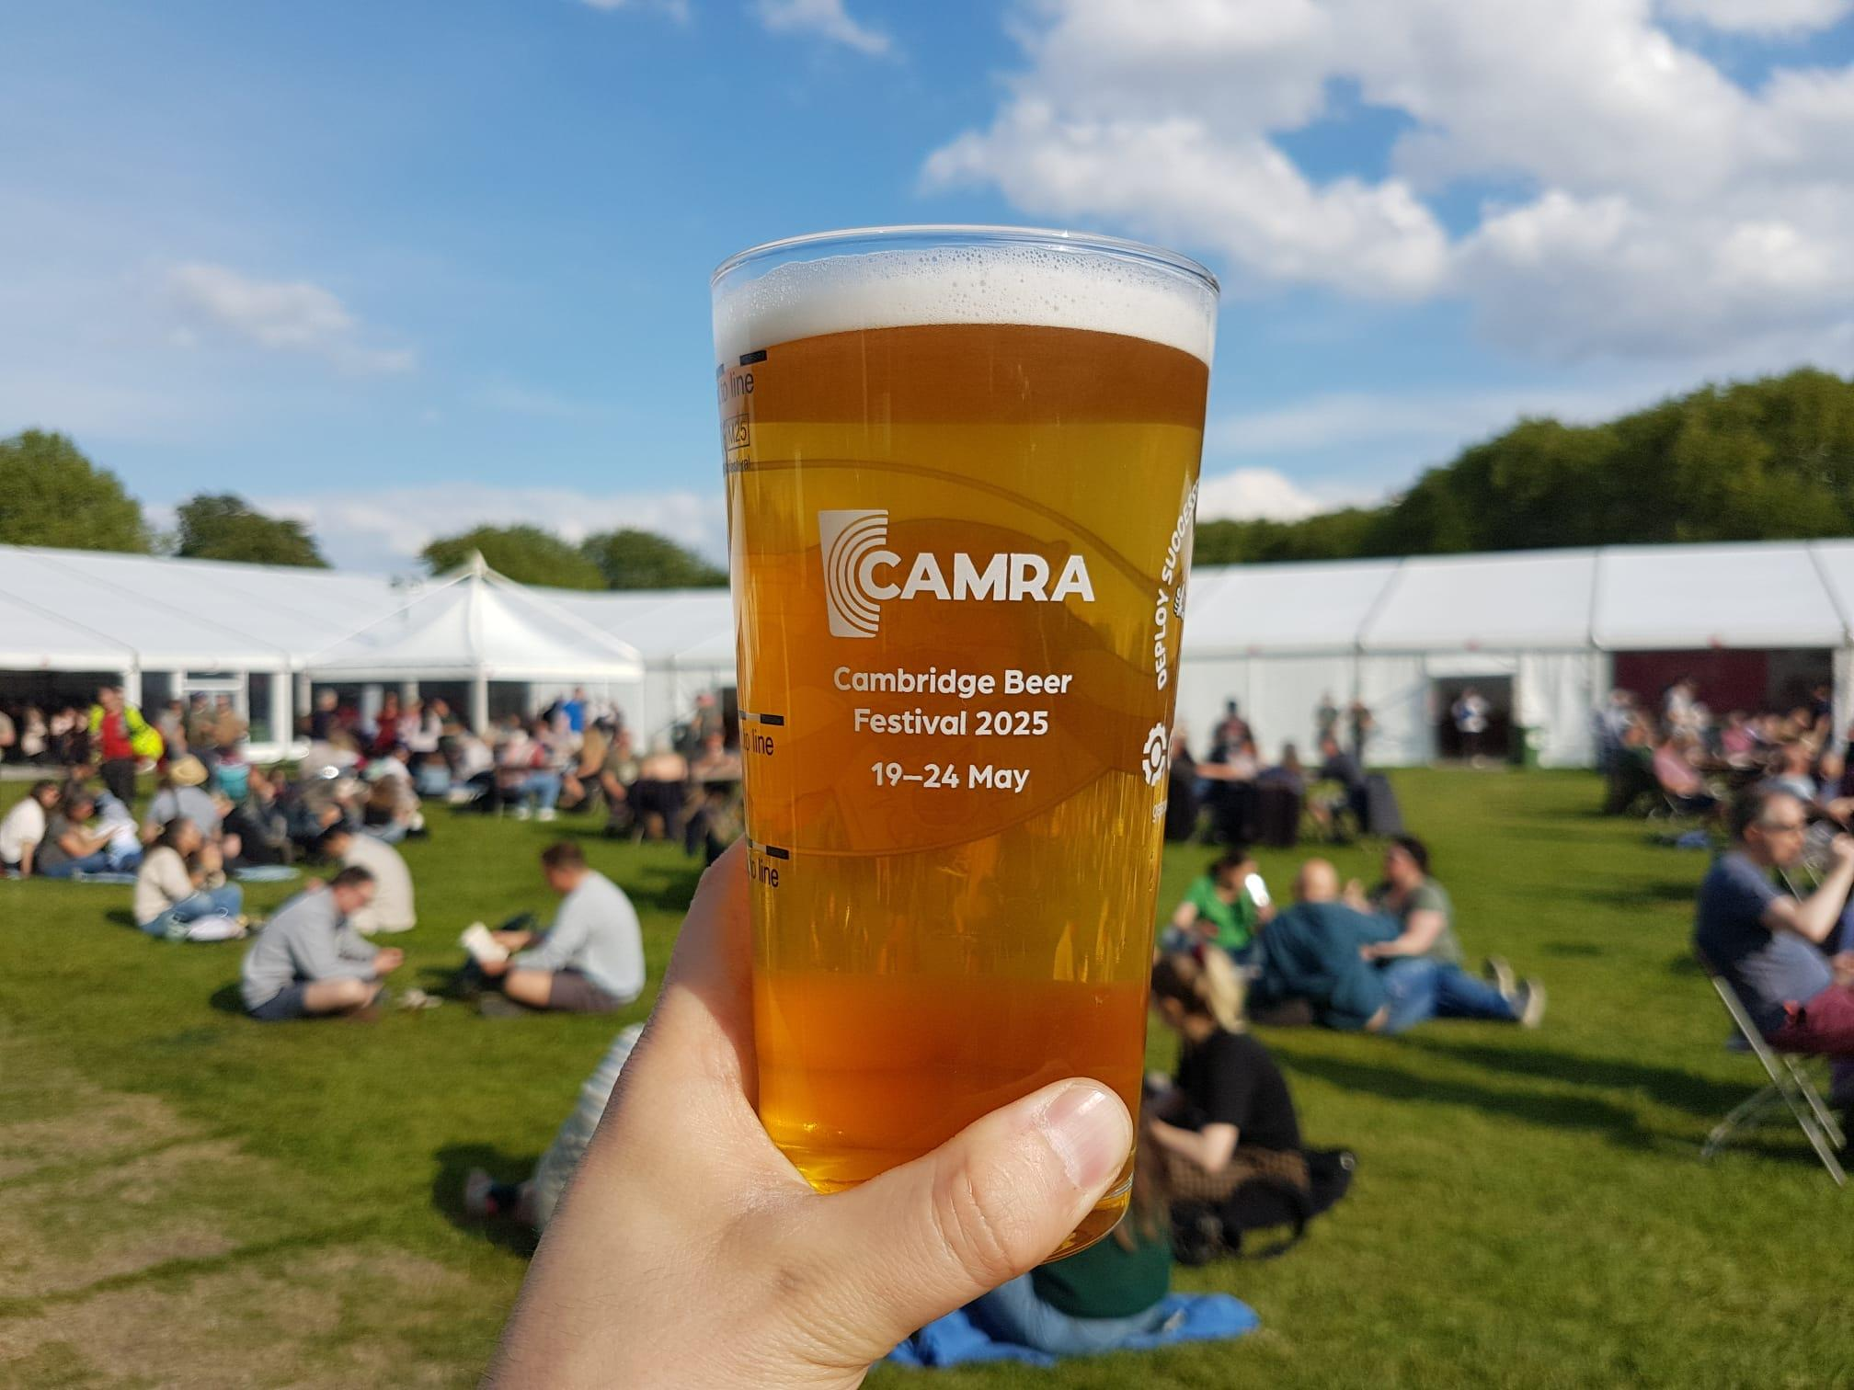

With all hopes of warm days over why not take shelter at one of CAMRA’s volunteer-run festivals? Make sure to make the most of them by checking out the list below. Members can get free entry to many CAMRA festivals (not including souvenir glass and programme) when booking tickets in advance. For more information and to see all upcoming CAMRA festivals visit the events webpage. Southend Beer and Cider Festival, 12-14 November The Palace Hotel, Church Street SS1 2AL Kidderminster Beer and Cider Festival, 12-14 November Kidderminster Harriers Sports & Social Club, Stadium Close, Kidderminster DY10 1NB Newark Winter Beer and Cider Festival, 20-21 November Newark Town Hall, Market Place, Newark-on-Trent NG24 1DU Dudley Winter Ales Fayre, 26-28 November Dudley Town Hall, St James's Road, Dudley DY1 1HP Pig's Ear Beer and Cider Festival, 1-5 December Round Chapel, 1D Glenarm Rd, Lower Clapton, London E5 0LY Exeter Festival of Beer, 14-16 January The Corn Exchange, Market St., Exeter, EX1 1B

Tewkesbury Winter Ales Festival, 4-6 February The Watson Hall, Barton Street, Tewkesbury, GL20 5PX Liverpool Beer Festival, 18-20 February Lutyens Crypt, Metropolitan Cathedral, Brownlow Hill, Liverpool L3 5TQ

Cambridge Beer Festival, 24-29 May Jesus Green, Cambridge, CB4 3AX (pictured)

