Looking for the exit?
07/11/2026 by Roger Protz
Opinion

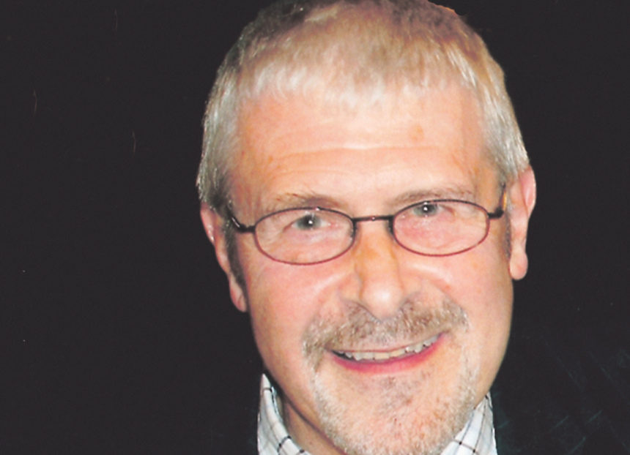

Jennings brewery has opened an Escape Room – a wise precaution if you’ve been bought, closed and rescued from the clutches of Carlsberg. Visitors to the room will be able take part in puzzles and murder mysteries. High on the list will be the mad hatchet activity of the Danish lager giant that went on a wild rampage when it formed the Carlsberg Marston’s Brewing Company (CMBC) in 2020 and in short order closed Jennings, Banks’s, Ringwood and Wychwood breweries. The argument for the closures – entirely specious – was that sales of cask beer were in such serious decline that the breweries feeling the axe had no future. This flew in the face of the evidence from major regional brewers that cask had bounced back from Covid and lockdowns and was reviving strongly. But Carlsberg, along with the global lager producers, has no interest in cask. It has been joined by Heineken, which closed Caledonian in Edinburgh, and Molson Coors that has shuttered Sharp’s in Cornwall. Jennings refused to die. The brewery in Cumbria closed in 2022 but reopened in 2025 to cheers heard not just in the Lake District but far and wide in England and Scotland. The rescue was led by two entrepreneurs, Kurt and Rebecca Canfield. Kurt runs an engineering business in Whitehaven while Rebecca owns a wine shop in Cockermouth. They dug deep to rescue the beloved local brewery, founded in the village of Lorton in 1828 and moved to Cockermouth in 1874. Carlsberg wanted £1m for the business. This was reduced to £700,000 but the Canfields paid less than that, though the final sum is confidential. They set about reviving the fortunes of a brewery that enjoys a superb location at the confluence of the rivers Cocker and Derwent and at the foot of Cockermouth Castle. They hired Chris France as managing director with wide experience of the hospitality industry and Buster Grant as head brewer. Buster is a highly respected brewer and was most recently at Bateman’s in Lincolnshire. He replaced old and antiquated kit with new equipment. Even before the CMBC takeover, Marston’s, which had bought Jennings in 2005, had stopped production of several popular ales and had cut costs by using cheaper ingredients. Grant wasn’t playing that game. He threw out cheap malts and hops and bought the finest Maris Otter malting barley. He also uses whole hops rather than cheaper pellets and adds the spicy, herbal and peppery notes of such English varieties as Challenger, Fuggles and Goldings to his brews. As part of the deal with Carlsberg, the Canfields bought all the Jennings’ trademarks, brands and recipes. The result has been the return of such much-loved cask beers as Castle Bitter (3.4 per cent ABV), Cumberland Ale (4 per cent), Sneck Lifter (5.1 per cent) and Cocker Hoop (4.6 per cent). The original recipes were found in a dusty drawer in a remote part of the brewery. The team has also added Derwent Mild (3.4 per cent). “Jennings did once brew a mild but this is our own recipe devised by Buster,” France said. There could be no surer sign of a strong belief in the brewery’s future than introducing a style that has been in decline for decades and ditched by many breweries. “It’s been a magical time, bringing back old recipes,” he added. One of the first innovations by France and the Canfields was a spacious Taproom on site. It’s open seven day a week and has become packed with both locals and visitors – and Cockermouth, at the heart of England’s most beautiful region, gets tourists by the coach load. The full range of beers is on offer at a spacious bar within the Taproom. As well as the regular beers, the brewery has a seasonal range of some nine brews a year. Grant has also launched a series of collaborative brews with like-minded craft brewers. The first will be Lake and Mountain brewed with Mikkel Borg Bjersø, founder of Mikkeller. Mikkeller is based in Copenhagen and proves that good beer, as well as Carlsberg, is produced in the Danish capital. Borg Bjersø set up his operation in 2006 with a mission to introduce drinkers to new tastes and experiences with unusual ingredients and storage methods. He’s been so successful that he now exports his brews to some 40 countries. He is returning to Jennings as in 2008 he brewed a beer there called Viking’s Return, marking the invasion of the region centuries ago. “I’m going back 18 years later,” Borg Bjersø said. “And the name Lake and Mountain will celebrate the fact that my name means lake and mountain.” There will be three versions of the beer, brewed in Cockermouth, London and Copenhagen. The Jenning’s version will be distinctive, using the softest Lakeland water. France and Grant are planning more collab beers with five other breweries, including Loch Lomond over the border in Scotland. France said the response to the reopening of Jennings has been heart-warming and national. “We’ve had messages of support from all parts of the country from both drinkers, publicans and supermarkets,” he said. “Not just messages but orders for our beers.” Packaged versions of the main brands are on sale in selected branches of Waitrose nationally, along with the Co-op in Cumbria. Free trade pubs in the region are also stocking the beers. Saving Jennings, with its long and rich history of brewing in the Lakes, is proof that, despite the lack of interest in cask shown by global lager brewers, pubgoers are keen to enjoy beer brewed in the traditional, time-honoured manner. So hats off to the Canfields, France, Grant and their team. They are planning to bring back another old Jenning’s beer, Back Yam (4 per cent), a local dialect term meaning back home. Long may the brewery stay Back Yam. If you visit, enjoy the Taproom and take part in an escapade in the Escape Room where one mystery could be: “Who shafted the lager brewer?”

