Bottled beer first as Welsh brewer takes top title
06/11/2026 by Harri Knight-Davis
Campaign

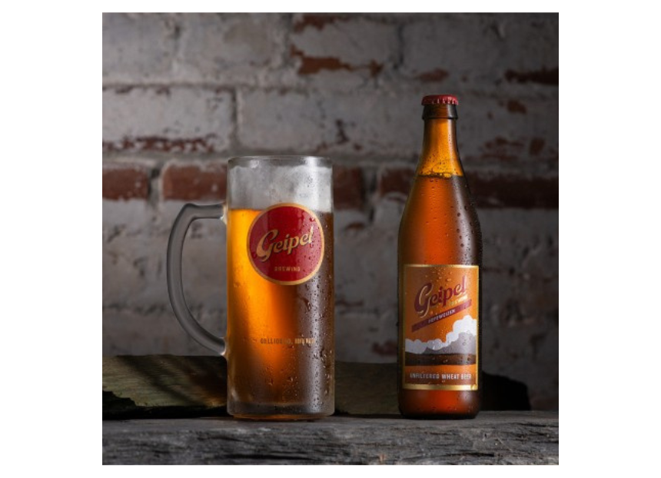

After a Welsh brewer took silver in last year’s Champion Bottled Beer of Britain competition, another has made history by taking the overall crown in 2026. North Wales’ Geipel Brewing struck gold in this year’s judging at Norwich Beer Festival, with its golden wheat beer, Hefeweizen – the first Welsh brewery to take the title. Geipel, which primarily focuses on brewing lagers, is run by American Eric Geipel, who developed a passion for brewing after a work trip to Burton-on-Trent. In the midst of losing his job after the 2008 financial crash he began to brew beers at home. Firmly bitten by the bug, he set up his microbrewery on the border of Eryri (Snowdonia) National Park. The brewery is going from strength to strength, and follows the 500-year-old German brewing Reinheitsgebot, where beer is made from just four ingredients: barley, hops, water and yeast. Geipel said: “We’re very honoured and amazed to win such a prestigious award. I never imagined that a non-native style would be a contender. Many thanks to the judges and ‘prosit’”. The award recognises the best bottle-conditioned beers in the UK. With rigorous blind tastings and nominations spanning two years of regional heats and national rounds, it remains one of the most respected accolades in the industry. Judging coordinator Christine Cryne said: “This year, the competition was particularly stiff with the feedback from the judges on the final panel saying that every single beer assessed was worthy of their place; the quality was thought to be excellent. Hefeweizen was described by the judges as: ‘everything you would expect of a wheat beer’. It pipped two past winners to gain the top spot: Fuller’s Vintage Ale, a full flavoured strong amber ale, and Durham’s Temptation, a robust, complex imperial Russian stout”. CAMRA awards director Shelly Bentley said: “Bottle and can-conditioned beers are often overlooked but when done well, they really are the crème de la crème. What is nice to see this year is the mix of brewers in the medals. Fuller’s, of course, is a large established London brewer, which has a small range of bottle-conditioned beers; Durham is a family brewery, dating from 1994, where all of its bottled beers are bottle conditioned; and Geipel, which set up in 2013, concentrates on bottom-fermented beers. So, when it comes to producing great bottle-conditioned beer, it just goes to show there is no set template!”

