Winter beer contest returns to Liverpool
06/11/2026 by WB Reporter
Campaign

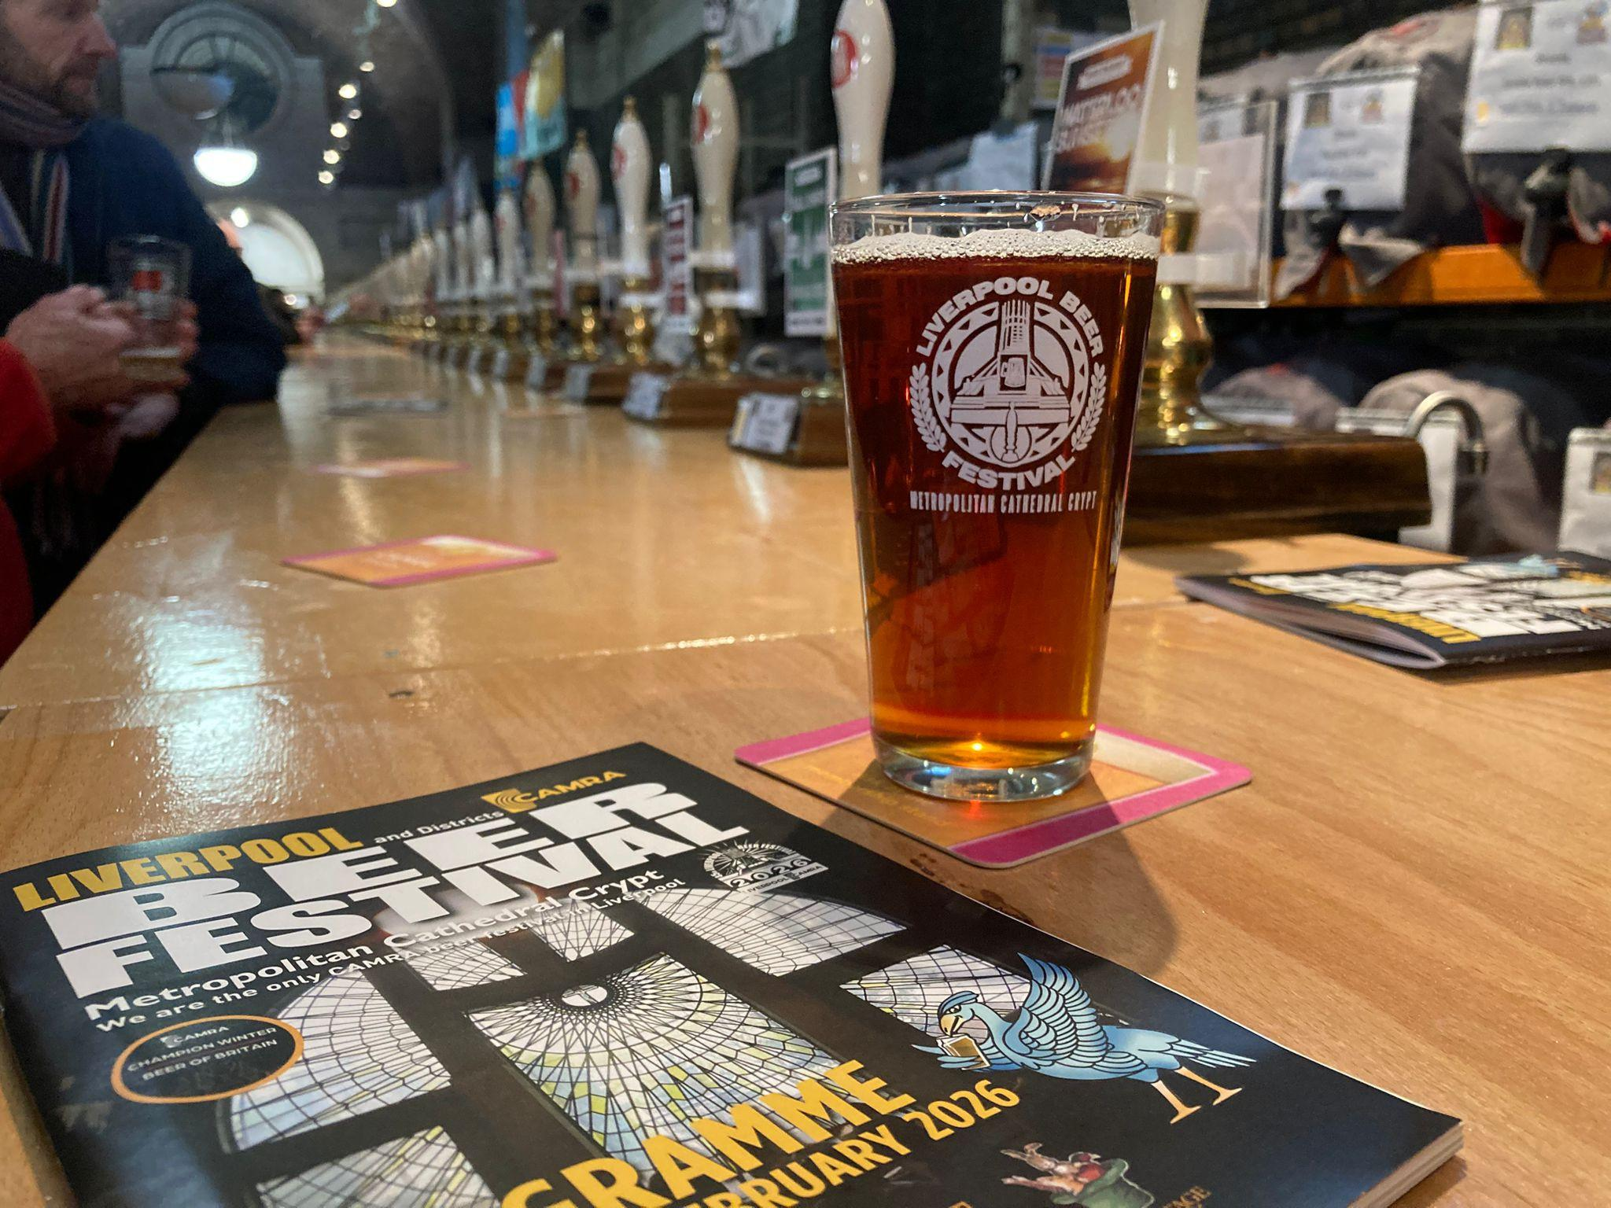

CAMRA’s Champion Winter Beer of Britain competition returns to Liverpool Beer Festival for the second year running next February. The champion will be crowned in the Lutyens’ Crypt at Liverpool Metropolitan Cathedral during the festival’s afternoon session on Thursday 18 February. The winning beer will be on sale while stocks last, as part of the 200-plus beers and ciders on offer. Naming the champion winter beer is the result of a year of local and regional blind judging heats, with category winners going on to the final judging for the crown of Supreme Champion 2027. Festival organiser Mel James-Henry said: “We are delighted to be hosting the competition once again in the magnificent surroundings of the Lutheran crypt. This is a great opportunity for festivalgoers to taste award-winning beers from around the country and for us to fly the flag for top quality cask beer.” The cathedral is just a 10-minute walk from Liverpool Lime Street station. You can buy tickets here: Liverpool Beer Festival 2027 - Tckty. The festival will be open to the public for five separately ticketed sessions: Thursday 18 February (midday until 6pm) Thursday 18 February (6pm until 10pm) Friday 19 February (midday until 4pm) Friday 19 February (6pm until 10pm) Saturday 20 February (midday until 6pm)

