K Sheps commits to cask future
05/11/2026 by Roger Protz
Industry

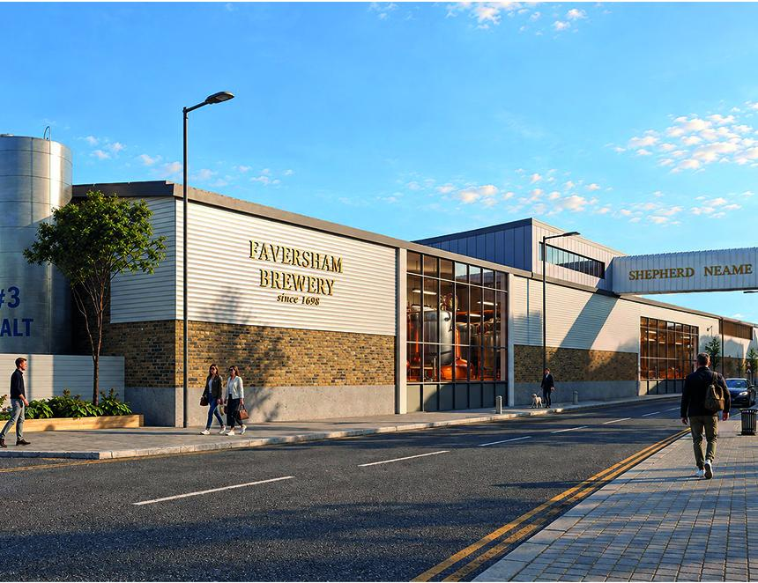

Shepherd Neame is committed to brewing cask beer despite social-media claims it was selling its soul and cashing in on its current site when it revealed plans to build a new brewery in Faversham, Kent. Executive chairman Jonathan Neame said the brewery will remain at its Court Street site in the Kentish market town and the new brewery, costing £15m over three years, will be based in the current bottling hall. He added that at the same time the plans were unveiled, Sheps was launching Bishops Finger IPA Reserve, a new version of one of its leading beers. Reserve IPA will be 4.6 per cent ABV draught and 5.5 per cent in bottle. In common with all Shep’s ales, it will use Kentish hops, including what Neame calls “the peerless East Kent Golding”. The new brewery (pictured) will be self-funding and Jonathan agreed some of the investment will come from the sale of non-core property that was bought 30 years ago. Sheps is Britain’s oldest brewery, dating from 1698 and possibly even earlier. That history will be enshrined in the new site. As well as the production space, there will be a visitor centre with a pub and an open space to be called Brewery Square. Most importantly, it will continue to draw water from the ancient artesian well that been at the heart of the brewery for 300 years. The water is rich in calcium, ideal for brewing good beer. Neame, chief executive since 2003, said change is necessary to make the company fit for the demands of the 21st century. “The current brewery is far too large,” he said. “It has a capacity of 200,000 barrels a year but we’re not brewing anything like that. “It’s inefficient, with beer losses. The new brewery will have a brew length that’s one third of the old plant’s. “It will have a higher utilisation and will be able to handle shorter brew lengths, enabling us to introduce new beers on a trial basis.” As well as Bishops Reserve, Sheps not only remains committed to its classic cask ales – Master Brew (3.7 per cent), Whitstable Bay Pale Ale (3.9 per cent), Spitfire (4.2 per cent) and Bishops Finger (5 per cent) – but is also currently rebranding them with new pump clips and labels. Bishops Finger takes its name from an old wayside road sign pointing pilgrims in the direction of Canterbury Cathedral. The brewery came into operation when Faversham was a major port. It used both the river and roads and later rail to transport beer to London and throughout the South East. It produced mild, porter and IPA along with stock ale, a beer used mainly for blending. The partnership of two local families, the Shepherds and the Neames, lasted for just 12 years and the Neames have been in sole control since the late 19th century. Now the company is looking to the future. In common with all independent breweries, Sheps is recovering from the Covid pandemic and lockdowns. The new brewery will concentrate on Shep’s own beers. Contract brewing for other companies will be phased out and Singha Lager will no longer be produced when the current contract runs out. The company has a large estate of 285 pubs and hotels and Neame agreed they will need lager as well as ale but he says it can be supplied in the form of Spitfire Lager and Whitstable Bay Blond. Jonathan is keen to take on the doomsters who say cask is in terminal decline. He said beer sales in London pubs were up 11.2 per cent in the second half of 2025 compared to 1.4 per cent outside the capital. He said London is booming with improved footfall from both more visitors and locals with more disposable income. He is investing heavily in London pubs to meet the increasing demand for food, drink and accommodation. He is disappointed – to say the least – by the October Budget that has not helped embattled breweries. “It was a something and nothing Budget,” he said. “The cut in business rates is welcome but high rates of excise duty plus VAT and National Insurance are impacting heavily on pubs and breweries. “The government is not addressing the fundamental problems facing the brewing industry.” Undeterred, Sheps is facing the future with confidence and determination. As well as Bishops Reserve, a hazy IPA and a stout are planned and pubs outside the M25 will be refurbished and modernised once the work on London outlets is complete. Neame believes the new brewery will underscore the company’s commitment to making fine ales. “Brewing is at the heart of our home,” he said. “The new brewery will be efficient and cost-effective. “It’s an exciting time for the company and its future development.”

