MPs back official recognition of cask beer
28/10/2026 by Paul Edgeworth
Campaign

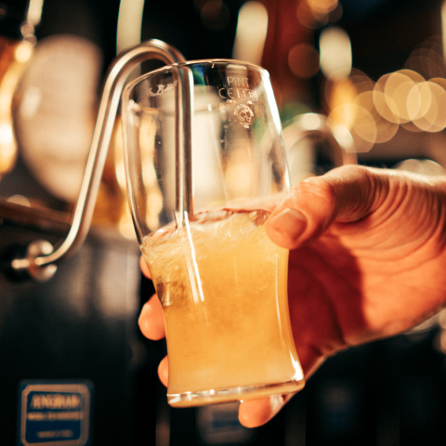

MPs yesterday debated “the potential merits of recognising the production and serving of cask ale as intangible cultural heritage” and saw MPs from five political parties and across the UK give their backing for official recognition of cask, for better access to market for independent brewers and the need to protect the UK’s brewing heritage. The debate came about because of Derby CAMRA’s local campaigning against misleading Fresh Ale kegged beer served through traditional cask handpulls, which convinced Derby South MP Baggy Shanker to apply for a debate about protecting and promoting cask. The debate also came on the back of the campaign by Craft Beer Channel to get cask recognised under UNESCO’s Intangible Cultural Heritage scheme which has already seen recognition for Belgian beer and the French baguette. The first step to getting cask the same recognition is a listing under the UK government’s Living Heritage scheme, which would then open up the possibility for its nomination for the UNESCO listing. The good news is that responding to the debate, government minister for tourism Stephanie Peacock said the government recognised the strong campaign for living heritage status for cask put forward by Craft Beer Channel and CAMRA, and said the bid is currently being assessed by an independent panel. She said the government recognises that the production and serving of cask is a vital living tradition. Many MPs spoke about the damaging decisions by multinational brewers to close cask breweries and move production of brands away from the places in which they have traditionally been brewed. Wolverhampton West MP Warinder Juss spoke about the impact on his city’s brewing heritage of the decision to close Banks’s brewery and the importance of this heritage being protected. Burton and Uttoxeter’s MP Jacob Collier raised Carlsberg Britvic’s announcement about closing Marston’s brewery in Burton-upon-Trent putting 300 jobs and the future of brands like Pedigree and Bass at risk. Staffordshire MP Sir Gavin Williamson said that the Marston’s decision was the latest in a pattern of behaviour following the decision to close Banks’s and said many global brewers seem determined to close all their cask breweries. Fellow Staffordshire MP Mike Wood agreed saying that losing Marston’s, Banks’s and Sharp’s breweries should set alarm bells ringing in government. Carlisle MP Julie Minns has long campaigned for better access to all pubs for independent breweries and said getting a pint of independently brewed cask in a pub can be a challenge due to the practices of large brewing companies. She called for a guest beer right to be introduced for tied tenants in England and Wales to improve access into pubs for small breweries – an argument repeated by the Green Party’s Hannah Spencer. The Democratic Unionist Party’s Jim Shannon MP said local, independent beers and breweries, including from Northern Ireland, need to be supported in the face of mass-produced conformity at the bar. Conservative shadow minister James Wild MP highlighted the fact that smaller, independent breweries are finding success in the cask beer market and spoke about the importance of supporting community pubs, taprooms and festivals which are vital to securing the future of cask beer. Sir Gavin Williamson MP said big brewing businesses are misleading customers into thinking they are getting real ale by serving non-cask beers through traditional handpulls. He called on government to drag in the chief executive of Carlsberg for a dressing down over the damage being done to Britain’s cask brewing heritage. Mike Wood MP said that cask beer served through a handpull at the bar defines British pubs and should be given protection, while Baggy Shanker MP called out the threat posed by 'Fresh Ale' masquerading as cask which misleads consumers by seeing kegged beers served through cask handpulls at the bar. Now it is a case of waiting for that independent panel to review applications to the Living Heritage scheme, but there are certainly positive noises from the government. Tomorrow's Budget will make key decisions on many issues facing pubs, breweries and consumers such as VAT and beer duty. The government’s Department for Business needs to take action to prevent misleading products being sold through cask handpulls at the bar – whether that’s Carlsberg’s Fresh Ale or Adnams kegged alcohol-free Ghost Ship. CAMRA will keep speaking to MPs and lobbying government about our Beer in the UK report and the need for wholesale reform of the market to guarantee full access to market for independent and small brewers who are committed to the production of cask ale. The debate can be viewed (from 09:30) here and a transcript of the debate is available here.

