Gen V returns home
27/10/2026 by Timothy Hampson
Industry

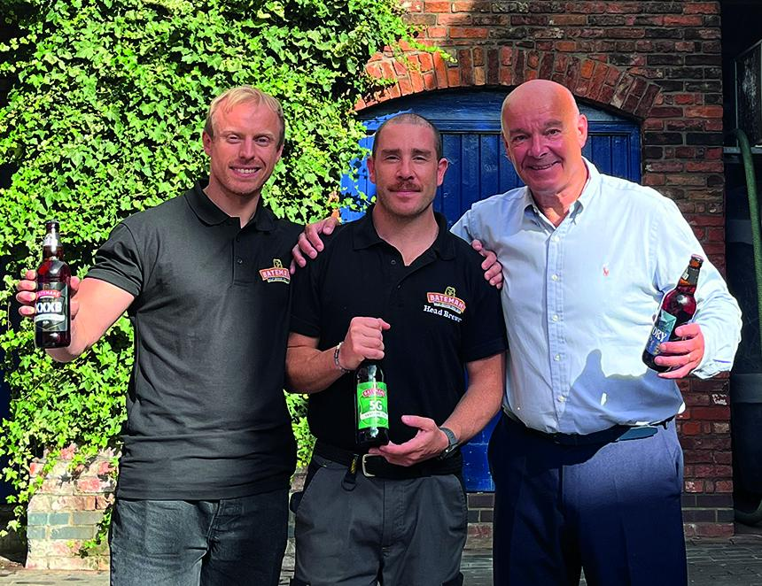

When family breweries were more common it wasn’t unusual for young members who wanted to brew to learn their craft at another operation before returning home. As the number of family brewers declined so the practice waned, but now a fifth generation of the Bateman family has returned to Wainfleet in Lincolnshire. A Batemans spokesperson said: “We are absolutely thrilled to announce that the fifth generation of the Bateman family has finally come home to Wainfleet. “After a five-year stint at Beavertown, Harry Bateman – part of the fifth generation of our 152-year-old family business – has returned to Wainfleet for good, joining Guiseppe D’Oriano in the brewhouse as assistant head brewer. “These moments really do only come once in a generation.” Batemans began from humble beginnings in 1874 and has been a continuous presence in Lincolnshire through two world wars, a keg beer revolution and a family share disagreement. Pictured, from left, Hary Bateman, Guiseppe D’Oriano and Stewart Bateman

