Mats the way to do it
26/10/2026 by Anne Burnham
Campaign

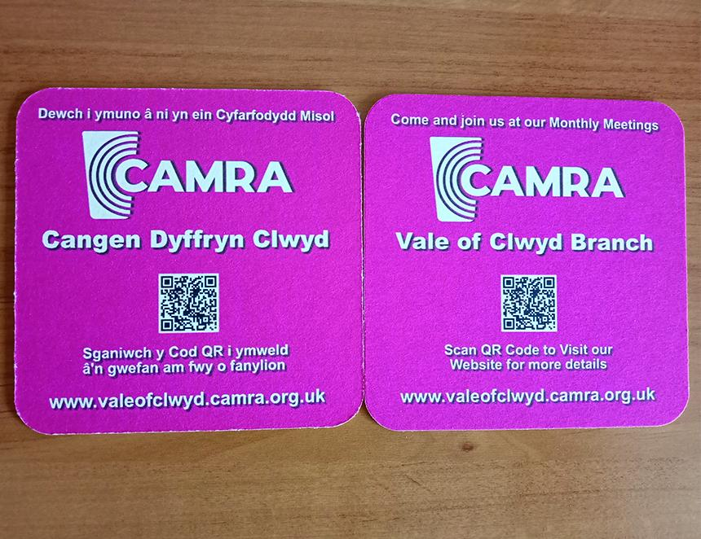

Vale of Clwyd CAMRA branch has launched a new grassroots initiative to encourage more people to join the Campaign and strengthen engagement among members. At the March branch meeting, members explored fresh ways to promote CAMRA. It was recognised traditional notice boards often go unnoticed in busy pubs, while beer mats offer a simple, eye‑catching way to reach people directly at the bar. As a result, the branch agreed to produce bespoke Vale of Clwyd beer mats to support local recruitment and awareness. The new beer mats feature clear contact details for the branch, including the website URL and an easy‑to‑use QR code with the aim to raise awareness of CAMRA and its work, encourage people to join and inspire more existing members to attend branch meetings and activities. Chairman David Tullett said: “Our treasurer, Clwyd Roberts, designed the mats with English on one side and Welsh on the other to reflect the bilingual character of the area. The first delivery arrived in June and members are now distributing them to pubs across the area.” It is hoped the campaign will spark conversations, strengthen local involvement and help more people discover the benefits of CAMRA membership.

