CAMRA Pub Heritage Group update – October
25/10/2026 by Tom Chapman
Pub

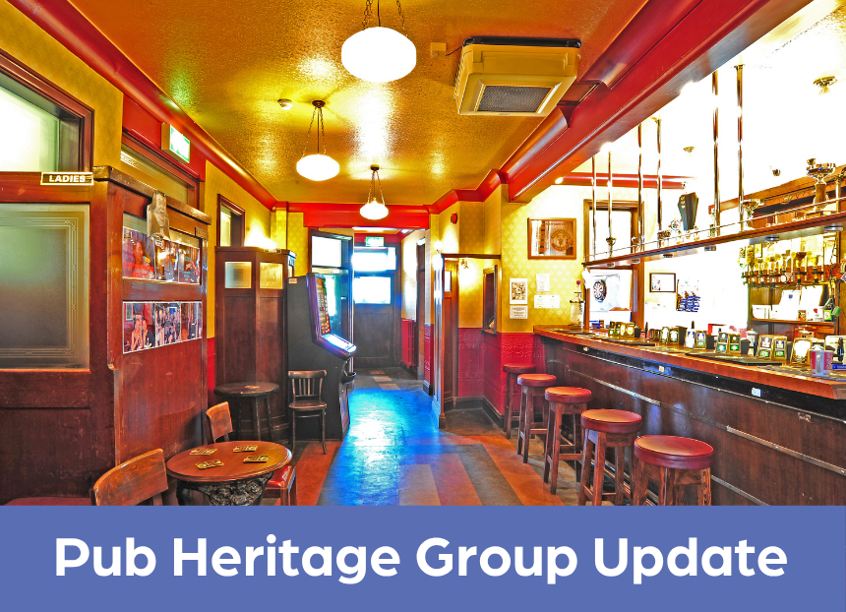

CAMRA’s Pub Heritage Group shares news and updates about pubs with historically significant interiors across the UK. For further news about the National Inventory of Historic Pub Interiors, see the Pub Heritage Group webpage. Three Star Heritage Pubs Grapes Inn, Heywood, Greater Manchester (above) The focus of this month’s bulletin is on the sale of pubs owned by Samuel Smith’s brewery. It was anticipated that following the death of Humphrey Smith there would be changes to the management of the estate, and that appears to be true with reportedly 26 of its pubs up for sale or sold in the last month. The pubs earmarked for sale have all been closed for a considerable time, due primarily to the old regime’s management practices, and are seemingly considered as not being viable, with most being marketed with suggested alternative uses. Four of its National Inventory pubs are for sale: Grapes Hotel in Heywood, Coach & Horses in Weaste (both Three Star), Bath Hotel in Dewsbury and Kingsway Hotel in Rochdale (both One Star). The most alarming development is that a number of the pubs are being marketed specifically as being for non-pub use only, with we assume a clause in the sale agreement. Consequently, Paul Ainsworth has written to Samuel Smith’s on behalf of CAMRA to express concerns over this and point out that any change of use requires planning permission, which is not that straight forward. This complication is likely to actually put off prospective buyers. The recently revised National Planning Policy Framework (NPPF) also requires that pubs must be advertised for at least 12 months before change of use can be considered, something that Samuel Smith’s is currently not doing. On a more positive note, the brewery has also been reopening many long-closed pubs including Victoria Hotel, Cleveleys (see Two Star news) which began trading again at the beginning of the month and also the Wellington, York and the Tankard, Rufforth (see August update). There have also been many reports of repair and maintenance works underway in preparation of reopening, as well as more active marketing of pub-management vacancies. The Grapes is a rare example of a surviving 1920s estate pub which retains much of its original floor plan and fittings. It has been shut since summer 2025 and has now been put on the market with an asking price of £250,000. See the listing here. Its sale is particularly concerning as it’s one of the Sam Smith’s pubs which is being marketed for non-pub use only. It also does not have the protection of statutory listing so an application has been submitted to Historic England by Paul Ainsworth.
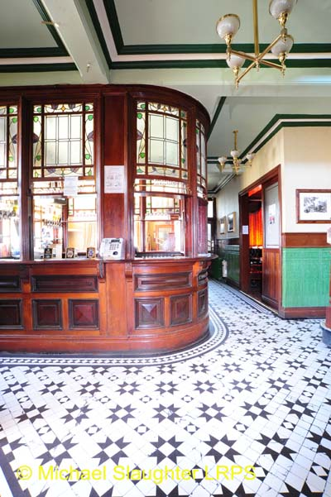
Coach & Horses, Weaste, Greater Manchester (above) Also owned by Sam Smith’s, this is a multi-room pub from 1913 with a fine interior. It has decorative-tiled flooring throughout and a substantial timber servery with a glass screen above, as well as a surviving off sales named the Outdoor Department. It’s been closed since 2021 and is on the market with an asking price of £295,000.
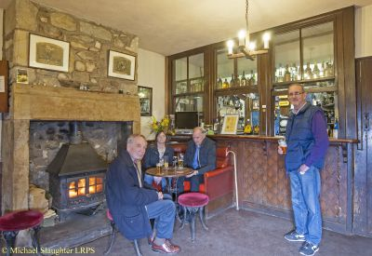
Limeburner’s Arms, Nether Kellet, Lancashire (above) The Limeburner’s Arms has been upgraded from Two to Three Stars. The basic interior of this rural two-room pub is a wonderful survivor and includes the public bar room to the left which has been little altered since 1900 and has a rare, shuttered bar counter, old back bar shelving, fixed seating and an old fireplace. The pub has been owned by the same family since 1931 and is a rare example of a pub attached to a working farm.
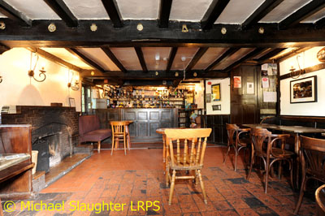
White Lion, Barthomley, Cheshire (above) The group recently reported the owner of this thatched village inn had given notice to East Cheshire Council of its intention to sell the pub, as is required when registered as an Asset of Community Value (ACV). The community group which has been campaigning since 2023, has been approved as a potential bidder and that the ACV six-month moratorium period on the sale has been triggered so the group can prepare a bid. To keep up to date with progress go to the Save the White Lion Barthomley Facebook group.
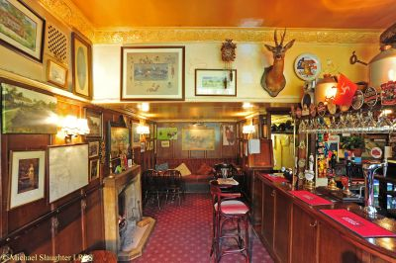
Bell, Walton-on-the-Hill, Surrey (above) Planning permission to convert this characterful country pub to a residential property was granted by Reigate and Banstead Borough Council in June 2025. Following a successful statutory listing application by CAMRA, owner Brakespear has now submitted a listed building application which will conserve most of the internal fixtures – including the bar counters. While, in the circumstances, this is a good outcome, it is difficult to see this restriction being adhered to. Paul Ainsworth has requested an annual check by the council. The group understands the pub is still trading, so it’s still not too late for a visit. Two Star Heritage Pubs
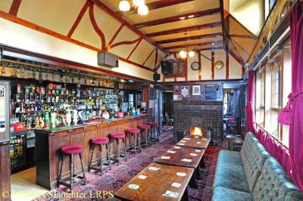
Gatehouse, Norwich, Norfolk (above) Following many objections from the local community on conversion plans to a mosque and community centre, we are relieved to hear that the application has been withdrawn. The owner, The Norwich Muslim Centre, outbid a community group which was planning to reopen the pub, when it purchased it in 2025. The owner wants to negotiate directly with officers to see how it can use the building without having to go the planning committee. The pub, which was built in 1934 as an improved public house, was listed in 2015 following Historic England’s review of interwar sites.
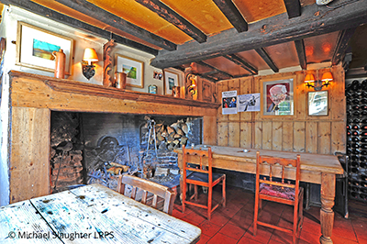
Crooked Billet, Stoke Row, Oxfordshire (above) The group reported in August that the Crooked Billet would be opening again soon and damage caused by a fire in the kitchen was not thought to be too severe. It is now reported by owner, Paul Clerehugh, that the interior has been badly damaged and the repair works will take a year to complete. Read more in the Oxford Mail.
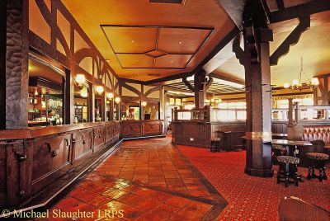
Victoria Hotel, Cleveleys, Lancashire (above) Some good news to report from Sam Smith’s. This imposing interwar pub in baronial style, reopened at the beginning of October. It had been closed since October 2023. One Star Heritage Pubs Bath Hotel, Dewsbury, West Yorkshire This Sam Smith’s pub has been shut since 2023 and is now on the market with an asking price of £175,000. The Bath Hotel is included on the inventory for its three-room layout that includes a mainly unaltered tap room with fixed settles and glazed screens.
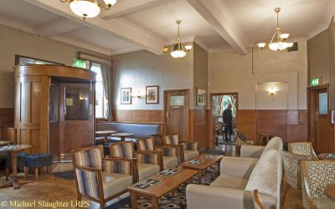
Kingsway Hotel, Rochdale, Greater Manchester (above) Closed since 2018, this pub is another Sam Smith’s which has been put on the market. The asking price is £425,000. The Kingsway is an impressive interwar pub built in 1938 by Rochdale & Manor brewery and retains its original four-room layout with many features from the period.
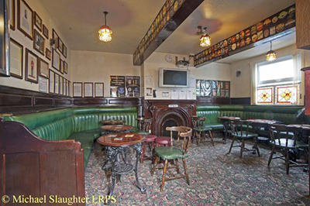
Sweet Green Tavern, Bolton, Greater Manchester (above) The Sweet Green Tavern, included on the inventory for its surviving 1950s interior, closed in October 2025. Owner Star Pubs & Bars has now put it on the market with an asking price of £195,000.
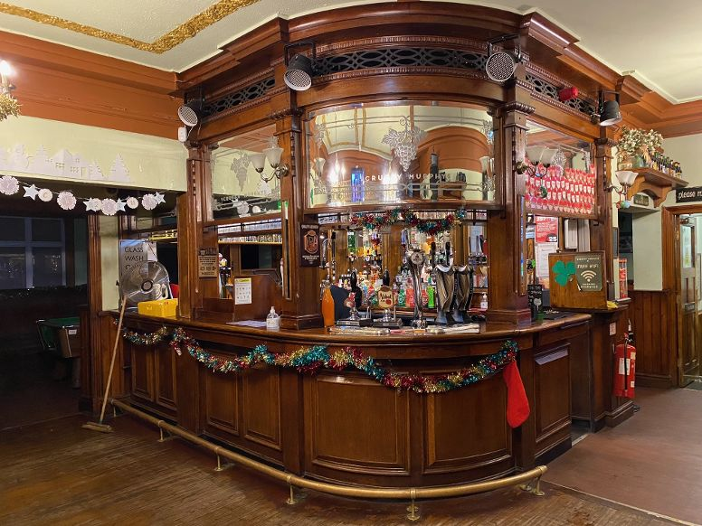
Scruffy Murphys, Blackpool, Lancashire (above) Previously called the Grapes, this Irish themed bar has been added to the inventory at One Star for its surviving Victorian layout of a lobby bar and three small rooms with a rare surviving screened servery with upper glazed panels. CAMRA Pub Design Awards 2027 The annual CAMRA Pub Design Awards are open for nominations. The categories include the Historic England Conservation and the Refurbishment awards as well as the Community Local prize. All the awards have been won by National Inventory pubs over the years. The nominations close on 18 November. For more information and the nomination form go to: CAMRA Pub Design Awards CAMRA Pub Saving Award CAMRA’s annual Pub Saving Award is also open for nominations. This is open to groups which have carried out campaigning activity that has directly led to the prevention of a pub being closed during the year ending 1 November 2026. Nominations close on 12 November. For more information and the nomination form go to: CAMRA Pub Saving Award To find out more about The National Inventory of Historic Pub Interiors and the work of the Pub Heritage Group go to: Historic Pub Interiors . If you have any news on heritage pubs send to: info@pubheritage.camra.org.uk Feel free to forward this bulletin to friends interested in visiting pubs like these. If you wish to receive the bulletins directly, sign up by sending an email to bulletin@pubheritage.camra.org.uk with the word “subscribe” as the subject or “unsubscribe” if you wish to stop.

