Ownership switch to secure brewery’s future
22/10/2026 by Timothy Hampson
Industry

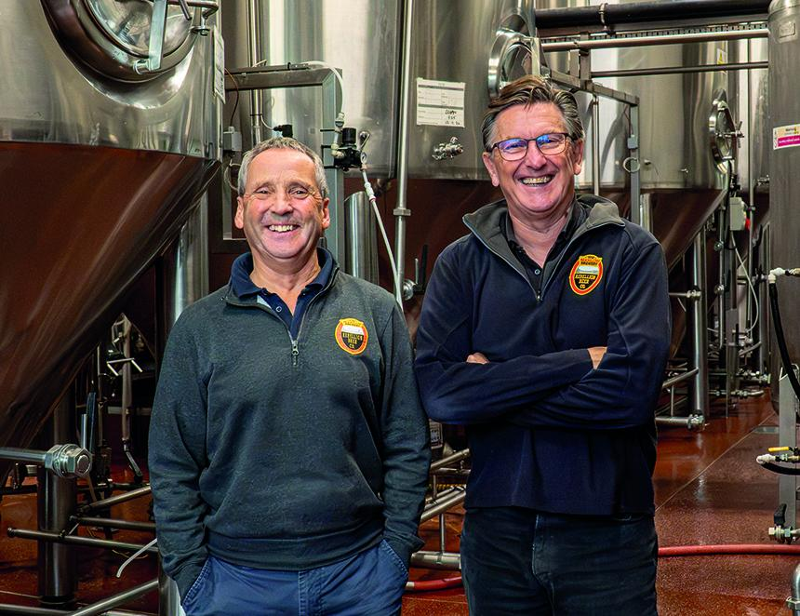

A Berkshire brewery has become employee-owned in a move which its founders say will safeguard its future in its current home in Marlow. The founders of the Rebellion Beer Company have announced that they have completed the transfer of the business to an Employee Ownership Trust (EOT). The brewery, which is now based at Bencombe Farm, was founded by Mark Gloyens and Tim Coombes (pictured, from left) in Marlow Bottom in 1993. The overriding aim of the new Rebellion Beer Company EOT is to provide continuity for both the staff and the many loyal local customers of the brewery, and to ensure the ethos and community spirit of Rebellion is maintained in perpetuity. The pair will continue to be involved with Rebellion over the next few years as a new management team, made up of existing long-term employees, begins to take over the running of the business. Rebellion says the move aims to provide continuity for staff and its customers while helping to maintain the brewery's community spirit and ethos. The brewery is also planning to launch a crowdfunding opportunity in early 2027 as it enters its next chapter. Rebellion says the scheme will give supporters of the brewery the chance to invest in the business and help fund its continued development. The business says its new employee-owned structure will help protect the Marlow brewery and safeguard more than 75 jobs in the town.

