Women’s brew day returns with sustainability focus
21/10/2026 by Timothy Hampson
Industry

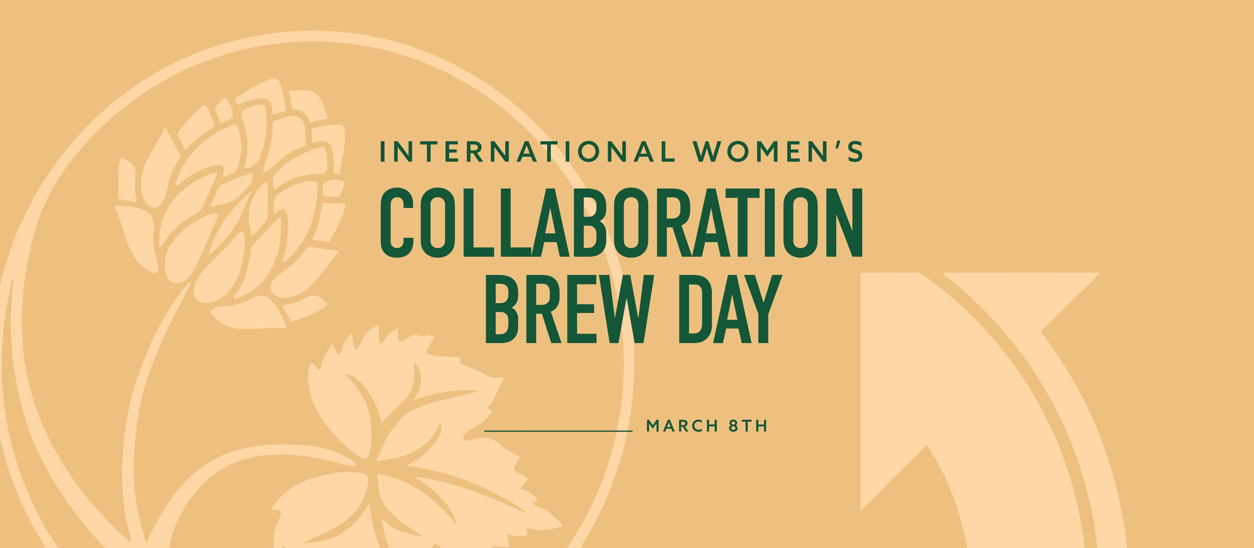

Women On Tap CIC International Women's Collaboration Brew Day (IWCBD) will be back in 2027 with a Unite Sustain theme. The campaign brings together beer and International Women’s Day by inspiring communities to gather at breweries on or around 8 March to brew, network, learn and celebrate women. The theme asks the beer community to consider what it takes to build an industry that lasts. The announcement follows IWCBD’s biggest year to date. In 2026, 88 brew days took place across the UK and internationally, bringing together 1,153 participants, producing 93 new beers and raising £33,889 for women’s causes, a 25 per cent increase on 2025. Of the participating breweries that responded to the post-campaign survey, 85 per said they will sign up again for 2027. The Society of Independent Brewers and Associates (SIBA) will continue as headline partner and Beer 50/50 partner for a third consecutive year. Across the partnership to date, IWCBD has raised more than £60,000 for women’s causes. Women On Tap CIC executive director Rachel Auty said: “Thanks to continued backing from SIBA, we are investing again in the development and delivery of IWCBD as one of the most inclusive and impactful campaigns in beer today. We know this campaign is instrumental in raising significant funds for good causes, bringing together a community of people who are underrepresented in beer, driving diversity and boosting career progression across the industry. The theme reminds us that sustaining beer means looking after both the planet and the people. Here’s to another great year of brewing together and making a difference.” Breweries can register through the commitment to brew online form, which opens on 30 October. The form asks for basic details only, with further information requested in the new year. Find out more at iwcbd.org and sign up to the Women On Tap CIC mailing list for updates.

