Original IPA returns with modern twist
20/10/2026 by Timothy Hampson
Industry

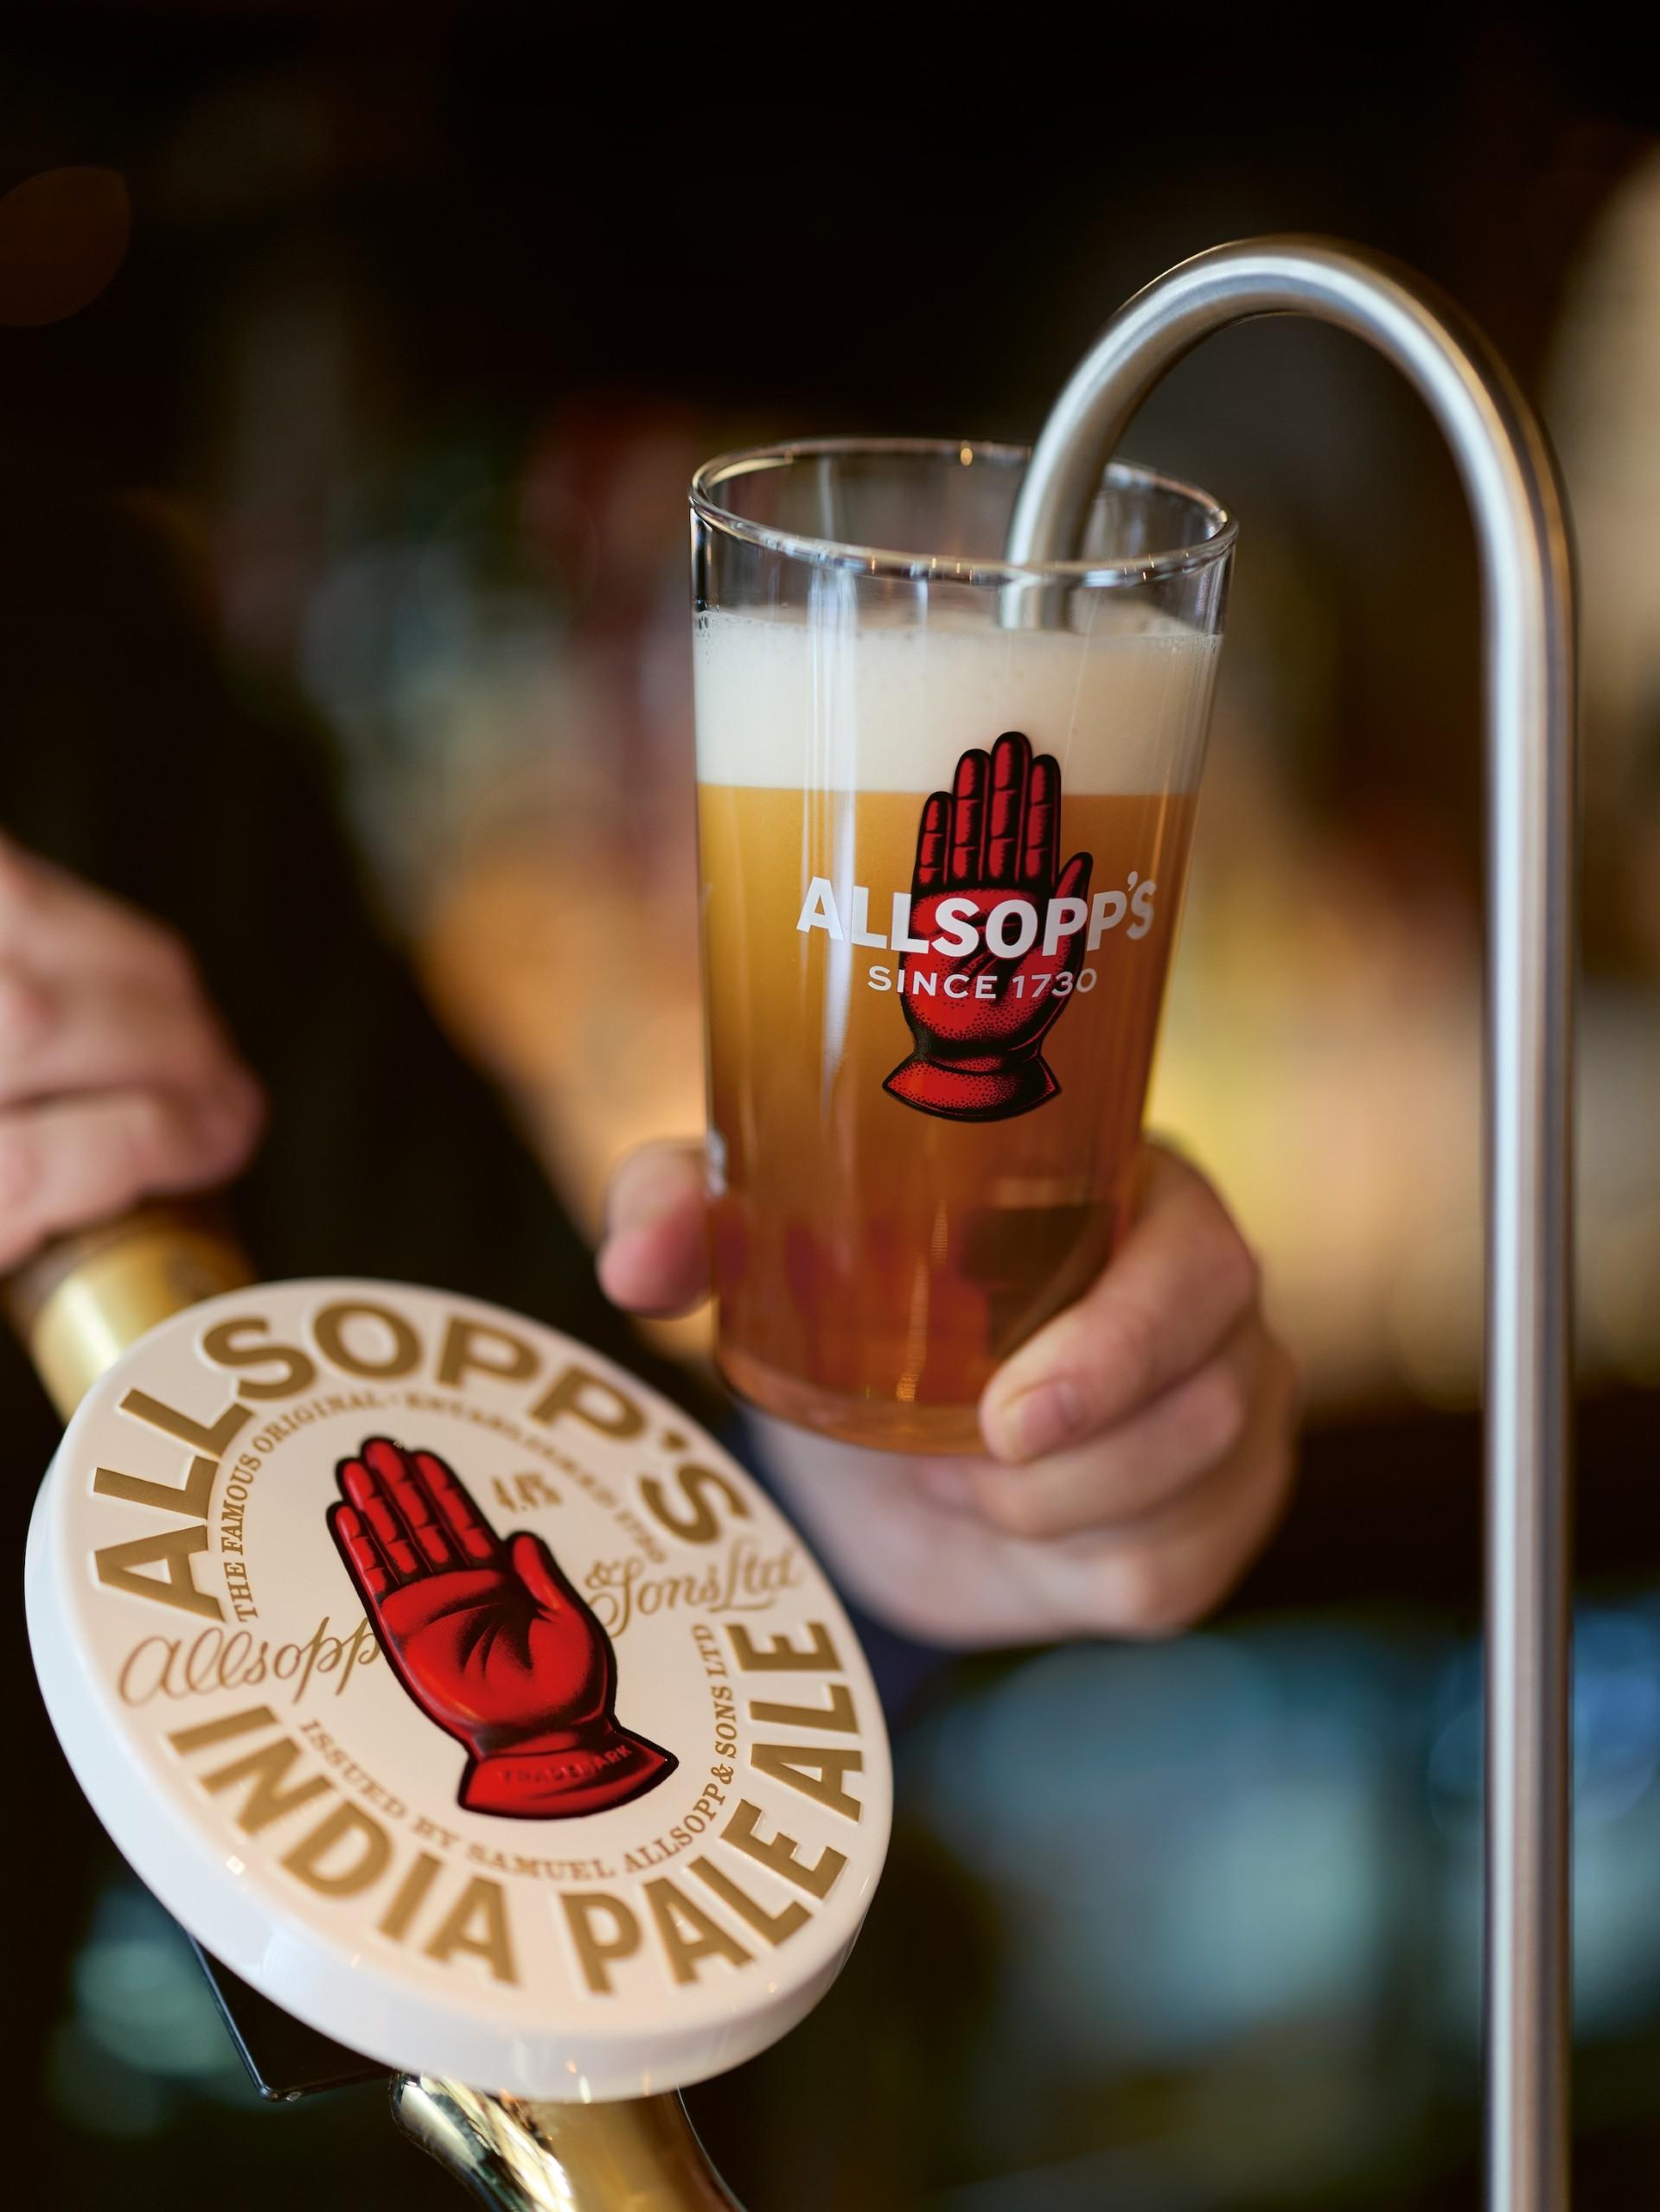

Allsopp’s has returned to the beer that made its name with the launch of IPA, a new 4.4 per cent ABV cask beer inspired by the Burton brewer’s original 1822 recipe. Brewed with UK Golden Promise malted barley and Challenger hops, Allsopp’s IPA is dark copper in appearance with herbal, spicy and resinous aromas, rounded bitterness and a sweet, robust malt backbone. The beer has been developed and brewed with the team at Kirkstall brewery as a balanced cask IPA rather, than a direct reproduction of a 19th-century export beer. Its recipe draws upon the only known surviving Allsopp’s brewing ledger, discovered in a pub in Leeds after founder Jamie Allsopp spent almost two years searching for original records from his family’s brewery as he plotted its return. The ledger contains more than 100 handwritten recipes, including Allsopp’s IPA, Pale Ale, Double Diamond, Stout and Arctic Ale, and has become the historic underpinning for the modern revival of Samuel Allsopp & Sons. Allsop said: “It is with immense pleasure and pride that we offer Allsopp’s IPA to the world, brewed to a recipe inspired by the very first viable IPA, a beer devised by us in 1822 in Burton-on-Trent. “We did not want to produce a museum piece – the IPA has the malt character, balance and bitterness that belong to our brewing heritage, but it is unmistakably a contemporary cask beer. It is very precisely what I believe Allsopp’s should be and is brewing today.” The launch returns Allsopp’s to the style that transformed the company from a regional Burton brewer into an internationally recognised name. In 1822, Jamie Allsopp’s seven times great grandfather Samuel Allsopp and his master brewer, Job Goodhead, were challenged to produce a beer capable of surviving the long sea journey to India and winning the East India Company’s supply contract from incumbent brewer Hodgson. The pair famously used a teapot as a miniature brewing vessel to conserve time and ingredients while developing the beer. Their solution was to increase both the hops and alcohol, whose combined preservative qualities allowed it to withstand the difficult voyage without spoiling. Allsopp’s IPA went on to become one of the most popular beers at home and abroad, helping establish both India Pale Ale as a global style and Burton-on-Trent as a centre of world brewing. Allsop added: “As an Allsopp, the story of IPA has a deep resonance. Samuel saw an opportunity, bet the future of the business on it and produced a beer that succeeded in conditions which had defeated others. “Arguably, there is no more important beer in brewing history. We have approached the IPA with the same spirit by taking the defining characteristics of the original and brewing them for today’s drinker. “We want this IPA to earn its place on the bar through the quality of the beer in the glass. There is a growing audience for properly brewed and well-kept cask and we want this IPA to help more drinkers discover its freshness, depth and character.” The beer was unveiled at Leeds International Beer Festival and joins a revived Allsopp’s range including Pale Ale, Best Bitter, Stout, Lager, Double Diamond and Arctic Ale.

