One pub a day shuts
19/10/2026 by Timothy Hampson
Campaign

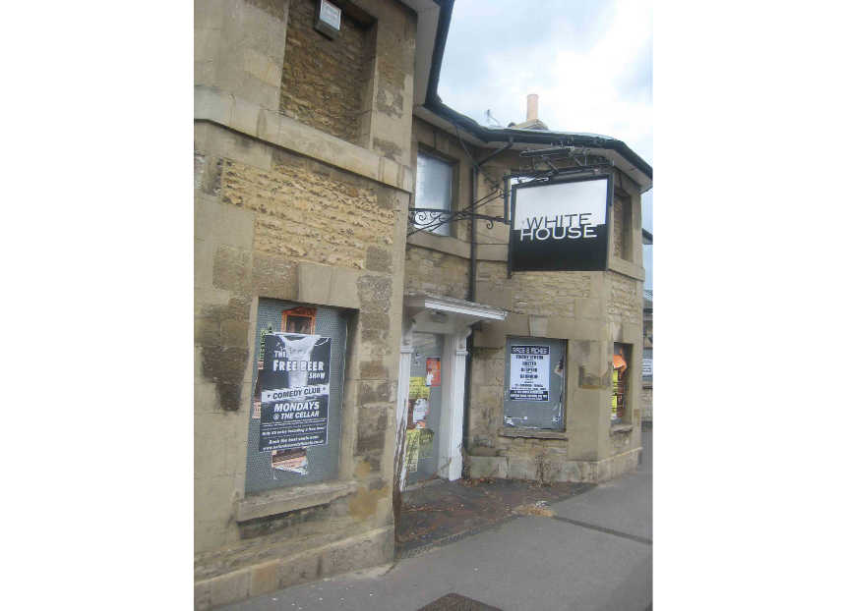

Approximately one pub a day will have closed by the end of 2026, according to the latest figures from the British Beer and Pub Association (BBPA). The trade body estimates that around 360 pubs will permanently shut their doors by the end of the year. This would result in around 5,000 job losses, with more than half of these roles being filled by under-25s. With the typical pub contributing approximately £200,000 to HMRC, the BBPA said that government could lose almost £72m in revenue including employment and corporation taxes, beer duty, business rates and VAT, by the end of the year. By the end of September, 295 pubs shut, with the BBPA warning successive Budgets have exacerbated the huge tax and regulatory burden that the industry already faced and which is at the heart of many closures. England lost 226 pubs in total, with the South East seeing the highest number of closures (42), followed closely behind by the North West (39) – the North East saw the fewest closures (11). Respectively, Scotland and Wales saw 64 and five pubs shut their doors. The BBPA said the impact of all the Budget measures in November 2025 added an eye-watering extra £322 million to business costs for pubs and brewers, forcing many to make incredibly tough decisions. The scale of closures underlines exactly why the prime minister’s promised 20 per cent business rates cut could not be more welcome, said the trade body. BBPA chief executive Emma McClarkin said: “When a local closes, the damage is felt far and wide. It’s not just workers, communities, our heritage and high streets who lose out when a pub closes – the Treasury loses, on average, £200,000 in tax receipts every time a local calls last orders. “We wholeheartedly welcome the prime minister’s promise to cut business rates by 20 per cent for pubs from next year which, when it comes in to effect, will be a significant help. This will build on the initial commitments to wider reform including the pub valuation methodology and a pub-specific relief recognising their unique social and community value. "The prime minister has pledged that the cavalry is coming, which is why we’re asking government to tackle the root of the problem through a permanently fair and sustainable rates burden, freezing beer duty, increasing draught relief and reviewing employment costs for under-25s. “This will mean we can carry on keeping people in jobs, boosting the economy, and being at the heart of communities.” For every three pounds spent in a pub, one goes straight to the tax man, the BBPA stressed. This is why it is also backing the wider hospitality industry campaign for fairer VAT rates. In 2025, the total net pub closure figure in the UK was 336. Over the last five years, there were nearly 2,200 net pub closures bringing the total number left to 43,656 by the end of 2025.

