Fab four go for ultimate pub crown
14/10/2026 by Timothy Hampson
Campaign

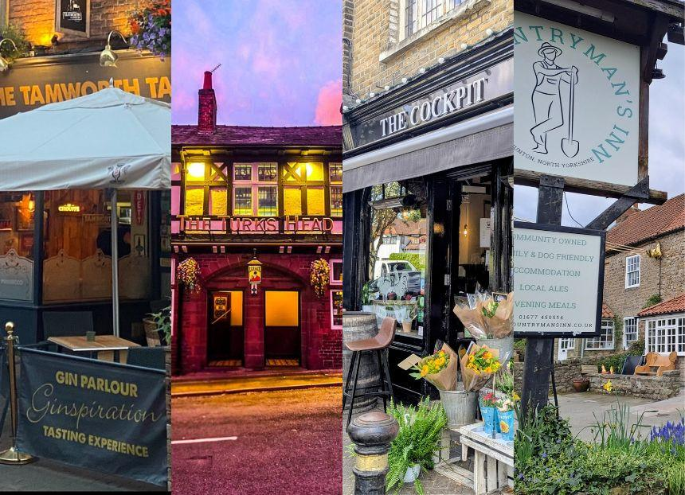

Pubs from Merseyside, Yorkshire, Tamworth and London are in the final race to be CAMRA’s National Pub of the Year 2026. CAMRA revealed today that the Turks Head, St Helens; Countryman’s Inn, Hunton; Cockpit, Chislehurst and Tamworth Tap, Tamworth will battle it out for the overall crown. The Turks Head is a previous regional winner while the Tamworth Tap will be seeking a record-breaking fourth title. The Countryman’s Inn and Cockpit are first time regional and super-regional winners with the latter only opening during the Covid-19 pandemic. The Countryman’s Inn is aiming to take home the top prize 10 years after a pub less than 10 miles away, the George and Dragon, Hudswell, did the same. The super-regional and final rounds of the competition are sponsored by CAMRA beer quality partner, Avani Solutions, and technology partner, ICRTouch. Pub of the Year coordinator Andrea Briers said: “I’m so proud of our final four pubs for 2026. Despite the well-documented challenges facing our pubs and brewers, these licensees have not just survived, but thrived. All four are amazing places that are definitely worth a visit, whether you want a top-quality pint, or just a brilliant community-orientated vibe.” Turks Head landlord Daryl Arrowsmith said: “To say we’re over the moon is an understatement! We’re incredibly proud to have reached the final four pubs and to be representing St Helens at this level is honestly a dream come true. “But this isn’t just an achievement for me – it’s an achievement for our amazing team, our wonderful regulars and our incredible local community. Without them, the Turks Head simply wouldn’t be what it is today. We’re proud to be a proper traditional local pub where everyone is welcome, whether you’re a lifelong regular or walking through our doors for the very first time.” Countryman’s Inn licensee Dan Male said “We are absolutely delighted to have made it to the last four. In our fourth year of community ownership, the pub continues to grow and we are so proud to be recognised by CAMRA in the work we are doing.” The Cockpit’s Adam Miller said: "What boggling news this is to receive! It has caused a frenzy of frenetic jubilation among us staff and stalwarts at the Cockpit. "This is a pub stripped back to basics, where the pristinity of our ales, ciders, food and wine speak to the uncompromising standards of the producers that grace our floorboards, along with our punters’ intangible whimsies seasoning the atmosphere so dotingly, it is a truly treasured environment to serve such a convivial community. “Thank you to all the stagehands that keep the wheels in motion, both on the jump and behind the curtain, and thank you, CAMRA, for recognising our little boozer with this accreditation – what splendid company to be in." Tamworth Tap’s George Greenaway said: “We’re absolutely thrilled to have made the final four again. It honestly feels just as exciting as it did the first time we became finalists. We were keeping everything crossed, but when you look at the quality of the final 16, we knew the competition was incredibly strong. To have made it through to the final four is something we’re really proud of, and it means a huge amount to the whole team.”

