Lion roars again thanks to generous locals
13/10/2026 by Timothy Hampson
Pub

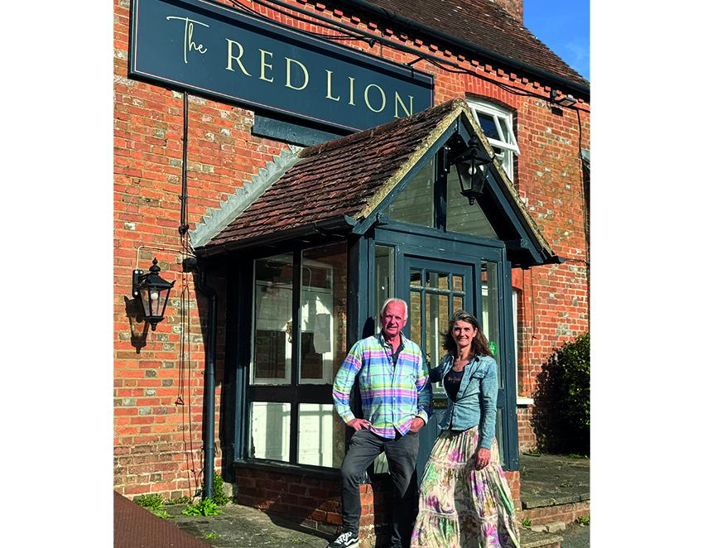

The village of Upper Basildon, Berkshire raised a staggering £450,000 to help new owners buy its local, the Red Lion, from pubco Stonegate. The community raised the astonishing amount in just weeks to support John Hunter and Annabel Cochrane (pictured) in their quest to bring the last pub in the village back to life. Residents clubbed together to save the pub, which closed in 2024, by contributing to the Lionheart Basildon Bond Club, a tiered membership scheme where households loan money which is repaid monthly through the pub till. The scheme’s name is a nod to the writing paper inspired by nearby National Trust property, Basildon Park. Hunter said: “This momentous commitment by the residents of Upper Basildon has meant we can secure the future of the Red Lion and re-establish it as the hub of the village. After almost three years without an open pub, we can't wait to reinvent the Red Lion and pull the first pints of traditional ale and feel and enjoy the vibe of a thriving country pub with a proper sense of place and purpose. “We’re proud to have worked alongside the community to incorporate this pioneering membership scheme as an example of how to reboot and re-energise the business model for village pubs.” The purchase completed just weeks after the government strengthened planning rules to protect pubs from redevelopment, a change which campaigners say reflects growing recognition of the role village pubs play in community life. Reading West and Mid Berkshire MP Olivia Bailey said: “This is such fantastic news for residents in Upper Basildon and across the constituency. I met John and Annabel this summer and was impressed with their vision and drive to reopen the Red Lion. Pubs are such a vital part of our communities, which is why I was delighted that the government has changed the planning rules to protect pubs from redevelopment. I wish them all the best as they work towards the opening and I shall definitely be popping by!” The partners are planning renovations throughout the pub including a new portico, orangery, all-day café and landscaped gardens in time for an official opening in spring 2027. Hunter added: “We’d love even more people to join us through the Lionheart Basildon Bond Club and follow our progress on social media as we get the pub ready to reopen.”

