Fury at decision to axe brewery
08/10/2026 by WB Reporter
Campaign

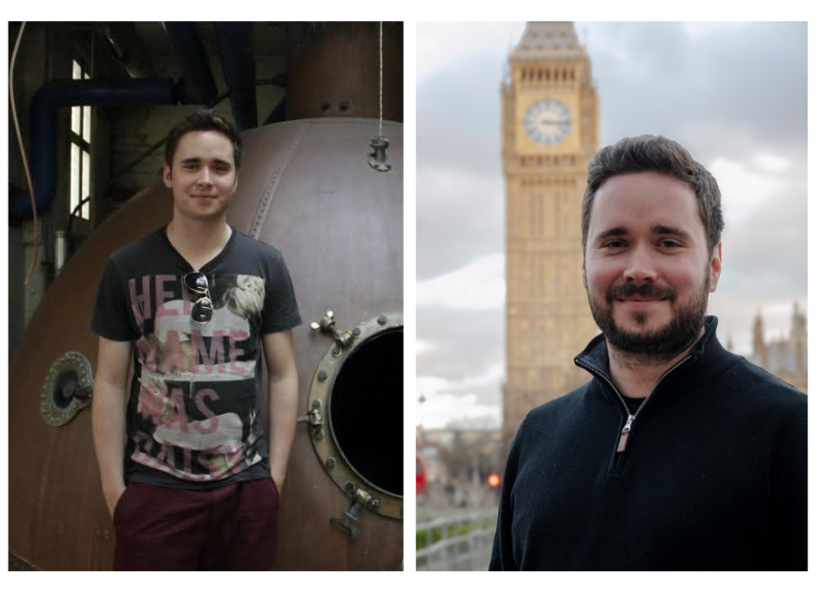

CAMRA has reacted with anger to the news that Carlsberg plans to close its Marston’s brewery in 2027. The Campaign has renewed its demands for the Competition and Markets Authority to investigate how global interests have consolidated the UK beer market and supports of Carlsberg’s assertion that it is seeking “suitable long-term custodians” for some of the cask beers in its portfolio. The global manufacturer, which bought Marston’s brewing business outright just two years ago, initially entered a joint venture with the brewer in 2020 and then acquired soft-drinks giant Britvic in 2025. This is not the first time it has closed a historic brewing site. Ringwood and Wychwood breweries have closed. Jennings in Cockermouth was also closed but has found success in independent ownership. Closure of the historic brewing site in Burton puts around 300 jobs at risk, with dramatic consequences for the town which has been a centre of brewing knowledge for centuries. Carlsberg wrote to CAMRA as the announcement was made (see below), setting out its reasons for the decision and highlighting that it will be seeking custodians for some of the cask beers within their portfolio. CAMRA recently launched its Beer in the UK report and a wider campaign urging the Competition and Markets Authority to launch a formal investigation of the UK beer market. The Campaign maintains independent brewers are locked out of the market by global conglomerates, despite providing genuine innovation and choice to drinkers. CAMRA chairman Ash Corbett-Collins said: “I was born and raised in Burton and I’m proud of our place at the centre of British brewing. Unfortunately, statements from Carlsberg about understanding the importance of the brewery to the town come far too little too late for most people, CAMRA included. “This announcement is an absolute disgrace and the latest in a string of actions that show how little they care about our brewing heritage or the nation’s drinkers. “However, we do agree with Carlsberg on one thing. The time is right to think about alternative, independent, brewers who are willing to become custodians of Carlsberg’s cask brands and will finally do the beers the justice they deserve. “Like the rescue of Jennings in Cumbria by passionate and experienced brewers, I hope the Burton brewery can be saved. I’ve got fond memories visiting the brewery in better days, and maybe I’ll be able to go again if it’s handed over to independent owners.” Pictured, left: a young Ash Corbett-Collins at Marston's brewery; right: Ash in Westminster Letter from Carlsberg Britvic CEO, Paul Davies, to CAMRA: Dear Ash and Tom, I am writing to let you know personally that Carlsberg Britvic has today announced a proposal to close Marston’s Brewery and the primary logistics operation in Burton upon Trent in summer 2027, subject to consultation. I recognise the significance of this proposal for our colleagues first and foremost, and for those who care deeply about cask ale and Britain’s brewing heritage. I know that CAMRA will have serious concerns and questions about what this could mean for the brewery, the traditional ale brands associated with Burton upon Trent, and the future of the category. This is not a proposal that we have reached lightly. People have always been at the heart of our business, and our immediate priority is supporting the approximately 310 colleagues whose roles are directly affected throughout the consultation process. We will approach every stage of this process with care, honesty and respect. Our brewery and logistics colleagues have shown exceptional commitment, skill and professionalism and have made an enormous contribution to Burton upon Trent’s proud brewing tradition. This proposal is not a reflection on them or the quality of their work. We are also engaging directly with the local Member of Parliament and other relevant stakeholders in Burton upon Trent to explain the proposal, hear their concerns and discuss its potential implications for the local area. The UK ale market has changed significantly over many years. UK cask ale volumes have more than halved in less than a decade, and the wider ale category continues to decline despite significant efforts across the industry, including our own, to reinvigorate it. These trends have had a particularly significant effect on our brewery in Burton upon Trent, where all our cask ale is brewed. The proposal reflects the long-term structural challenges facing the cask and wider ale market, and the impact those trends have had on the economics of operating the brewery. Against this backdrop, we are proposing to focus our investment where consumer demand is stronger and where we believe it can best support the long-term strength of our business. As part of the proposal, we are also considering the long-term future of a number of traditional ale brands currently produced at our Burton upon Trent brewery. We recognise the importance of the traditional ale brands associated with Burton upon Trent and the loyalty they inspire among consumers, publicans and communities. While no final decisions have been made, we are in active engagement with potential partners with the aim of finding suitable long-term custodians who can give these brands the specialist focus and dedicated stewardship they deserve. This proposal does not mean that Carlsberg Britvic is withdrawing from ale. We will continue to sell and support ale brands including Hobgoblin, McEwan’s and Brooklyn, and remain committed to the UK beer and pub sector. We will treat every impacted colleague with the respect they deserve, recognising the skill, pride and dedication they have given to the brewery, the logistics operation and the business. Support for those affected will be available throughout the consultation process – including practical, emotional and professional support – and we will explore suitable redeployment opportunities for affected colleagues wherever possible. I do not underestimate the brewery’s significance to the town and those who care deeply about Burton upon Trent’s brewing heritage. While it is too early to confirm specific plans for the future of the site, we understand its importance to Burton upon Trent and will give careful consideration to its heritage assets and place within the local community. I recognise that CAMRA will reach its own view of the proposal. We may not agree on every aspect of the commercial assessment, but I believe it is important that we are open about the evidence behind the proposal and that you have the opportunity to raise any questions or concerns you have.

