Search for latest pub grand designs starts
08/10/2026 by WB Reporter
Campaign

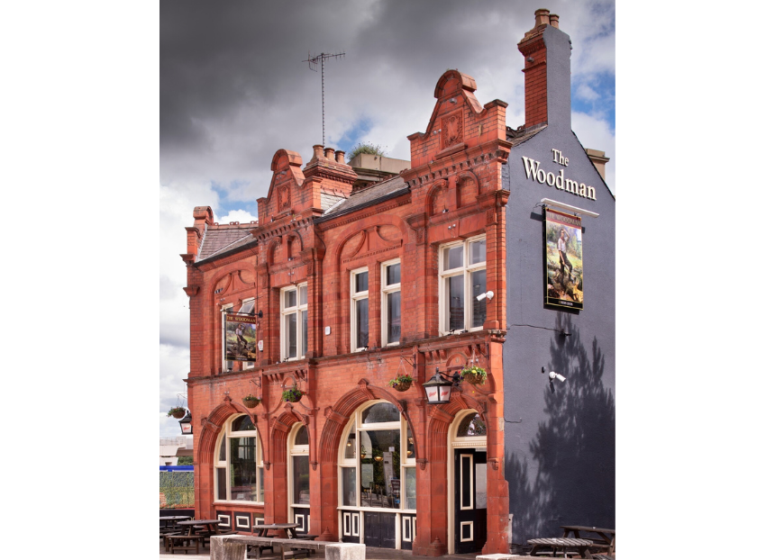

Pubs across the UK are being urged to enter CAMRA’s Pub Design Awards which celebrates the UK’s most eye-catching hostelries and seeks out gems where people have converted a building into a local. Working with Historic England, the CAMRA award showcases pub architecture across the UK. First introduced in 1983, dozens of locals have been recognised, with visitors flocking to enjoy the winning pubs. Judged by a panel of experts, the awards recognise the highest standards of pub refurbishment and conservation, plus the construction of new pubs and spaces being converted. There are five categories: Conversion to Pub Use, Historic England Conservation, New Build, Refurbishment and Community Local. Nominations open today to all pubs that meet the criteria, which can be found on CAMRA’s website. The Pub Design Awards are open to all pubs in the UK and anyone can nominate. Entrants may be asked to provide more photographs and plans of the building and the licensee should be aware of and approve the entry. To be eligible, work will need to have been completed between 1 July 2025 and 30 June 2026. The competition is free to enter and closes on 18 November 2026. Award chair Historic England’s Andrew Davison said: “I am delighted to announce the launch of our annual Pub Design Awards. They are a wonderful opportunity for owners, publicans and communities to show just how much creative flair, craftmanship and imagination goes into protecting, refurbishing and repairing their much-loved locals and creating brand-new pubs. “The judges are always so enthused and encouraged to see the wide range of entries, making our job very difficult indeed! To see these fabulous design projects come to fruition is both humbling, while creating a sense of community for generations to come. This is especially important at a time when pubs are struggling against a difficult economic backdrop and gives us the opportunity to celebrate these amazing buildings.” To enter and see previous winners, visit: camra.org.uk/awards/pub-design Pictured: Historic England Conservation 2026 winner, the Woodman in Birmingham. Credit: James O Davies

