CAMRA festival update - October
07/10/2026 by Harri Knight-Davis
Campaign

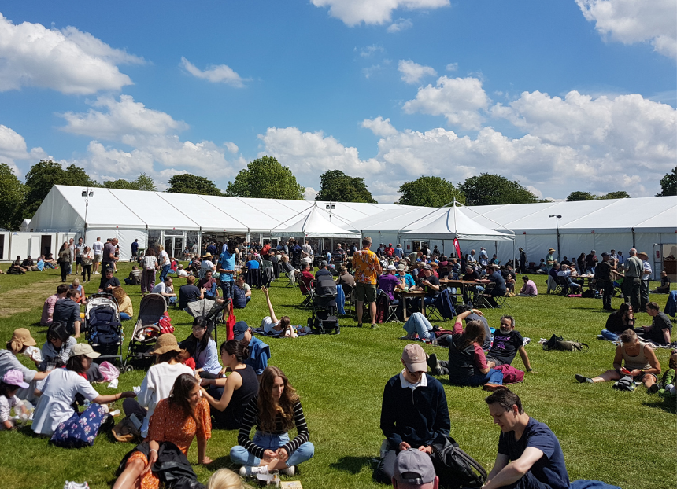

As we head further into autumn, CAMRA’s festivals keep coming thick and fast. Make the most of them by checking out the list below. Members can get free entry to many CAMRA festivals (not including souvenir glass and programme) when booking tickets in advance. For more information and to see all upcoming CAMRA festivals visit the events webpage. Nottingham Robin Hood Beer and Cider Festival, 7-10 October Trent Bridge Cricket Ground, Bridgford Road, West Bridgford NG2 6AG Bedford Beer and Cider Festival, 7-10 October Bedford Corn Exchange, St Paul's Square, Bedford MK40 1SL Derby Heritage Beer Festival, 14-17 October Derby Market Hall, Market Hall, Derby DE1 2DB Weymouth Octoberfest, 16-17 October The Weymouth Pavilion, The Esplanade, Weymouth DT4 8ED Steel City Beer and Cider Festival, 21-24 October Kelham Island Museum, Alma Street, Sheffield S3 8RY Swindon Beer Festival, 22-24 October Steam Museum, Fire Fly Avenue, Swindon SN2 2EY Worthing Beer and Cider Festival, 23-24 October Rooms at the Guildbourne Centre, Worthing BN11 1LZ Norwich Beer Festival, 26-31 October The Halls, St Andrews St, Norwich NR3 1AU

Redhill Beer Festival, 29-31 October Merstham Village Hall, Station Road North, Merstham RH1 3ED Carlisle Beer and Cider Festival, 29-31 October Station Hotel, Court Square, Carlisle CA1 1QY Poole Beer Festival, 30-31 October St Aldhelms Centre, Poole Road, Branksome BH12 1AD

Woolston Beer Festival, 30-31 October Pear Tree Church Hall, Peartree Road, Southampton SO19 7RT

CAMRA@East Boldon (Sunderland Beer and Cider Festival), 5-7 November Station Approach, East Boldon NE36 0AB

Belfast Beer and Cider Festival, 5-7 November Banana Block, PortView Trade Centre, Belfast BT4 1HE Alloa Real Ale and Cider Festival, 6-7 November Alloa Town Hall, Marshill, Alloa FK10 1AB Southend Beer and Cider Festival, 12-14 November The Palace Hotel, Church Street SS1 2AL Kidderminster Beer and Cider Festival, 12-14 November Kidderminster Harriers Sports & Social Club, Stadium Close, Kidderminster DY10 1NB Newark Winter Beer and Cider Festival, 20-21 November Newark Town Hall, Market Place, Newark-on-Trent NG24 1DU Dudley Winter Ales Fayre, 26-28 November Dudley Town Hall, St James's Road, Dudley DY1 1HP

