Inspirational orchardist scoops Pomona prize
05/10/2026 by Tori Wood
Campaign

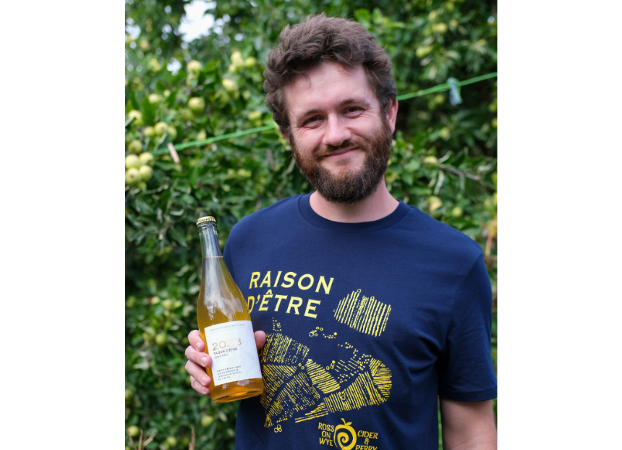

Albert Johnson, from Ross-on-Wye Cider and Perry Company, has won CAMRA’s 2026 Pomona Award. The Pomona Award honours people who have made an outstanding achievement, commitment, or contribution to the promotion of real cider or perry. Johnson (pictured) grows a significant collection of around 120 apple and 30 pear varieties. This means that he has introduced the largest range of single-variety ciders and perries in the UK. Between new plantings and maintaining established orchards of more than 35 acres, Johnson has made an outstanding contribution to preserving a vast number of diverse apple and pear varieties. His Oak Meadow Orchard project futureproofs the DNA of rare, heritage, commercial-use varieties, within the UK cider scene, on his family farm. Albert is taking the traditional drink to a higher level of quality, authenticity and provenance while inspiring future generations of orchardists, cidermakers and perrymakers. He shares his knowledge widely and has been instrumental in launching a number of initiatives to promote and provide education about these products. Johnson said: “I’m humbled and delighted to receive the Pomona Award. It’s an honour to have been nominated by peers and friends across the cider industry. In 2009, my father Mike Johnson was also recognised by the Pomona Award and it brings me great pride to know that 17 years later, the same values of hospitality, inclusivity and openness are what characterise my decisions and the work that everyone at Ross-on-Wye Cider and Perry does on a daily basis. The joy of working in cider is the co-operation and collaboration between cidermakers, retailers and advocates, of whom I am lucky to call many my great friends." Award coordinator Andrea Briers said: “His advocacy in the industry is not only inspirational but commendable, encouraging current and future orchardists, cidermakers and perrymakers to help safeguard our cider and perry heritage and helping to promote these products to a widespread audience. “His impressive work in collecting and futureproofing apple and pear varieties and the orchards that grow them plus sharing his knowledge, is truly inspirational in protecting an entire industry of great drinks made by independent producers for consumers.”

