Brewery founders ‘betrayed’
01/10/2026 by Timothy Hampson
Campaign

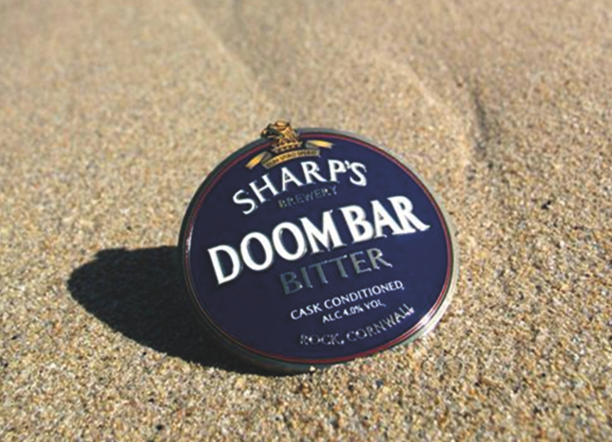

CAMRA is demanding new consumer laws following the closure of Sharp’s brewery in Rock, Cornwall and moving its cask production 417 miles away to Hartlepool. The Campaign is now seeking a legal “pasty-style” guarantee to prevent the beers being marketed as Cornish. Molson Coors announced plans to close the brewery in February this year, with no indication of where beer production would continue. At the time, CAMRA Cornwall raised fears that the brewing giant could follow in the footsteps of Carlsberg, which markets Wainwright as a Lake District Original despite brewing it more than 100 miles away in Wolverhampton. Cornwall CAMRA chairman Dave Pedlar said: “This is a betrayal of the founders of Sharp’s, the 40 people whose jobs are at risk and the locals that have supported this business for decades. “We’ve known for a while that the Sharp’s cask production was moving out of the Duchy, but Hartlepool is 417 miles away, which is as far from Rock as Brussels. We need ‘pasty-style’ consumer protection laws that stop Molson Coors from continuing to market these beers as Cornish.” Since Molson Coors announced its intention to close Sharp’s, CAMRA has launched a UK-wide campaign and the Beer in the UK report to raise awareness of the tactics of global brewers in the British market. The Campaign highlights misleading marketing and how independent brewers struggle to get their beers onto bars. CAMRA chief executive Tom Stainer said: “It’s entirely ridiculous that a beer named after a sandbank in the Camel Estuary, and marketed as a ‘Cornish original’, is now going to be made in Hartlepool. Once again, global brewers are closing breweries, trashing our reputation as a great brewing nation, and misleading ordinary drinkers. “This is why we’ve launched our campaign to expose Big Beer in the UK, its misleading marketing tactics and demand that the Competition and Markets Authority investigate how global corporations dominate the beer market. We need decisive action to deliver a fairer beer market for independent brewers and ordinary drinkers.”

