Latest Good Beer Guide released
24/09/2026 by WB Reporter
Campaign

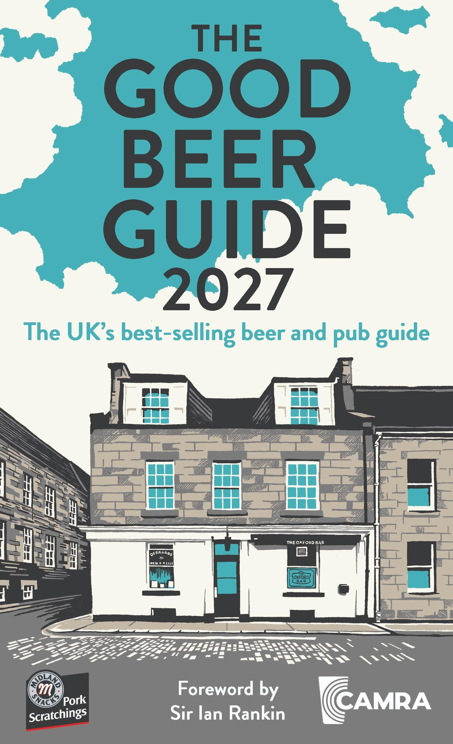

CAMRA has published the 2027 Good Beer Guide and renewed its calls for a formal competition investigation into the global brewers that dominate the UK beer market. The newcomer definitive guide to pubs that serve great cask beer across the UK​ and uses an independent, volunteer-led selection process that makes it the authoritative and trusted voice of real ale drinkers. The 2027 version features 4,500 pubs, 1,700 brewers and 5,000 beers. The foreword is written by Sir Ian Rankin. He, and his fictional detective John Rebus, both frequent the Oxford Bar, in Edinburgh, which features on the cover of this year’s guide. Data from the guide shows: 137 breweries have closed and only 57 have opened

there are 812 new entries. In a year where independent brewery closures have slowed, but not returned to growth, the guide remains the go-to source for finding choice and good quality in pubs. CAMRA chairman Ash Corbett-Collins said: “The Good Beer Guide is fiercely independent, just like the brewers making the best beer. It is the result of the time and effort of our volunteers across the UK to find the pubs serving the best cask beer. “This year, we released our flagship report, Beer in the UK, alongside our campaign to expose how Big Beer is dominating the UK market and how ordinary drinkers and independent brewers lose out as a result. Because of that, we need the Competition and Markets Authority to start a formal investigation of the UK on-trade beer market. If you agree with us, please join CAMRA, buy the guide and find amazing independently brewed beers for yourself.” In the foreword Sir Ian Rankin said: “What makes the perfect pub? Ask 50 people and you might get 50 different answers… My preferences might not be yours, but there are a few things we can probably agree on. We want the beer to be good and the welcome to be friendly. We want to see signs that the bar represents the best of its community or neighbourhood. We want to feel like we fit in.” Midland Snacks Traditional Pork Scratchings sponsors the new guide. It is also endorsed by Cask Marque. Buy the guide: shop1.camra.org.uk/product/the-good-beer-guide-2027 and book stores. It costs £16.99.

