Cost-cutting beer range launched
23/09/2026 by Timothy Hampson
Industry

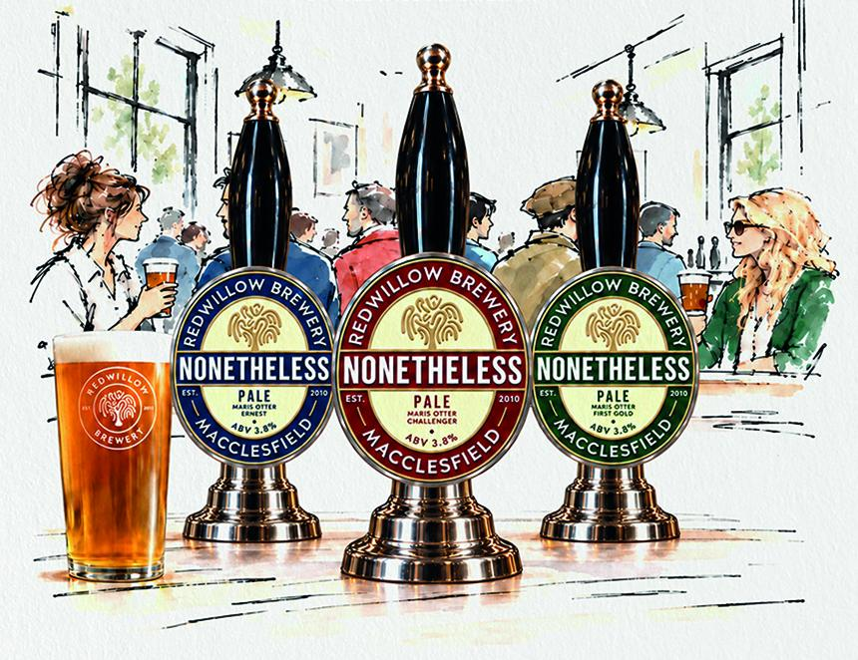

As pubs and bars continue to navigate rising costs, RedWillow brewery has announced Nonetheless, a new series of cask-only pale ales. Nonetheless has been designed to be the most competitively priced beer in the brewery’s range and the first orders go out this week in time for the Cask Ale Week promotion which runs until 27 September. RedWillow is releasing the Nonetheless series a beer at a time, once a month, with each one sharing the same base recipe. The range is built on the maltiness of Maris Otter, with a rotating single hop or pairing. Each release will celebrate the best of British and European hops, many of which aren't commonly used in modern craft beer. The series opens with a 3.8 per cent ABV Challenger Pale brewed with Maris Otter and Challenger hops. A modern take on a British classic, it delivers soft orange marmalade, gentle hedgerow fruit and subtle spice over a smooth malt base, finishing clean, balanced and effortlessly drinkable. This will be followed by Ernest Pale and First Gold Pale. The look of the range takes its cue from the past. The team found an old pump clip from a long-closed Macclesfield brewery, Stancliffe Brothers, and used its dense, text-heavy style as the starting point for the new artwork. The result is a deliberately old-school design that nods to the pump clips of decades past rather than the minimal, illustration-led look of most modern beers. Having run its own pubs in Macclesfield and Buxton for more than a decade, the RedWillow team knows first-hand how important value is at the bar and Nonetheless has been priced with that in mind.

