Where are all the women?
21/09/2026 by Dave Pickersgill
Campaign

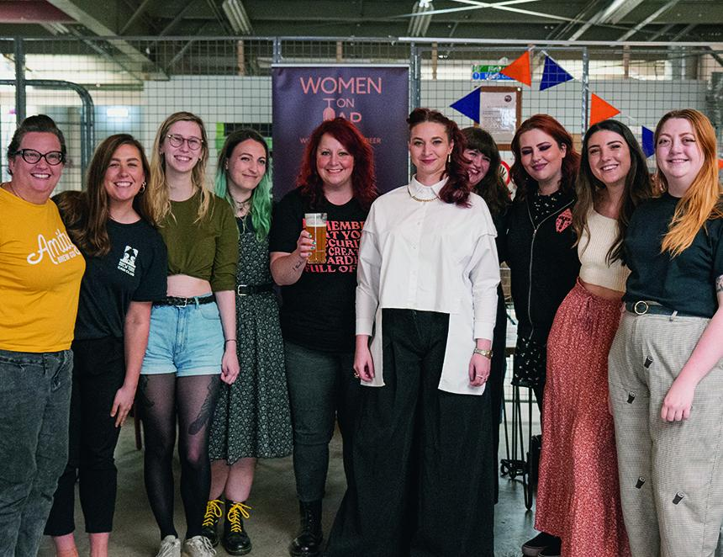

One of the highlights of Sheffield CAMRA’s Steel City Beer Festival 2026 (SCBF50) promises to be a tutored beer tasting and discussion by Women On Tap CIC founder Rachel Auty on Saturday 24 October. Women’s involvement with beer dates back millennia. Throughout the 9,000-year history of fermented drinks, archaeologists and historians have charted the role of women, both in the production and sale of beer. For example, in Medieval Britain, it was women that took charge of the production of beer, both for consumption within the home and for commercial sale. However, women remain significantly under-represented in beer – as makers, drinkers and buyers – and in some areas, the numbers are heading in the wrong direction. As Women On Tap CIC marks its 10th anniversary, founder Rachel Auty will unpack what's driving that gap – from the barriers women face working in the industry to why so many still don’t see beer as “for them”. She’ll share what Women On Tap CIC is doing to change that from bursaries breaking down financial barriers to entry, to events and initiatives designed to bring more women into beer, as drinkers, brewers and industry professionals. It’s a talk about why closing this gap matters not just for equity, but for the future health of an industry we all love. Full details and booking information is available on Tckty. Pictured Rachel Auty, centre (Image: Ryan Walsh)

