KPUBlic Affairs update – September
19/09/2026 by Tori Wood
Campaign

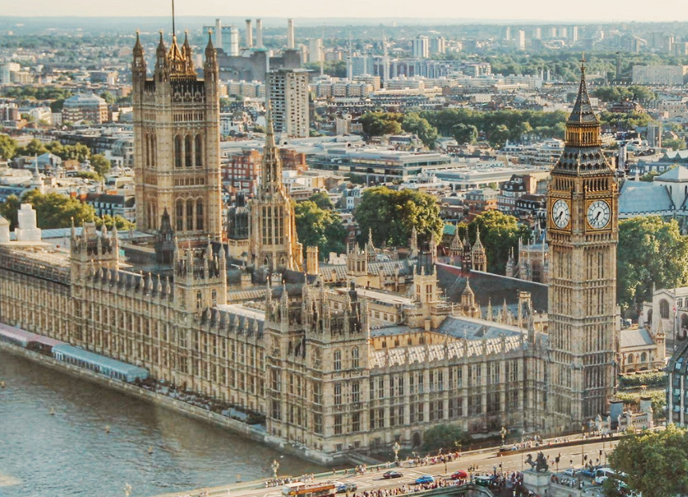

The regular series returns to What’s Brewing with the Campaigns and Communications team’s latest campaigning for pubs, pints and people across Westminster, devolved parliaments and local government. Westminster Budget 2026 CAMRA continues to campaign for pubs, pints and people ahead of chancellor (and CAMRA member) John Healey’s Budget on Wednesday 28 October. The team has made its official submission to the Treasury which includes calls for action on VAT, beer and cider duty, business rates, energy costs and Employer National Insurance contributions. You can find the full submission here. Planning [England only] After the government considered watering down planning protections for pubs in England, where only the last one in an area would be protected, stronger measures to preserve them were announced instead – a huge Campaign win. Changes to the National Planning Policy Framework (NPPF) include: a requirement for developers to give evidence that there is no reasonable prospect of keeping a pub business running, and evidence of proof it has been marketed for sale for at least 12 months before change of use permission will be granted

rules to stop owners from deliberately killing off trade in order to justify a closure and change of use. The government stated: “In relation to policy HC6, the provision in paragraph HC6(2) has been revised. The previous wording limiting the policy to cases where the facility would be the last of its type has been removed and replaced with a new subparagraph HC6(1)(c), which allows the policy to be disapplied where decision-makers are satisfied that there is adequate alternative provision in the area. This means that all of the key facilities named in the policy now fall within scope of the broad protection which it offers, while also allowing a pragmatic and proportionate approach to be taken where a loss would not diminish access to key community facilities and public service infrastructure. CAMRA believes the changes apply to all pubs as the policy states “decision-makers must be satisfied that the loss will not diminish access to key community facilities”. Permitted development rights and Assets of Community Value CAMRA submitted to the government’s consultation supporting proposals on removing permitted development rights to demolish a pub, social club or other building listed as an Asset of Community Value. Read CAMRA’s submission here. Business rates valuation [England and Wales] Last month, the government announced an independent review of how the Valulation Office Agency, now part of HMRC, will calculate business rates bills for pubs and hotels in England and Wales. It will look at whether current valuation approaches are appropriate and where improvements can be made to be implemented for the next three-year ratings period from 2029. Read CAMRA’s response to the announcement here. The review does cover business rates valuation in Wales, but the Welsh government will make final decisions on policies. It has committed to “improving support for businesses through reform of the non-domestic rates system” and said “the cabinet minister for finance will set out further details on our proposals in due course”. Plaid Cymru’s manifesto included a commitment to “reform business rates to level the playing field for businesses on our high streets, and redress the existing imbalance that advantages out-of town shopping over hospitality, leisure and retail in our town centres”. Scottish government and parliament Business rates On the back of the prime minister’s announcement that business rates bills for pubs in England will be discounted by 20 per cent, we wrote to deputy first minister Jenny Gilruth MSP asking for its commitment to match bills for pubs in Scotland. CAMRA is also waiting for the Scottish government’s response and recommendations to its independent review of business rates methodology for pubs. It has said it is committed to applying the review’s recommendations for 2029. Northern Ireland assembly and executive Business rates As in Scotland, CAMRA are asking NI’s Department for Finance for its commitment to match the UK prime minister’s pledge to discount rate bills for pubs. Its response stated that as it does not know how much money will be allocated by the UK government, no commitment was made.

