CAMRA Pub Heritage Group update – September
18/09/2026 by Tom Chapman
Campaign

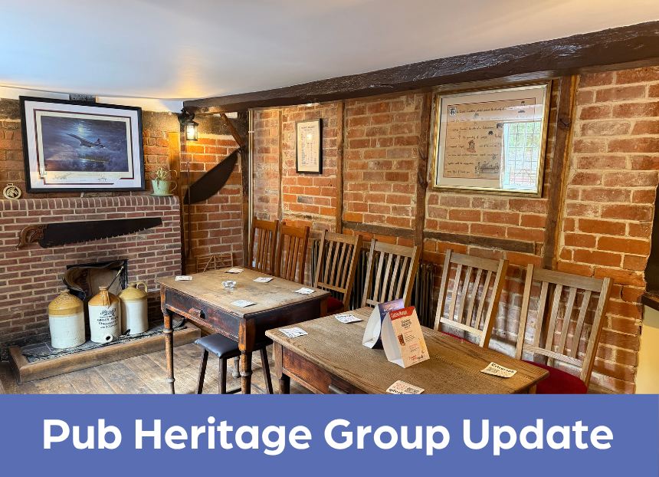

CAMRA’s Pub Heritage Group shares news and updates about pubs with historically significant interiors across the UK. For further news about the National Inventory of Historic Pub Interiors, see the Pub Heritage Group webpage. Heritage Pub Revival Award The Pub Heritage Group is delighted to announce the winners of the Heritage Pub Revival Award. The winner is the North Star, Steventon Oxfordshire and the runner up is the Beacon Hotel, Sedgley, West Midlands (both Three Star). The award recognises pubs or pub operators who have renewed the fortunes of a pub on CAMRA’s National Inventory of Historic Interiors, by preserving its heritage features, benefiting the business and having a positive impact on its local community. The winners have been announced to coincide with Heritage Open Days, a week of free events across the country, celebrating heritage and history between 11-20 September. Similar events will also be taking place across Scotland and Wales. Heritage Pub Revival Award coordinator Paul Ainswoth said: “Both these pubs have truly precious historic interiors. At the North Star it’s brilliant that the serious structural issues have been fully addressed but equally great to find it in the hands of management committed to making it a real community hub. The work at the Beacon is a text-book example of how to expand and improve customer facilities without any detriment to the historic core.” North Star, Steventon, Oxfordshire (top) Judges were hugely impressed with North Star licensee Kerry Tyrrell’s efforts and pride in the pub, which has been owned by her family for generations, describing the reopened pub as having “a new lease of life”. The pub was recently closed for nine months for extensive works to fix damp and preserve the Grade II-listed building, all carried out by local craftsman Michael Toplis. The results speak for themselves, with a refreshed building which retains its outstanding heritage value.
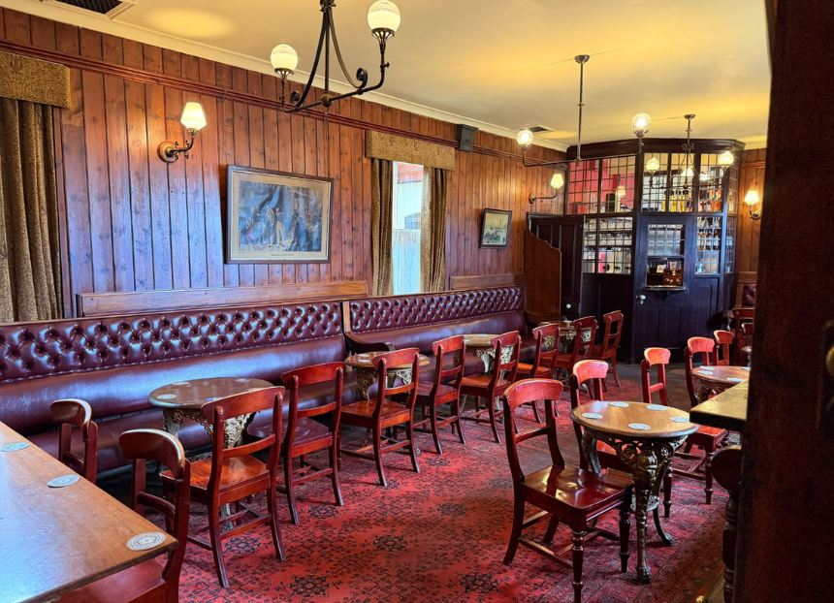
Beacon Hotel, Sedgley, West Midlands (above) Sarah Hughes brewery has been honoured as runner up for its work at the Beacon Hotel, Sedgley, its pub and brewery tap. Judges praised the high quality of work to convert a sitting room into an additional customer area and the sensitive replacement of the old conservatory. The changes provide improved additional space and seating for this bustling community local. Three Star Heritage Pubs
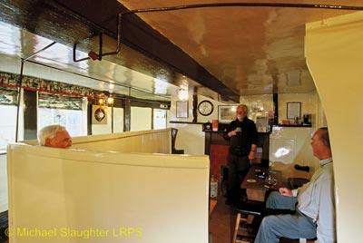
Star Inn, Netherton, Northumberland (above) Since the last update in the April bulletin, the group’s campaigning efforts have been stepped up, alongside CAMRA’s Tyneside & Northumberland branch, to help find a future for this national treasure. Recognising that its owner’s efforts to market the Star had not been reaching much beyond the local area, the Pub Heritage Group issued a press release of its own. It emphasised the potential of the pub’s spacious premises as well as the advantages to be gained from being a part of Northumberland’s booming visitor economy. Read the release here.
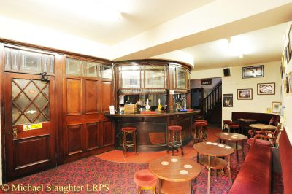
Royal Oak Hotel, Oldham, Greater Manchester (above) This Grade II-listed pub closed suddenly in late 2023 after being sold by Inglenook Inns. With no indication of the new owner’s intentions, an ACV was registered by a local community group. After three years, it has now been put on the market for £450,000. The owner has undertaken a basic refurbishment to the upper floors, but we understand the historic pub features, including the splendid semi-circular servery, remain intact. Find the listing on On The Market. However, as these are so downplayed it raises questions about the owner’s motives. It seems the community group that registered the ACV is no longer active, so we must now hope that a sympathetic buyer comes forward. Any further information welcome.
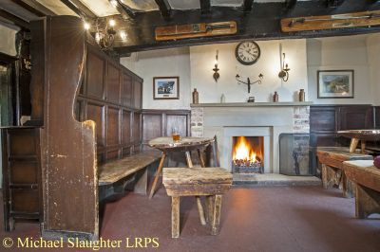
White Lion, Barthomley, Cheshire (above) The last update on the Grade II-listed, 16th-century White Lion, which has been closed for three years, was in the March bulletin when the owners, the trustees of Lord O’Neill’s estate, committed to undertaking restoration work with the intention of reopening it. However, East Cheshire Council has been given notice by the trustees that they are intending to sell. The pub was registered as an Asset of Community Value in 2023 so the council must now decide if the six-month moratorium is enacted to give a community group the opportunity to purchase. The pub requires significant conservation work and has been added to Historic England’s At Risk Register.
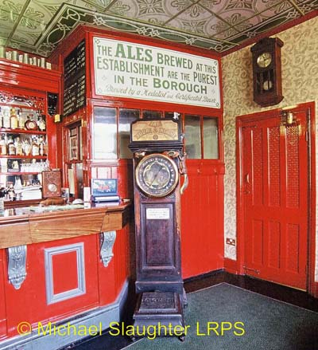
Old Swan, Netherton, West Midlands (above) Following a recent visit, this famous brewpub, one of only four such establishments still serving their own beer when CAMRA first formed in 1971, did not appear to be thriving. Confirming our last report from August 2025, when long-serving landlord Tim Newey was preparing to retire. The lease is now being formally advertised by Star Pubs & Bars with a £375,000 refurbishment planned. Two Star Heritage Pubs
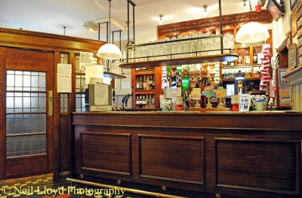
Roscoe Head, Liverpool, Merseyside (above) The award-winning Roscoe Head, one of only five pubs to feature in every edition of the Good Beer Guide, is up for sale. Licensee Carol Ross has decided to retire, having been there for 28 years. Her family have run the pub for 45 years with the freehold bought from pubco New River Retail in 2020, following a protracted battle over the tied lease. The pub is on the market through Licensed Trade Associates with a price of £885,000. Details of the sale can be found on RightBiz.
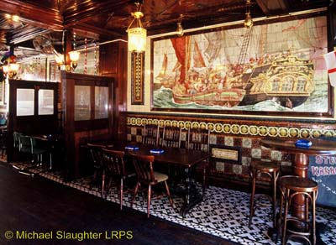
Havelock, Hastings, East Sussex (above) The Havelock is included on the inventory for probably the most spectacular pictorial tiling in England, which dates from a refit of the pub in 1890 – it features historic scenes including the Battle of Hastings. The pub is owned by Stonegate and the freehold is now on the market with an asking price of £450,000.
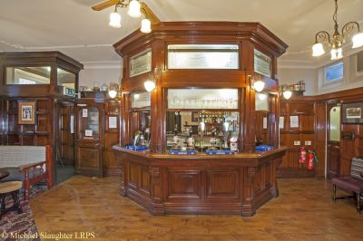
Mort Arms, Tyldesley, Greater Manchester (above) This corner pub owned by Joseph Holt brewery, which is included on the Inventory for the surviving inter-war refit, has reopened following a major refurbishment. The pub has been smartened up in a traditional style including new flooring and the addition of new panelling. There appear to have been some changes to the layout and fixtures that will need further assessment.
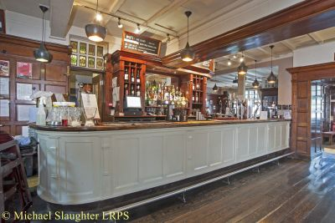
Park Tavern, Wandsworth, Greater London (above) Star Pubs and Bars seemingly heavy-handed dealings with the licensee of the Park Tavern have resulted in a campaign to save it supported by local councillors and MP Fleur Anderson, who have reported Star to the Pub Code adjudicator. Star had given notice to the licensee, after it had spent £150,000 on refurbishing the pub. Read more in the Putney News. One Star Heritage Pubs Cover Bridge Inn, East Witton, North Yorkshire This ancient riverside establishment, justly popular and delightfully located in mid-Wensleydale, has been added to the Inventory at One Star. Its two small main rooms and one a former private lounge, have matching counters that were installed in the 1960s. A major loss has been the removal of an imposing high-backed settle from the main bar, but the characterful interior has been considered sufficiently unaltered overall to be given the benefit of the doubt for One Star grading.
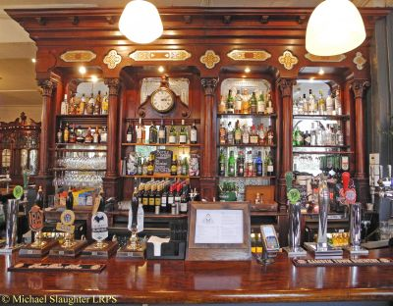
Masons Arms, Kensal Green, Greater London (above) The May bulletin covered the planning application to demolish the unlisted Masons Arms and redevelop it as a residential block with a modern bar at ground level. A listing application had been made by North London CAMRA to seek protection for the Victorian pub whose notable surviving features include the original bar counter and back-fitting. Sadly, the listing application has now been refused which is highly disappointing, particularly for the campaigners who are fighting the demolition plans.
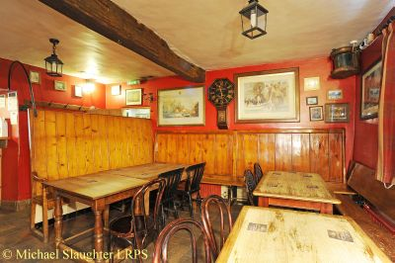
Lord Nelson, Burnham Thorpe, Norfolk (above) This pub, in the village where Admiral Nelson was born and reputedly frequented by, has closed after brewer Woodforde's relinquished the lease. Owner, the Holkham Estate, which purchased the pub from Greene King in 2019 and reopened it in 2021 after major remodelling, is now looking for new tenants. Despite the refurbishment, the main bar still retains much of its age-old atmosphere.
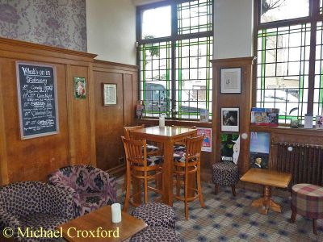
Magdala, Hampstead, Greater London (above) The retrospective planning application to convert the first-floor function room to residential has been rejected by Camden Council, which is now preparing to take enforcement action against the owner (who had also achieved national notoriety as the owner of the Carlton Tavern when it was demolished illegally in 2015). The unlawful conversion of the function room resulted in strong opposition from the community, which has registered the pub as an Asset of Community Value. Read more in London Now.
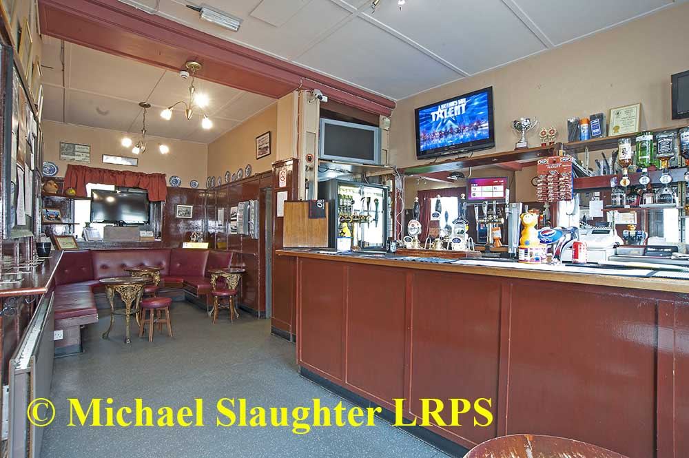
Albert Hotel, Douglas, Isle of Man (above) The Victorian two-room pub which was refitted in the 1960s, in a basic style typical of the period with painted ply panelling throughout, is up for sale with price on application. Find details on Cowley Groves. Hare & Hounds, Barlow, Derbyshire This multi-room pub, which was modified and refitted in the 1950s, had been closed since 2020, so its reopening in August sounded like good news. However, a major refurbishment has taken place that has removed all the historic features and consequently has been removed from the Inventory. Wynnstay Arms, Llanrhaeadr, Mid Wales This Mid-Wales pub has been put on the market for £250,000. The public bar, which had a fine 1950s bar counter with sliding screens, has been completely remodelled. Sadly this has been removed from the Inventory. If you have any news on heritage pubs, send to: info@pubheritage.camra.org.uk Feel free to forward this bulletin to friends interested in visiting pubs like these. If you wish to receive the bulletins directly, send an email to bulletin@pubheritage.camra.org.uk with the word “subscribe” as the subject or “unsubscribe” if you wish to stop receiving bulletins.

