Heritage pub heroes celebrated
15/09/2026 by WB Reporter
Pub

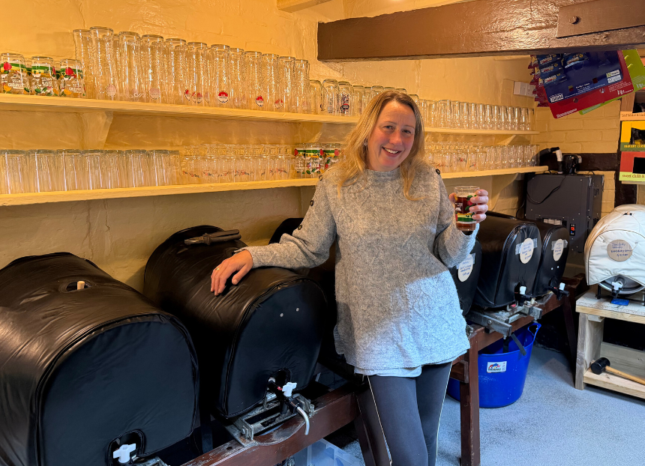

Just in time for Heritage Open Days CAMRA has honoured two publicans for their significant efforts in reviving important heritage pubs. Kerry Tyrrell, licensee of the North Star, Steventon in Oxfordshire (above) scooped the top prize and said: “We are very pleased indeed to have won this very special award and thank everyone who nominated the North Star. It will take a special place on the mantlepiece at the centre of the settle.” Judges were hugely impressed with Kerry’s efforts and pride in the pub, which has been owned by her family for generations, describing the reopened local as having “a new lease of life”. The pub was recently closed for nine months to undergo extensive works to fix damp and preserve the building, all carried out by local craftsman Michael Toplis. The results speak for themselves, with a refreshed building which retains its outstanding heritage value, a new programme of events and a buzzing atmosphere. The North Star building dates back to the late 15th century with little known about its history before it became a public house. It was previously run by Wantage Brewing Co then Morland brewery of Abingdon. It has been a freehouse since 1998 and Kerry’s family has owned the pub for around 200 years. Sarah Hughes brewery has been honoured as runner up for its work at the Beacon Hotel, Sedgley, its pub and brewery tap in the West Midlands. Judges praised the high quality of the work to convert a sitting room into an additional customer area and a sensitive replacement for the old conservatory. The changes created badly needed additional seating. Owner Simon Massey said: “This award is an incredible recognition of all the hard work that goes into keeping the Beacon Hotel in its current condition. Thanks to all the staff for their hard work and the craftmanship of the builders for making this possible.” Both the North Star and Beacon Hotel are Grade II-listed buildings and both appear on CAMRA’s National Inventory for interiors of national heritage importance. The Heritage Pub Revival Award recognises pubs or operators which have renewed the fortunes of an entry on CAMRA’s National Inventory of Historic Interiors, by preserving its heritage features, benefiting the business and having a positive impact on its local community. The winner has been announced to coincide with Heritage Open Days, a week of free events across the country, celebrating heritage and history between 11-20 September. Similar events will also be taking place across Scotland and Wales. Heritage Pub Revival Award coordinator Paul Ainsworth said: “Both these pubs have truly precious historic interiors. At the North Star, it’s brilliant that the serious structural issues have been fully addressed, but equally great to find it in the hands of management committed to making it a real community hub. The work at the Beacon is a text-book example of how to expand and improve customer facilities without any detriment to the historic core.” Heritage Open Days is England’s largest community led festival of history and culture involving thousands of volunteers and organisations. Every year in September it brings people together to celebrate their heritage, community and history. More information here.

