Double drop commitment to cask
12/09/2026 by Timothy Hampson
Industry

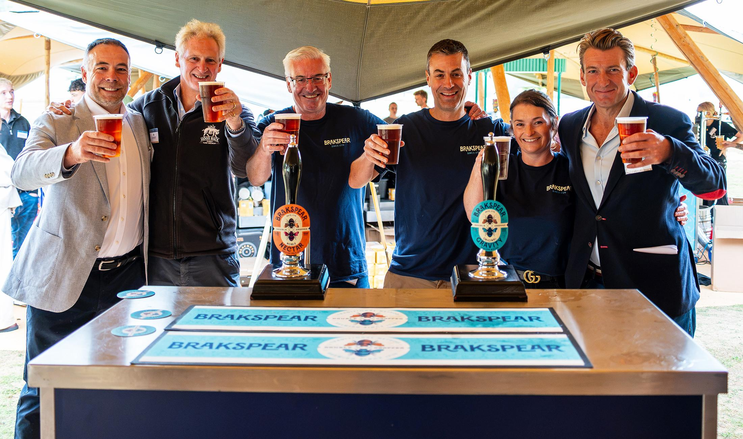

Brakspear cask beers, including the flagship Original Gravity bitter, are now being brewed at Hogs Back in Tongham, Surrey triggering a significant investment in installing traditional double-drop brewing at the brewery. The new partnership between pub operator Brakspear and Hogs Back represents a major commitment to the future of cask beer. Once widely used in British brewing, double dropping involves transferring the beer 12 hours into the fermentation process from one vessel to another and Hogs Back will be using gravity rather than mechanical means. This helps to remove sediment and oxygenates the beer to get a clean, vigorous fermentation. While it is more labour-intensive, the method is valued for the intensity of character it brings to the beer. Brakspear chief executive Tom Davies said: “Cask ale, served consistently and to the highest quality, is at the heart of all our pubs, from town-centre locals to destination food businesses. “The team at Hogs Back shares our passion for cask and this partnership, along with the return of the double-drop brewing method, will give our pub teams and customers confidence that our cask ales are brewed, cellared and served in premium condition. “The scale of the investment demonstrates our commitment to restoring the standing of cask ale as Britain’s signature beer style, while building on the strong reputation of Brakspear and giving customers the opportunity to enjoy our flagship beer brewed in a way that is even closer to its historic roots.” Original Gravity is a sessionable 3.4 per cent ABV cask bitter. Originally known as Brakspear Bitter and more recently Brakspear Gravity, it has a distinctive malt character with a bitter-sweet, fruity finish and a well-hopped aroma. The new Original Gravity name signals that it is brewed to the classic Brakspear Bitter recipe, as well as being a nod to brewers’ traditional use of original gravities to measure the strength of beers before ABVs became standard. Original Gravity is made with a combination of pale, crystal, and chocolate malts; special invert sugars and is hopped with Fuggles and Goldings. It is the same classic session cask bitter, brewed with premium ingredients, as always. Launching alongside Original Gravity is Noble Nectar, a 4 per cent ABV modern, hop-forward pale ale which complements the traditional style of the flagship bitter. Noble Nectar is brewed using Farnham White Bine hops, which are grown on the Hogs Back farm adjacent the brewery. The beers are also brewed using the original Brakspear live yeast strain. The move to Tongham represents the second time Hogs Back owner Rupert Thompson has taken on the stewardship of Brakspear’s beer and brewing style. In 2004, following the closure of the Brakspear brewery, Thompson’s Wychwood invested £300,000 in moving six double-drop fermenters to its site in Oxfordshire. Since the closure of the Wychwood in 2023, Brakspear beers have been brewed in Burton on Trent by Carlsberg Britvic. Thompson said: “My experience of brewing Brakspear cask ales is obviously very important, but what’s essential here is that Brakspear and Hogs Back share the same values, in terms of respecting the traditions of British beer and pub culture, while looking to drive our businesses forward in a fast-changing market. “We’re now brewing for Brakspear using the double-drop method for the same reason we revived the near-extinct Farnham White Bine hop a decade ago, because these initiatives deliver high quality, great flavours, and offer a real point of difference for today’s discerning beer drinkers. “Original Gravity has always been a 3.4 per cent session bitter, unlike beers which have been reduced in strength for marketing or commercial reasons. It’s an accessible beer that fully delivers on flavour.” Pictured at the partnership launch, from left, Brakspear chief operating officer David Nathan, Rupert Thompson, Hogs Back marketing consultant Chris Keating, Hogs Back MD Miles Chesterman, Hogs Back head of sales Gina Fletcher and Tom Davies

