New guide to Island delights
10/09/2026 by Dave Pickersgill
Pub

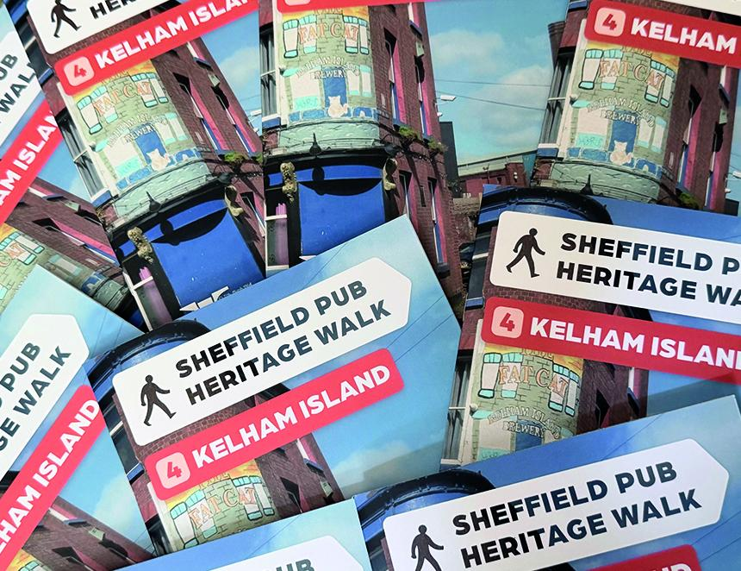

The fourth booklet in the Sheffield pub heritage walk series is now available. Sponsored by Abbeydale brewery and Kelham Island Brew Co, it concentrates on Kelham Island with images, maps, pub details plus information on the area and its history. The release comes before the formal launch the Sheffield Steel City Beer Festival (21-24 October). The full-colour, A5 booklet is slightly larger than its predecessors at 34 pages. It costs £2.99 and has a 1,000-copy print-run. It is currently available from local stockists, including: Abbeydale brewery, Barrel and Anvil, Biblioteka, Draughtsman (Doncaster Railway Station), Famous Sheffield Shop, Hop Hideout, Kelham Island Books and Records, National Emergency Services Museum, Rhyme and Reason and St Mars of the Desert Taproom. The first two booklets are sold out and there is a dwindling number of the 2025 Neepsend booklet. The pub heritage walk series will continue with Riverside in 2027. For copies and more information contact: pubheritage@sheffield.camra.org.uk

