Younger drinkers lead charge for cask brands
08/09/2026 by John Porter
Industry

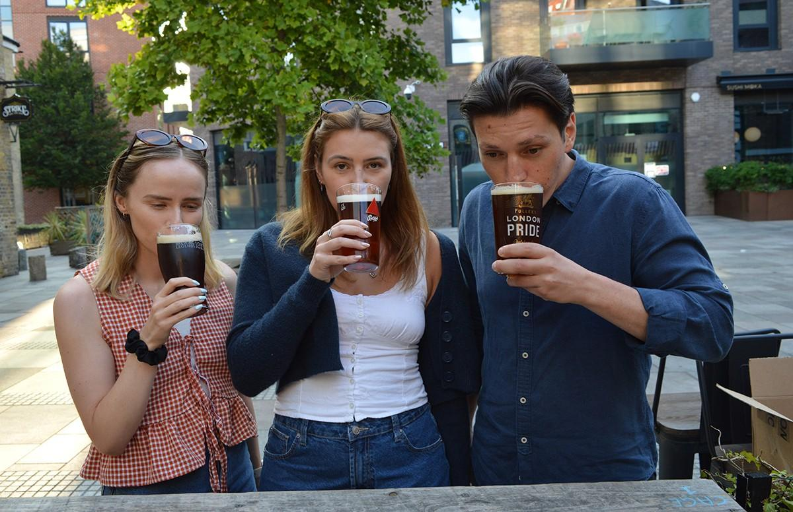

Younger beer drinkers are increasingly ordering the cask beers they remember their parents and grandparents drinking at the pub. Gen Z and younger millennials, broadly those aged 18-35, are as likely to enjoy a pint of Old Peculier as they are a trendy craft beer. New research ahead of this year’s Cask Ale Week (17-27 September) shows the fastest-growing cask beers are all those that have been on the bar for decades – if not centuries. The fastest is veteran Bass. The Bass red triangle was Britain’s first registered trademark and the beer was first brewed in Britain’s beer capital, Burton on Trent, almost 250 years ago in 1777. Bass owner, Budweiser Brewing Group (BBG), has worked with hospitality industry insight company The Oxford Partnership to track the changing age demographics of Bass drinkers. Brand manager Warren White said: “Bass has always been a cask beer with broad appeal to beer drinkers. What this research shows is that since 2024/25 the age mix in pubs serving Bass has changed, with more under 35s, and particularly more in the 18-24 and 25-29 age groups, drinking in Bass pubs.” Completing the fastest-growing cask beer brands by value after Bass are Timothy Taylor Landlord, Wadworth 6X, St Austell Tribute and Theakstons XB. Wadworth’s Adam Russell said: “There’s definitely a trend among younger drinkers to look for cask beers with provenance and heritage. They know Wadworth 6X as a brand their dad, or maybe even their grandad, drank and they want to revive and continue that family tradition.” Cask beer drinker Beth Dean, 34, of Parkstone, Dorset said: “We have a great taproom near us, the Barking Cat Ale House, which regularly wins CAMRA awards. “My dad has been a cask beer drinker for as long as I can remember and it’s great to see his favourite beers still on the bar, and to carry on the family tradition with a pint. “During the long hot summer we’ve had, I’ve preferred pale ales and cooler-served beers, but hopefully there’ll be a few interesting darker beers on the bar by the time Cask Ale Week comes around.” Phillip Montgomery, business unit director at CGA by NIQ, which measures drinks sales in pubs, said: “For the past five years, really since the end of the Covid lockdown, cask beer has felt a bit like a beer style that was being left behind, especially by younger drinkers. “However, in the same way that stout has seen a revival in fortunes, we’re also starting to see an upturn in interest in cask beer among younger drinkers and it’s often traditional brands and well-established regional favourites that bring them into the cask category.” The figures also show that cask beer retains a strong regional following, with Timothy Taylor Landord the top seller in Scotland and the North, Greene King IPA in East Anglia, and Fuller’s London Pride in London and the South East. More than 10,000 pubs will be taking part in Cask Ale Week, with many offering free tasters to encourage more Gen Zs and Millennials to try cask beer. Other activities include beer festivals, local ale trails, pub quizzes and special limited edition beers. For details see caskaleweek.co.uk

