Free CAMRA festival tickets for out-of-pocket punters
07/09/2026 by WB Reporter
Campaign

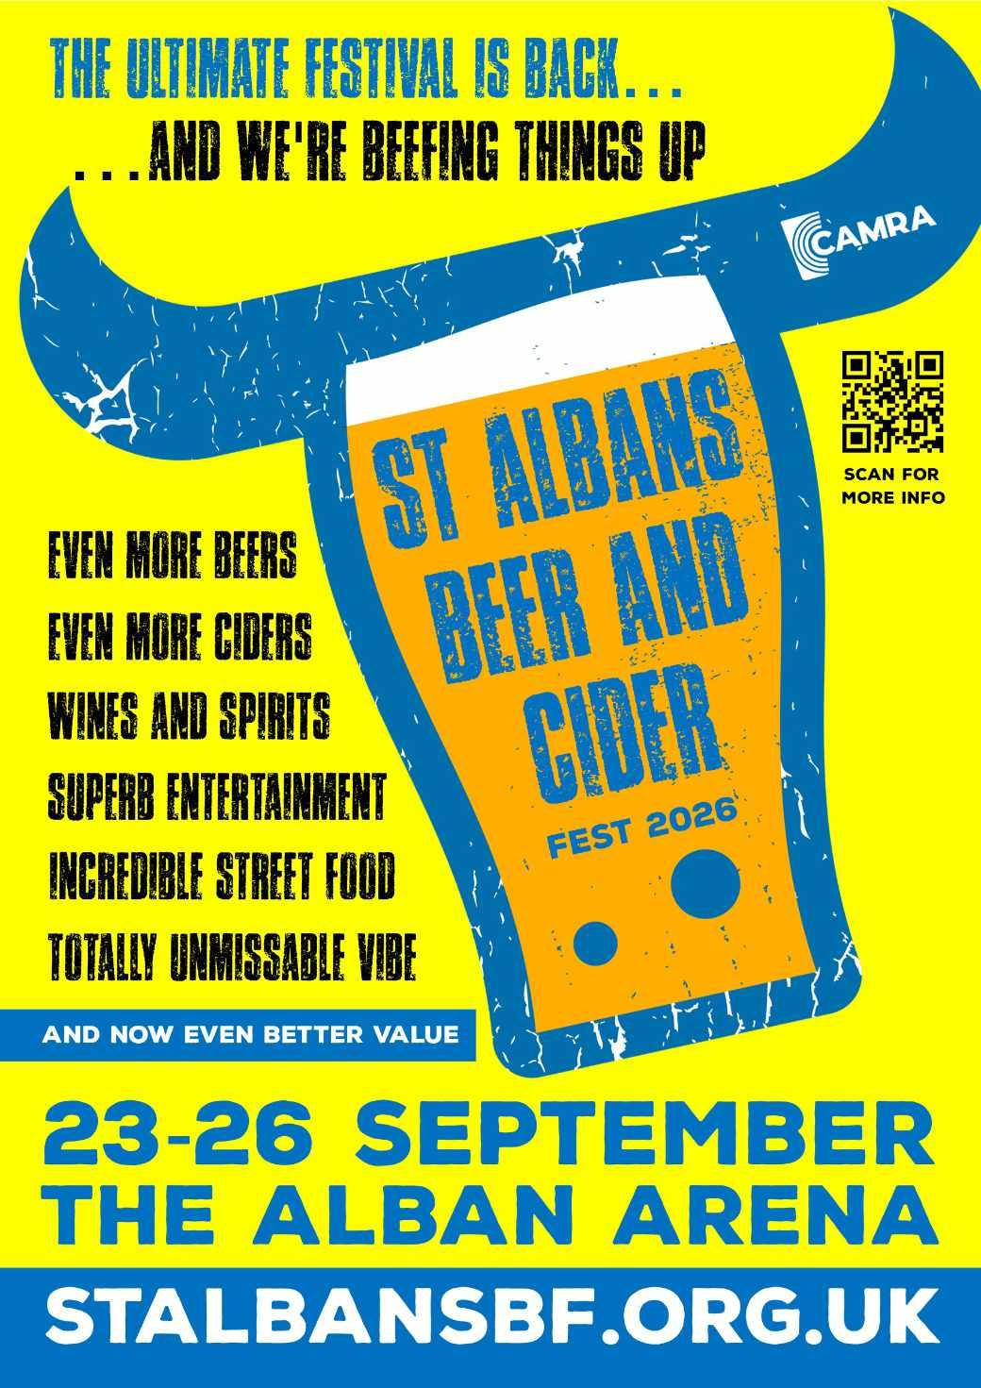

Hundreds of people who lost money following the cancellation of a Sound Bites food-and-music event are being offered free entry to CAMRA’s St Albans Beer and Cider Festival. The festival, which returns to the Alban Arena 23-26 September, is making the offer to ticketholders who have not received a refund. Sound Bites, a new food-and-music gathering billed as a replacement for the city’s popular Pub in the Park, had been due to take place the same month, but was canned at short notice following similar cancellations elsewhere. Its ticketing platform has said responsibility for refunds lies with the Sound Bites organisers leaving many customers still waiting for their money back with only days to go until the event was due to take place. The beer festival, which is organised by CAMRA volunteers and reinvests its proceeds into local charities and campaigning, wants to make sure disappointed ticket holders don’t miss out on a great day or evening out in the city this September. Organiser John Tubridy said: “We know how frustrating and upsetting it is to book tickets for something you’re looking forward to only to be let down and left chasing a refund. “We can’t get anyone’s money back from Sound Bites, but we can offer something in its place – a warm welcome, a great atmosphere and a proper St Albans day or evening out. “While our vast range of drinks is key to what we do, our event is so much more than just a traditional beer festival these days. Alongside 300-plus cask beers, craft beers, lagers, ciders and perries, we’ve also got incredible street food, excellent live bands, interactive games, and more, with something for everyone. “As well as beer and cider, our drinks options also include wines, spirits, cocktails, soft drinks and zero-alcohol choices.” “We’re a smaller event than Sound Bites was meant to be, but bigger isn’t always better! Now in our 29th year, we can be relied on to deliver the kind of event St Albans deserves.” To claim free admission to St Albans Beer and Cider Festival email proof of purchase of your Sound Bites tickets to publicity@stalbansbf.org.uk confirming which day of the week you would like to attend. The festival will then issue admission-only tickets for that day. Souvenir glasses and drinks tokens can be purchased on arrival. Due to licensing restrictions, children are only permitted at the festival until 5pm each day. Dogs (with the exception of guide/assistance dogs) are only permitted in the foyer and outdoor areas. Full terms and conditions at stalbansbf.org.uk/soundbites For more festival information go to: stalbansbf.org.uk

