Who will be our next champion brewer?
05/09/2026 by Tori Wood
Campaign

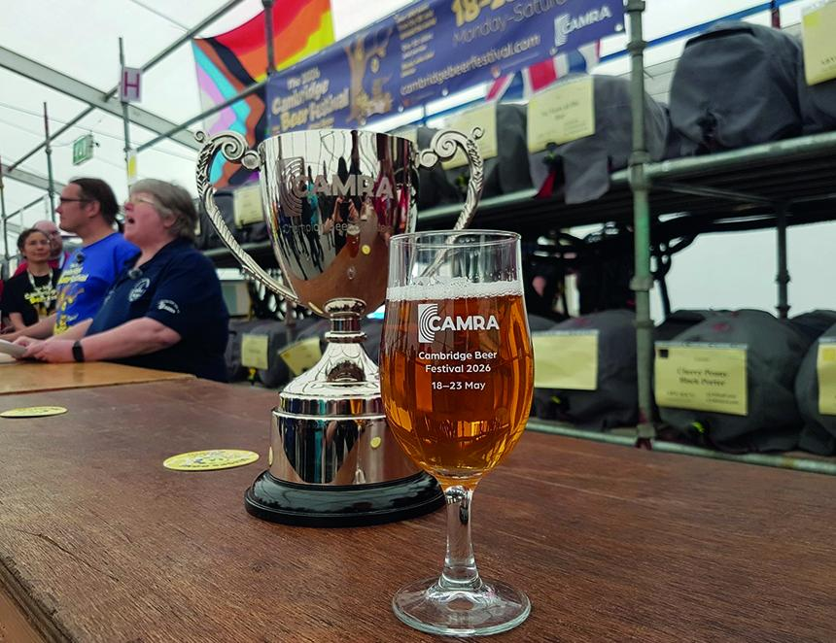

Nominations are now open for the Champion Beer of Britain 2028 CAMRA competition and members are invited to have their say, bu choosing their champions. Local heats in nine areas will take place across the country throughout 2027 before the final judging and announcement in 2028. All beer judging adheres to CAMRA standards, including, a strict blind-tasting process. This year at the Cambridge Beer Festival (pictured), Bristol Beer Factory’s premium pale ale Independence (4.6 per cent ABV) was crowned overall winner, with Highlands brewery Cairngorm’s premium bitter Wildcat (5.1 per cent) claiming Silver and Driftwood Spars’ Cornish strong ale Alfie’s Revenge (6.5 per cent) securing Bronze. Winning the title is the ultimate honour for UK brewers and has helped many gain both national and international attention. Members can nominate up to five beers across each category using the voting portal. Nominations are open until 31 October here: cbob.camra.org.uk The competition beer style categories are: Milds: up to and including 4 per cent

Session Bitters: up to and including 4.3 per cent

Premium Bitters: 4.4-6.4 per cent

Session Pale, Blond and Golden Ales: up to and including 4.3 per cent

Premium Pale, Blond and Golden Ales: 4.4-6.4 per cent

British & New World IPAs: 5.5 per cent and above

Brown and Red Ales, Old Ales and Strong Milds: up to 6.4 per cent

Session Stouts and Porters: up to and including 4.9 per cent

Strong Stouts and Porters including Imperial Stouts and Baltic Porters: 5 per cent and above

Barley Wines and Strong Ales: 6.5 per cent and above

Speciality Beers – differently produced

Speciality Beers – differently flavoured. There is also a competition for the Champion Bottled and Canned Beer of Britain with two categories – 4.3 per cent or below and 4.4 per cent ABV or above. Members can join CAMRA tasting panels or train as a beer judge to take part in area heats and national finals, a unique opportunity to try some of the best beers across the UK and help crown our 2028 winners. If you are not a member, join the Campaign today to nominate your favourite beer while enjoying the benefits a CAMRA membership offers too, including grassroots campaigning and getting involved in national campaigns for pubs, pints and people. Join here: camra.org.uk/join

