CAMRA festival update - September
03/09/2026 by Harri Knight-Davis
Campaign

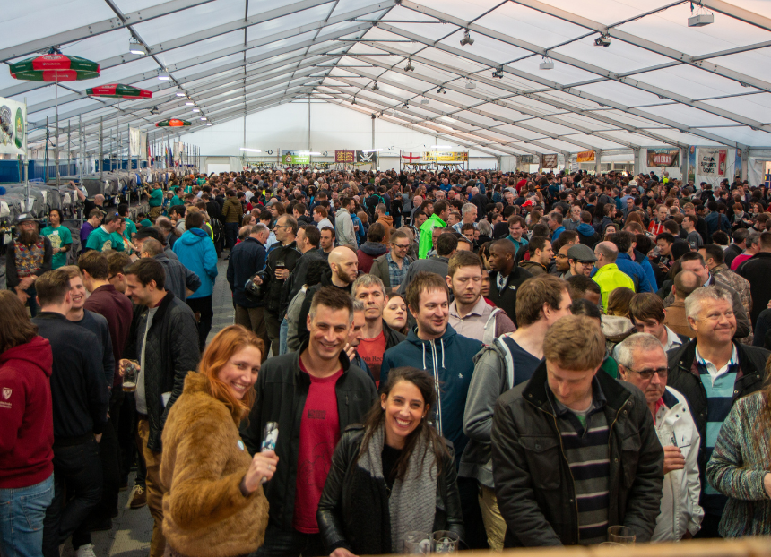

Summer may be over but CAMRA’s festivals are not so make sure you make the most of them by checking out the list below. Members can enjoy free entry to many CAMRA festivals (not including souvenir glass and programme) when booking tickets in advance. For more information and to see all upcoming CAMRA festivals visit the events webpage. Durham Beer Festival, 3-6 September Durham City Rugby Football Club, Hollow Drift, Green Lane, Racecourse, Durham, DH1 3JU Barnsley St Peter’s Beer Festival, 3-5 September St Peter’s Church, Brinkman Street, Barnsley, S70 1JQ Harbury Beer and Cider Festival, 4-5 September Harbury Village Hall, South Parade, Leamington Spa, CV33 9JE Crewe Rail Ale Festival, 4-6 September Crewe Heritage Centre, Vernon Way, Crewe, CW1 2DB Basingstoke Beer Festival, 4-6 September Basingstoke Sports and Social Club, Fairfields Road, Basingstoke, RG21 3DR East Malling Beer and Cider Festival, 5 September East Malling Research Centre, New Road, East Malling, ME19 6BJ CAMRA Bar at Faversham Hop Festival, 5-6 September East Street, Faversham, ME13 8AF Tamworth Beer Festival, 10-12 September Tamworth Assembly Rooms, Corporation Street, Tamworth, B79 7DN Moreton Beer and Cider Festival, 11-12 September Moreton in Marsh Cricket Club, Batsford Road, Moreton in Marsh, GL56 9QA York Beer and Cider Festival, 16-19 September St Lawrence Parish Church, Lawrence Street, York, YO10 3WP Shrewsbury Beer and Cider Festival, 23-26 September The Church of St Mary the Virgin, St Mary’s Street, Shrewsbury, SY1 1DX St Albans Beer and Cider Festival, 23-26 September The Alban Arena, St Peter’s Street, St Albans, AL1 3LD Calderdale Beer and Cider Festival, 24-26 September Arden Road Social Club, Arden Road, Halifax, HX1 3AG Ayrshire Beer and Cider Festival, 1-3 October Troon Concert Hall, South Beach, Troon, KA10 6EF Carmarthenshire CAMRA Beer and Cider Festival, 1-3 October St Peter’s Civic Hall, 1 Nott Square, Carmarthen, SA31 1BA Nottingham Robin Hood Beer and Cider Festival, 7-10 October Trent Bridge Cricket Ground, Bridgford Road, West Bridgford, NG2 6AG Bedford Beer & Cider Festival, 7-10 October Bedford Corn Exchange, St Paul's Square, MK40 1SL Derby Heritage Beer Festival, 14-17 October Derby Market Hall, Market Hall, Derby, DE1 2DB Weymouth Octoberfest, 16-17 October The Weymouth Pavilion, The Esplanade, Weymouth, DT4 8ED Steel City Beer and Cider Festival, 21-24 October Kelham Island Museum, Alma Street, Sheffield, S3 8RY Redhill Beer Festival, 29-31 October Merstham Village Hall, Station Road North, Merstham, RH1 3ED Carlisle Beer and Cider Festival, 29-31 October Station Hotel, Court Square, Carlisle, CA1 1QY Belfast Beer and Cider Festival, 5-7 November Banana Block, PortView Trade Centre, Belfast, BT4 1HE Alloa Real Ale and Cider Festival, 6-7 November Alloa Town Hall, Marshill, Alloa, FK10 1AB Kidderminster Beer and Cider Festival, 12-14 November Kidderminster Harriers Sports & Social Club, Stadium Close, Kidderminster, DY10 1NB Newark Winter Beer and Cider Festival, 20-21 November Newark Town Hall, Market Place, Newark-on-Trent, NG24 1DU

