Steel City fest teams up with local legend
02/09/2026 by Dave Pickersgill
Campaign

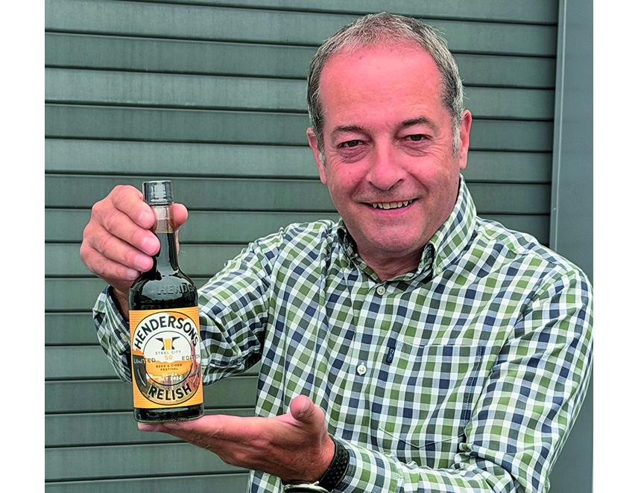

The CAMRA Sheffield Steel City Beer & Cider Festival 2026 has teamed up with Henderson’s Relish for a limited-edition run of event bottles. Only 500 have been produced with more than 300 sold before delivery. Local stockists include Craft & Berry (Ecclesall Road), Hop Hideout (Leah’s Yard) and Pangolin Craft Beer (Hillsborough). Several pubs including the Bankers Draft and the True North chain will be supplying the limited-edition to dining customers. In 1885, 35 year-old Henry Henderson blended the first batch. By 1951, sales exceeded a million bottles per year – enough relish for every Sheffield resident to enjoy. Hendersons continues to be blended to a secret vegan recipe with only directors Pamela Freeman and her two children knowing the recipe. The 50th Sheffield & District CAMRA Beer Festival takes place at Kelham Island Industrial Museum from 21-24 October. Above, organising committee chair Paul Crofts with the first of the 500 bottles (photo: Dave Pickersgill)

