Brewery celebrates 30th birthday
01/09/2026 by Dave Pickersgill
Industry

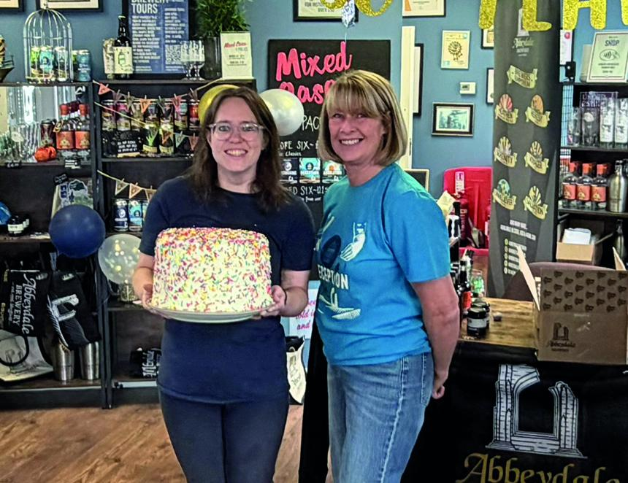

The UK’s first 100 per cent, employee-owned brewery celebrated its 30th anniversary with an open day and a Black Mass-inspired birthday cake. Abbeydale brewery is the oldest in Sheffield as its first cask beer Absolution (5.3 per cent ABV) went into the Three Stags Heads at Wardlow Mires in 1996. In 2025 it was the only brewery to make the finals of the BBC Food & Farming Awards. It is also the current SIBA Employer of the Year. Above, from left, Abbeydale marketing manager Laura Rangeley, with the special cake, and company secretary Dawn Milton (photo Dave Pickersgill)

