Rescued Lion still roaring
30/08/2026 by WB Reporter
Campaign

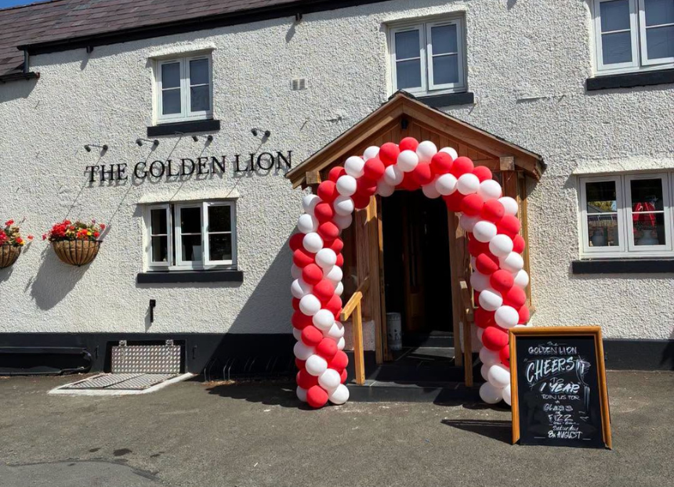

With nominations for this year’s Pub Saving Award now open, What’s Brewing is discovering what success meant for the 2025 winners. The Ashton Hayes Community Hub and its Golden Lion in Chester (above) was runner up, so what has the past 12 months brought the project? The only pub in Ashton Hayes village was at risk of being turned into housing when the previous owner of the 300-year-old building closed it in early 2013 and neglected the pub for 12 years. The local community applied for the pub to be registered as an Asset of Community Value (ACV) and spent more than a decade campaigning to save it. It raised enough money, including share offers from as far as Australia, to purchase the Golden Lion in June 2024. The next year was spent undertaking a mammoth renovation of the pub including solar-panel installation and uncovering a hidden cellar. The Golden Lion finally reopened 7 August 2025. Ashton Hayes Community Hub chair Hugo Deynem said: “Being recognised by CAMRA was a tremendous honour and a proud moment for everyone who helped save the Golden Lion. The pub had stood closed and silent for 12 years, and at times its future looked bleak. To see it restored, reopened and nationally recognised is a powerful reminder of what a determined community can achieve. “The Golden Lion has been part of Ashton Hayes for more than 300 years. Once a farmhouse, it became the last surviving pub of the village’s three original inns and is fondly remembered as an award-winning pub in the 1990s. When it closed in 2013 and faced the threat of demolition, residents were determined that such an important part of the village’s history should not be lost. “In 2016, a group of local people formed the Golden Lion Working Group and began developing an ambitious plan to bring the pub into community ownership. Ashton Hayes Community Hub was established as a Community Benefit Society the following year, ensuring that the Golden Lion would be owned by, and run for, the community. After years of fundraising, planning and perseverance, we purchased the building with the support of community shareholders and £360,000 from the Community Ownership Fund. “The restoration was an extraordinary collective effort. Local volunteers gave countless hours of their time, while tradespeople and other professionals were inspired by the project and, in some cases, worked at reduced rates to help us bring the building back to life. The work revived original features, sensitively modernised the interior and introduced sustainable technology, including solar panels in the car park, reflecting Ashton Hayes’ long-standing ambition to become a carbon-neutral community. “One of the most rewarding outcomes has been the friendships formed during the restoration. Volunteers with different trade skills came together as a team, many of whom had not known one another before. They remain ready to help with other projects around the village, so the benefits of saving the pub are already being felt far beyond the Golden Lion itself. “In April 2025, experienced Cheshire publican Lance Warburton was appointed as our tenant, bringing more than 35 years of experience to the Golden Lion while sharing our commitment to keeping it at the centre of village life. The pub officially reopened on 27 August 2025, when more than 100 guests joined us for the launch and the Sheriff of Chester, Simon Eardley, cut the ribbon. ITV News Granada Reports covered the event live, and more than 350 meals were served during the opening weekend.” The Golden Lion has continued to go from strength to strength since winning the award, celebrating the first anniversary of the pub reopening its doors earlier this month, marking the milestone with a special community event and gathering. Hugo added: “Since then [winning the award], the Golden Lion has quickly re-established itself as a welcoming and inclusive community hub. It hosts school activities, PTA fundraisers, Women’s Institute meetings, parish council gatherings, charity quizzes and live music, while also welcoming local clubs, sports teams and community groups. The monthly quiz regularly attracts more than 100 people and raises money for local charities, including the Samaritans and North West Air Ambulance. “At the same time, we have never forgotten that excellent beer and high-quality, home-cooked food are the foundations of a successful pub. As a free house, the Golden Lion can showcase cask beers from local and regional breweries, including Weetwood, MBH Beers and Salopian. Its food is prepared using locally sourced ingredients wherever possible, with traditional favourites, seasonal specials and the flexibility to create menus tailored to community celebrations and special occasions. "That focus on quality has been recognised by the pub's success since reopening. Less than a year after welcoming its first customers back through the doors, the Golden Lion was named Dining Pub of the Year at the 2026 Cheshire Life Food and Drink Awards, at a ceremony held at Carden Park Hotel and Spa on 20 July. The award was particularly pleasing because it reflects not only the quality of the food and hospitality provided by Lance Warburton and his team, but also the success of the community's vision in creating a destination that people actively want to visit." “The Golden Lion now has more than 400 shareholders, some living as far away as Canada, and enjoys tremendous support both within Ashton Hayes and beyond. Because it is community-owned, income from the tenancy supports the hub and any future surplus can be reinvested in projects that benefit the local area. Every visit therefore helps sustain not only the pub but the wider community. “CAMRA’s recognition has helped raise the Golden Lion’s profile and celebrate the persistence of everyone who refused to let this historic pub disappear. We are enormously grateful to our volunteers, shareholders, funders, professional team, customers and supporters. Together, they have done much more than reopen a pub: they have restored the heart of the village and created a lasting legacy for future generations. “The story of the Golden Lion shows that, with determination and collective action, even a pub that has been closed for more than a decade can have a thriving future. We hope our experience inspires other communities not to give up on the places that matter to them.” CAMRA’s Pub Saving Award recognises people who have come together to rescue a pub that would have otherwise been demolished or converted to another use. It aims to secure publicity for pub-saving campaigns to encourage others to save their local. Community groups can nominate for the Pub Saving Award here.

