Community pub ownership update – August
29/08/2026 by Paul Ainsworth
Campaign

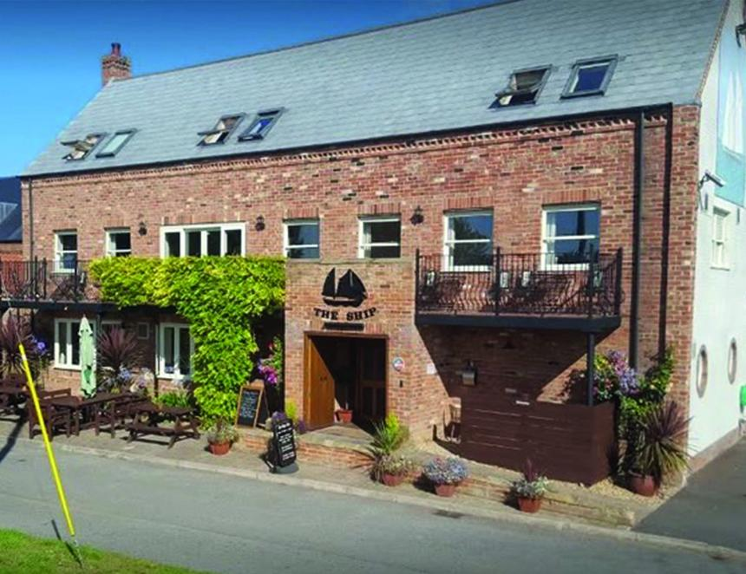

Since May’s bulletin, the number of community-owned pubs has increased from 227 to 234. Those not owned but run by the community has seen a slight decrease of two, down to 29, however, one of the losses is now community owned. The number of active campaigns has risen from 90 to 101, so there is clear public interest in community ownership. CAMRA supports the community-ownership model and is keen to help groups which wish to save their local and run it as a community-owned pub. The community pubs webpage of CAMRA’s website contains advice and guidance as well as regularly updated information about existing and planned projects. A list of current, active campaigns will be sent to local CAMRA branches in order to seek feedback on the status of community-owned pubs and campaigns in their area. Community Right to Buy Parliament has now passed the English Devolution and Community Empowerment Act, which includes the new Community Right to Buy. However, these provisions will not come into force until the accompanying regulations and guidance are issued. CAMRA is keeping in touch with officials at the Ministry of Housing, Communities and Local Government and expects a review of the Asset of Community Value (ACV) process to follow as part of these changes. The legislation gives community groups first refusal on the purchase of ACV-listed community assets that are put up for sale. If a deal cannot be agreed, an independent valuer, appointed by the Council concerned, will set the price based on market value. The moratorium period has also been extended from six to 12 months, and ACV-nominating groups now have a right of appeal against council refusal decisions. The legislation applies to existing ACVs as well as any new ones. CAMRA welcomed government’s announcement of a £61m Community Right to Buy Fund. The Campaign had been calling government to reinstate the funding to allow community groups to take ownership of their local since the previous fund was axed in 2024. Secretary of state for Housing, Communities and Local Government Steve Reed said: “We will introduce a new Pride in Place Community Right to Buy Fund, backed by £61m, to empower communities – focussing on the most deprived areas to take ownership of valued local assets such as pubs, clubs and community centres, reversing the decline in shared public spaces and supporting social connection. This funding is part of the £301m earmarked to support our high streets and community spaces. It will directly support communities in taking advantage of Community Right to Buy, created by our English Devolution and Community Empowerment Act, and will support efforts to revitalise local high streets, building on the new powers for councils I announced last month.” Read the full statement here. This potentially game-changing new fund, however, has two caveats. Firstly, pubs would need to be ACV-listed to qualify for possible funding, which would currently restrict the scheme to England only. The Welsh government has recently announced its intention also to introduce a community right to buy, which will presumably involve introduction of an ACV scheme. Scotland already has a community right to buy (of sorts), CAMRA would expect the devolved governments to receive additional funding for community facility saving purposes. Secondly, clarification is needed about the stated focus on “the most deprived areas”. At present there are very few community-owned or ACV-listed pubs in such areas, which raises questions about likely take-up levels. CAMRA has been in contact with relevant officials on both these issues. Campaign news Ship Inn, Surfleet Seas End, Lincolnshire (above) Campaigners fighting to reopen the Ship Inn, which closed more than a year ago, are celebrating that the village pub has been registered as an Asset of Community Value (ACV) following application to South Holland District Council by the Shipmates community group. Work will begin soon on preparing a business case to demonstrate that the pub represents a viable investment. Kenley Hotel, Croydon, Greater London This 19th-century pub closed in August 2025. The Kenley Hotel Community Benefit Society (CBS) has been set up to reinstate the pub as a community hub. A crowdfunder has been launched, aiming to raise £10,000 for the initial stages of the campaign, including building valuation, business plan modelling and final CBS legal setup. Take part in the campaign here: crowdfunder.co.uk/p/help-save-the-kenley-hotel Golden Ball, York, Yorkshire The Golden Ball Co-operative took out a lease on this Victorian back-street local in 2012. Owner Stonegate put the Grade-II listed pub on the market for £585,000 in September 2025. By March, the co-operative successfully completed the purchase of the freehold. This is a brilliant achievement that should secure the future of this wonderful heritage pub and its interior of outstanding national historic importance. Crown, Cuddington, Buckingamshire Dating back to the 17th century, the Crown closed its doors on 19 January. Village Blue Sky Limited Community Benefit Society, with more than 200 shareholders, raised in excess of £600,000 in just six weeks purchased freehold of the Grade-II-listed pub from owner Fuller’s on 8 June. An amazing volunteer effort completely restored the pub, and in just three weeks, it was ready to open its doors again. Crosswater, Barrhill, Ayrshire Using funding from the Scottish Land Fund, the Barrhill Development Trust bought the pub in 2020 and oversaw extensive renovations bringing the building back to a standard that would make it an attractive and welcoming destination. The Crosswater reopened in March as a village pub and restaurant. Kings Head, East Hoathley, Kent The pub was put up for sale in early 2025 when the long-serving licensees retired. The Kings Head Community Benefit Society was formed and launched a well-supported campaign to acquire the pub. The society received support from Sussex Weald MP Nusrat Ghani, Wealden District Council, celebrity chef Tom Kerridge, several local breweries, and other organisations. The King’s Head came into community ownership this February and, after sympathetic restoration and refurbishment, the pub opened for business in June. Work continues on the gardens, function rooms and a micro-brewery. Trafalgar, Merton, Greater London Plans to demolish this much-loved South London pub to build flats were thankfully refused by the Merton Council. The pub’s future, however, is still uncertain. A CBS has been formed and is holding a community meeting at St John the Divine church in Merton on Wednesday 9 September at 7:30pm to formally launch the Save the Traf share offer. It hopes to raise £500,000 through share sales. Farmers Arms, Wellington Heath, Herefordshire The rural pub closed in February and up for sale with agent Sidney Phillips with an asking price of £795,000. Villagers are concerned for the future of this pub and are considering a purchase offer. More than 120 people attended a public meeting at the local memorial hall in June to discuss the potential for a buy-out. Ivy, Heddington, Wiltshire Wadworth brewery put the pub up for sale in May 2024. CBS, Friends of the Ivy was set up, raising more than £430,000 to secure the purchase of the pub in December 2025. A second share offer has been launched to raise the money to develop the building as a pub, café and community hub. Dolphin, Kenton, Devon The Dolphin closed in 2019 and had fallen into a state of disrepair. A group of villagers formed a CBS, the Dolphin Inn Kenton Limited, and raised more than £130,000 in shares to purchase the pub. The hope is to reopen by Christmas though around £100,000 is still needed for the renovation works. If you have information about community ownership developments in your area, particularly new campaigns, send updates to info@communitypubs.camra.org.uk If your pub has closed or is under threat, CAMRA’s website has in-depth guides and resources, including those about community pub ownership, to help save your local here.

