Top 16 UK pubs revealed
27/08/2026 by WB Reporter
Campaign

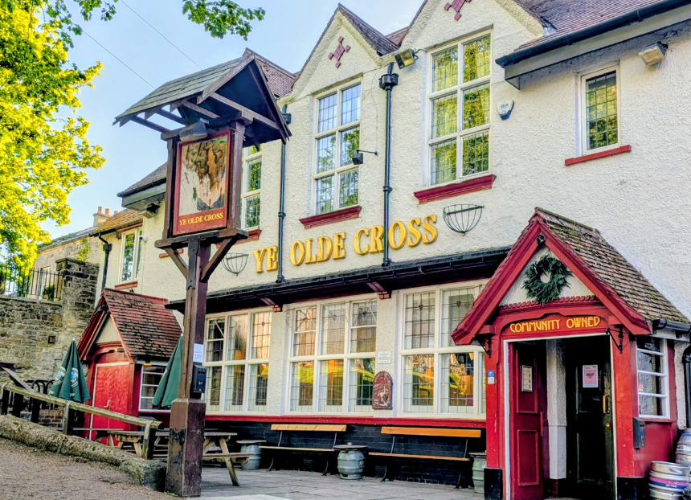

The 2026 Pub of the Year competition is hotting up with CAMRA’s England regions and overall Scotland, Wales and Northern Ireland winners revealed ahead of a busy bank holiday weekend for pubs. The pubs now advance to the super-regional stage of the competition, with a final four announced in October, ahead of the reveal of the overall National Pub of the Year in January 2027. The final stages of the award are supported by Avani Solutions, CAMRA’s beer quality partner and technology partner ICRTouch. Competition coordinator Andrea Briers said: “We have a formidable top 16 this year with both familiar faces and some first-time winners in the mix. Behind each one is a deserving and hard-working team, running an amazing pub for their local community, and serving brilliant cask beer. “Please make the most of this bank holiday weekend by showing your support for the UK’s amazing pubs. You never know, you might pick one that ends up a winner next year.” CAMRA chairman Ash Corbett-Collins said: “CAMRA’s Pub of the Year competition highlights the very best that the UK has to offer, but unfortunately, it’s much more common that licensees are struggling with day-to-day trading. “The new prime minister and chancellor have the power to change that. With the next UK Budget coming up, they could take action on business rates, draught beer duty and VAT, to deliver a Budget for beer drinkers and publicans.” Our top 16
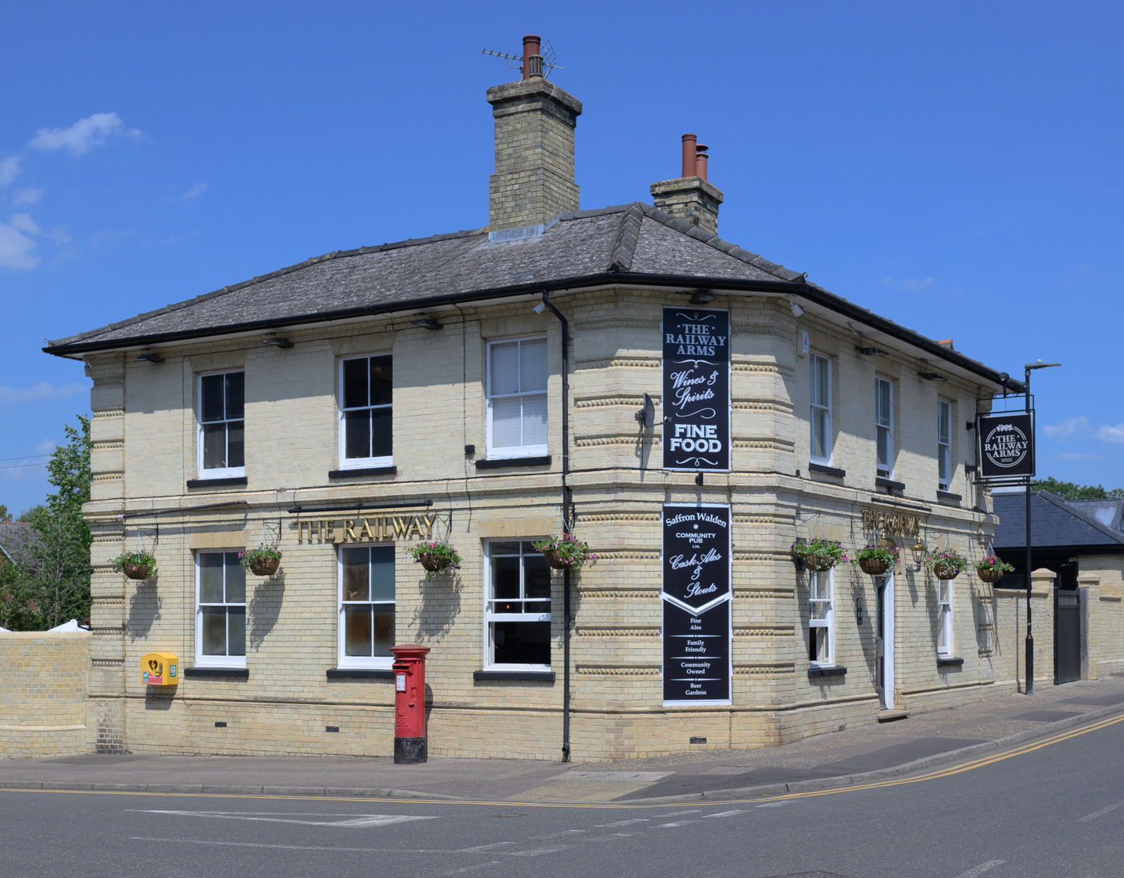
East Anglia: Railway Arms, Saffron Walden (above, photo by Helga Naried) A lovingly restored Victorian street-corner pub which was saved by its local community in 2020, the Railway Arms combines traditional character with a lively, welcoming atmosphere. The pub champions independent breweries and cider makers, with up to six changing cask beers on tap and Wriggers’ Cider produced on site.
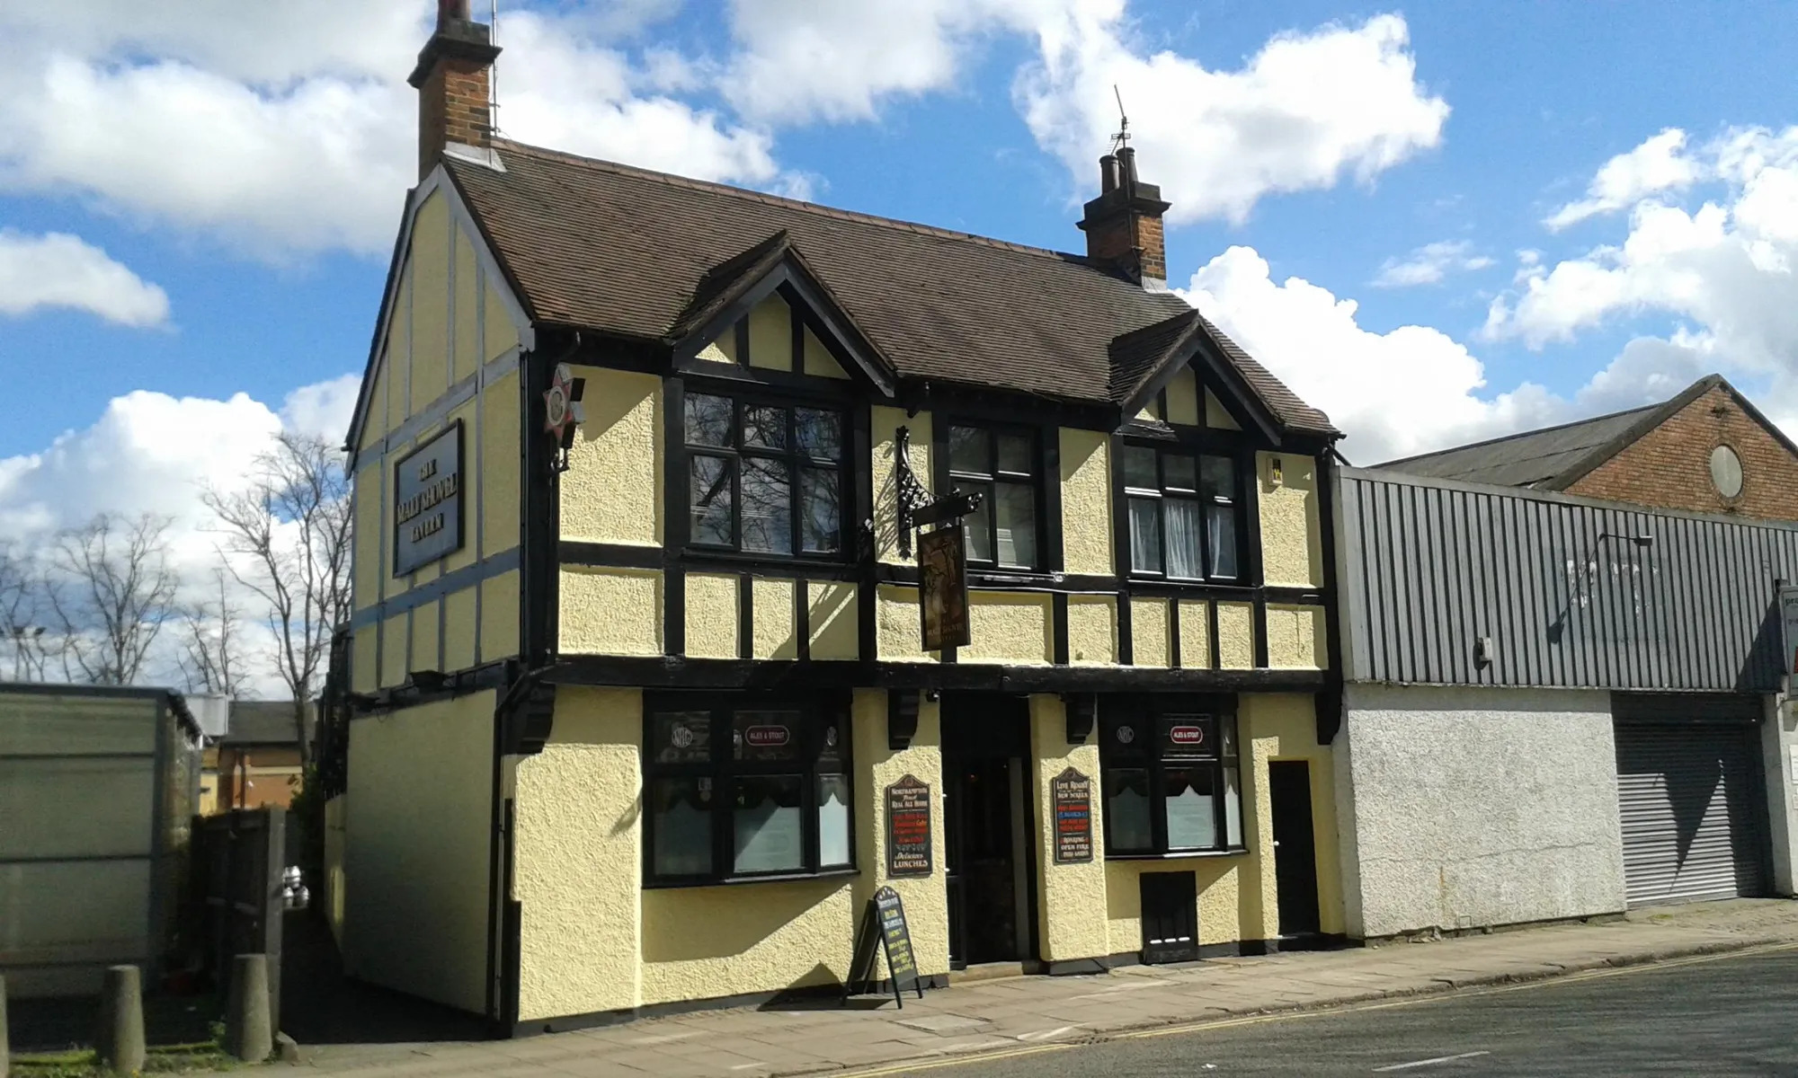
East Central: Malt Shovel Tavern, Northampton (above) This popular pub, opposite the Carlsberg brewery, serves up to eight cask beers from local and regional microbreweries, three real ciders and Belgian draught and bottled beers. The exterior consists of a unique Northampton Brewery Company neon-lit star, while the inside features a great array of breweriana.
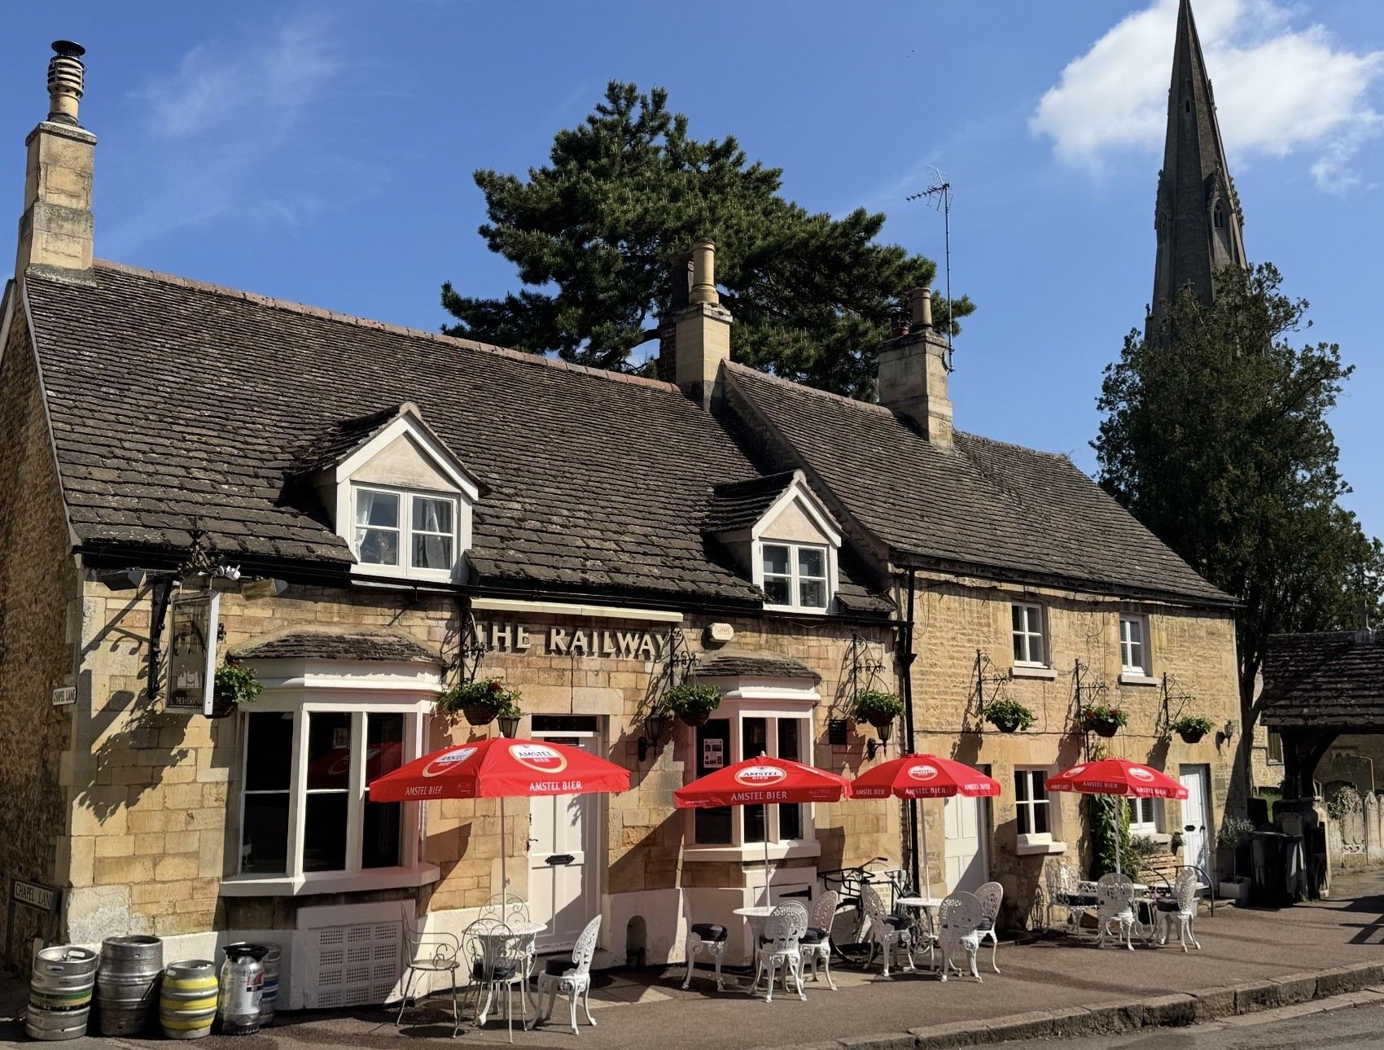
East Midlands: Railway Inn, Ketton (above) A village gem that serves great cask beer and good wine in a welcoming, friendly atmosphere. The Grade II-listed building is several hundred years old with much character and more than a dash of charm. It's also been presented with a plethora of CAMRA awards.
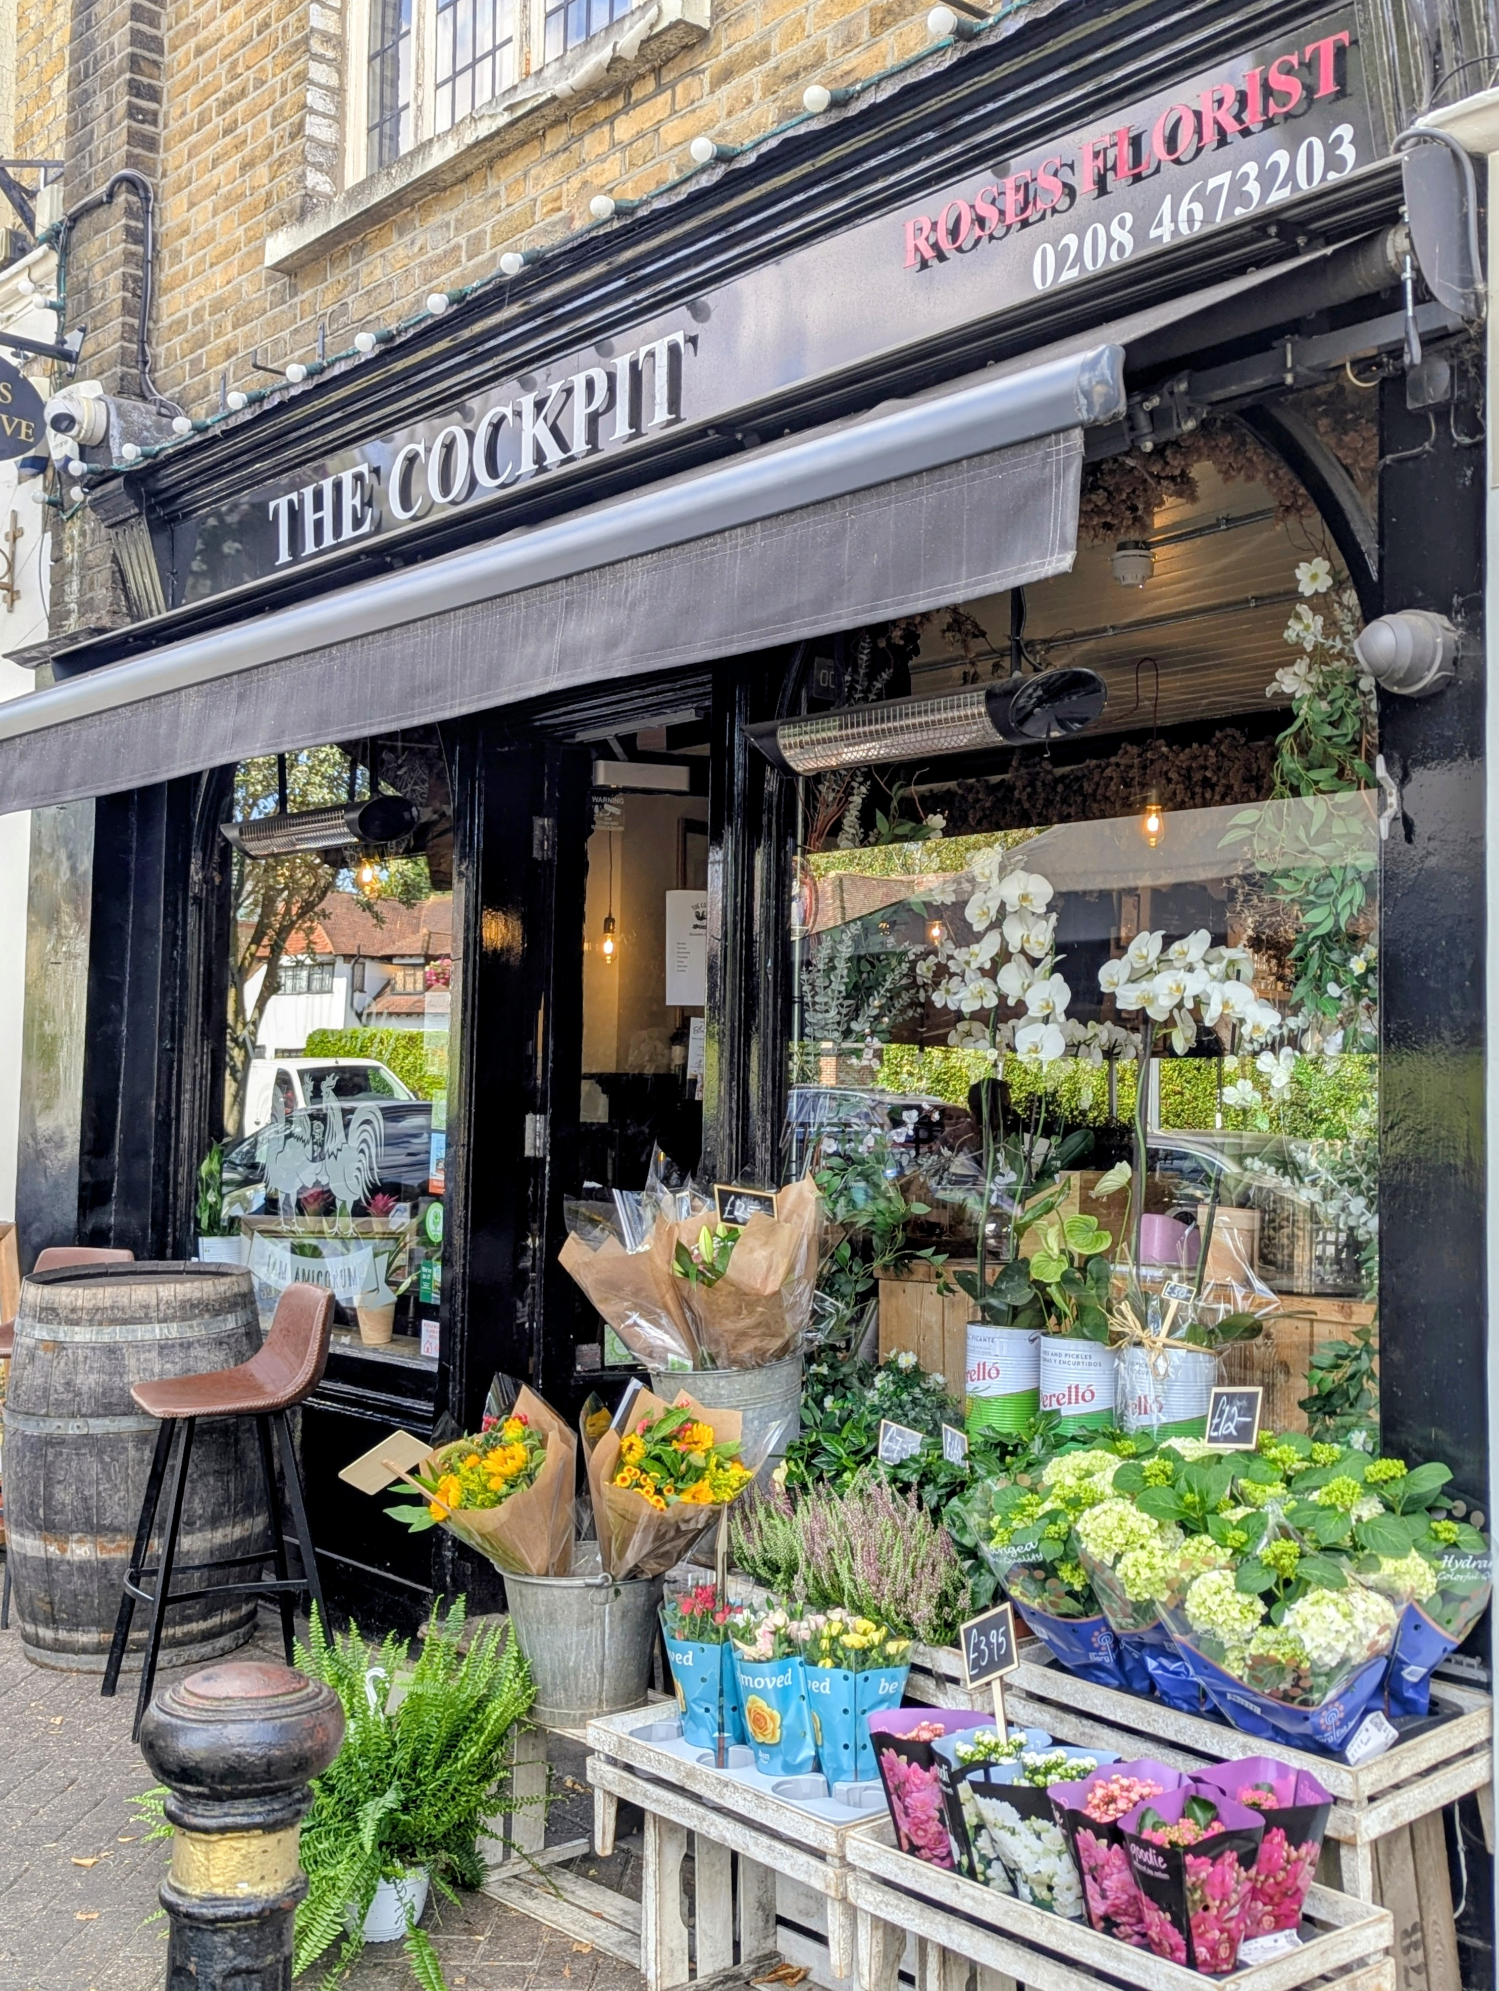
Greater London: Cockpit, Chislehurst (above, photo by Adam Miller) This easy-going and chatty pub is Chislehurst’s first micropub and offers a choice of cask beers from small breweries all over the country, served from a cold room behind the small bar. The premises are shared with a florist but it's still a spacious pub with plenty of seating inside, plus further high tables and benches by the small bar at the rear.
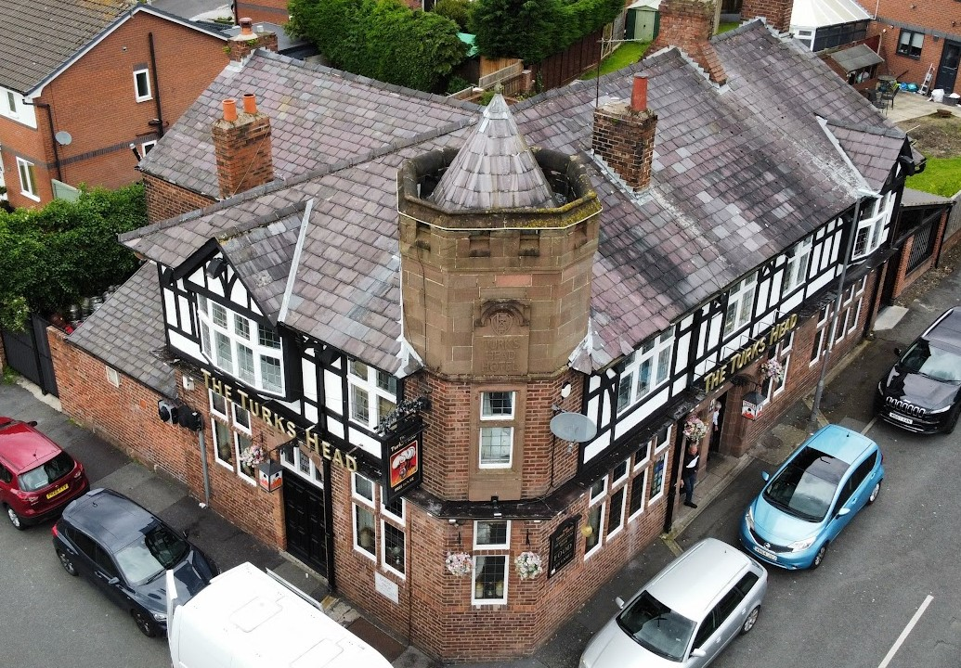
Merseyside and Cheshire: Turks Head, St Helens (above) An attractive Tudor-style pub dating back to the 1870s near the town centre, the Turks Head was also in our top 16 pubs in 2024. The friendly and welcoming pub offers a rotating line-up of 14 handpulls, real ciders plus a large whisky and gin bar. An extensive variety of craft and continental beers can also be found in the upstairs Tower Lounge room, which hosts live music and events for community groups.
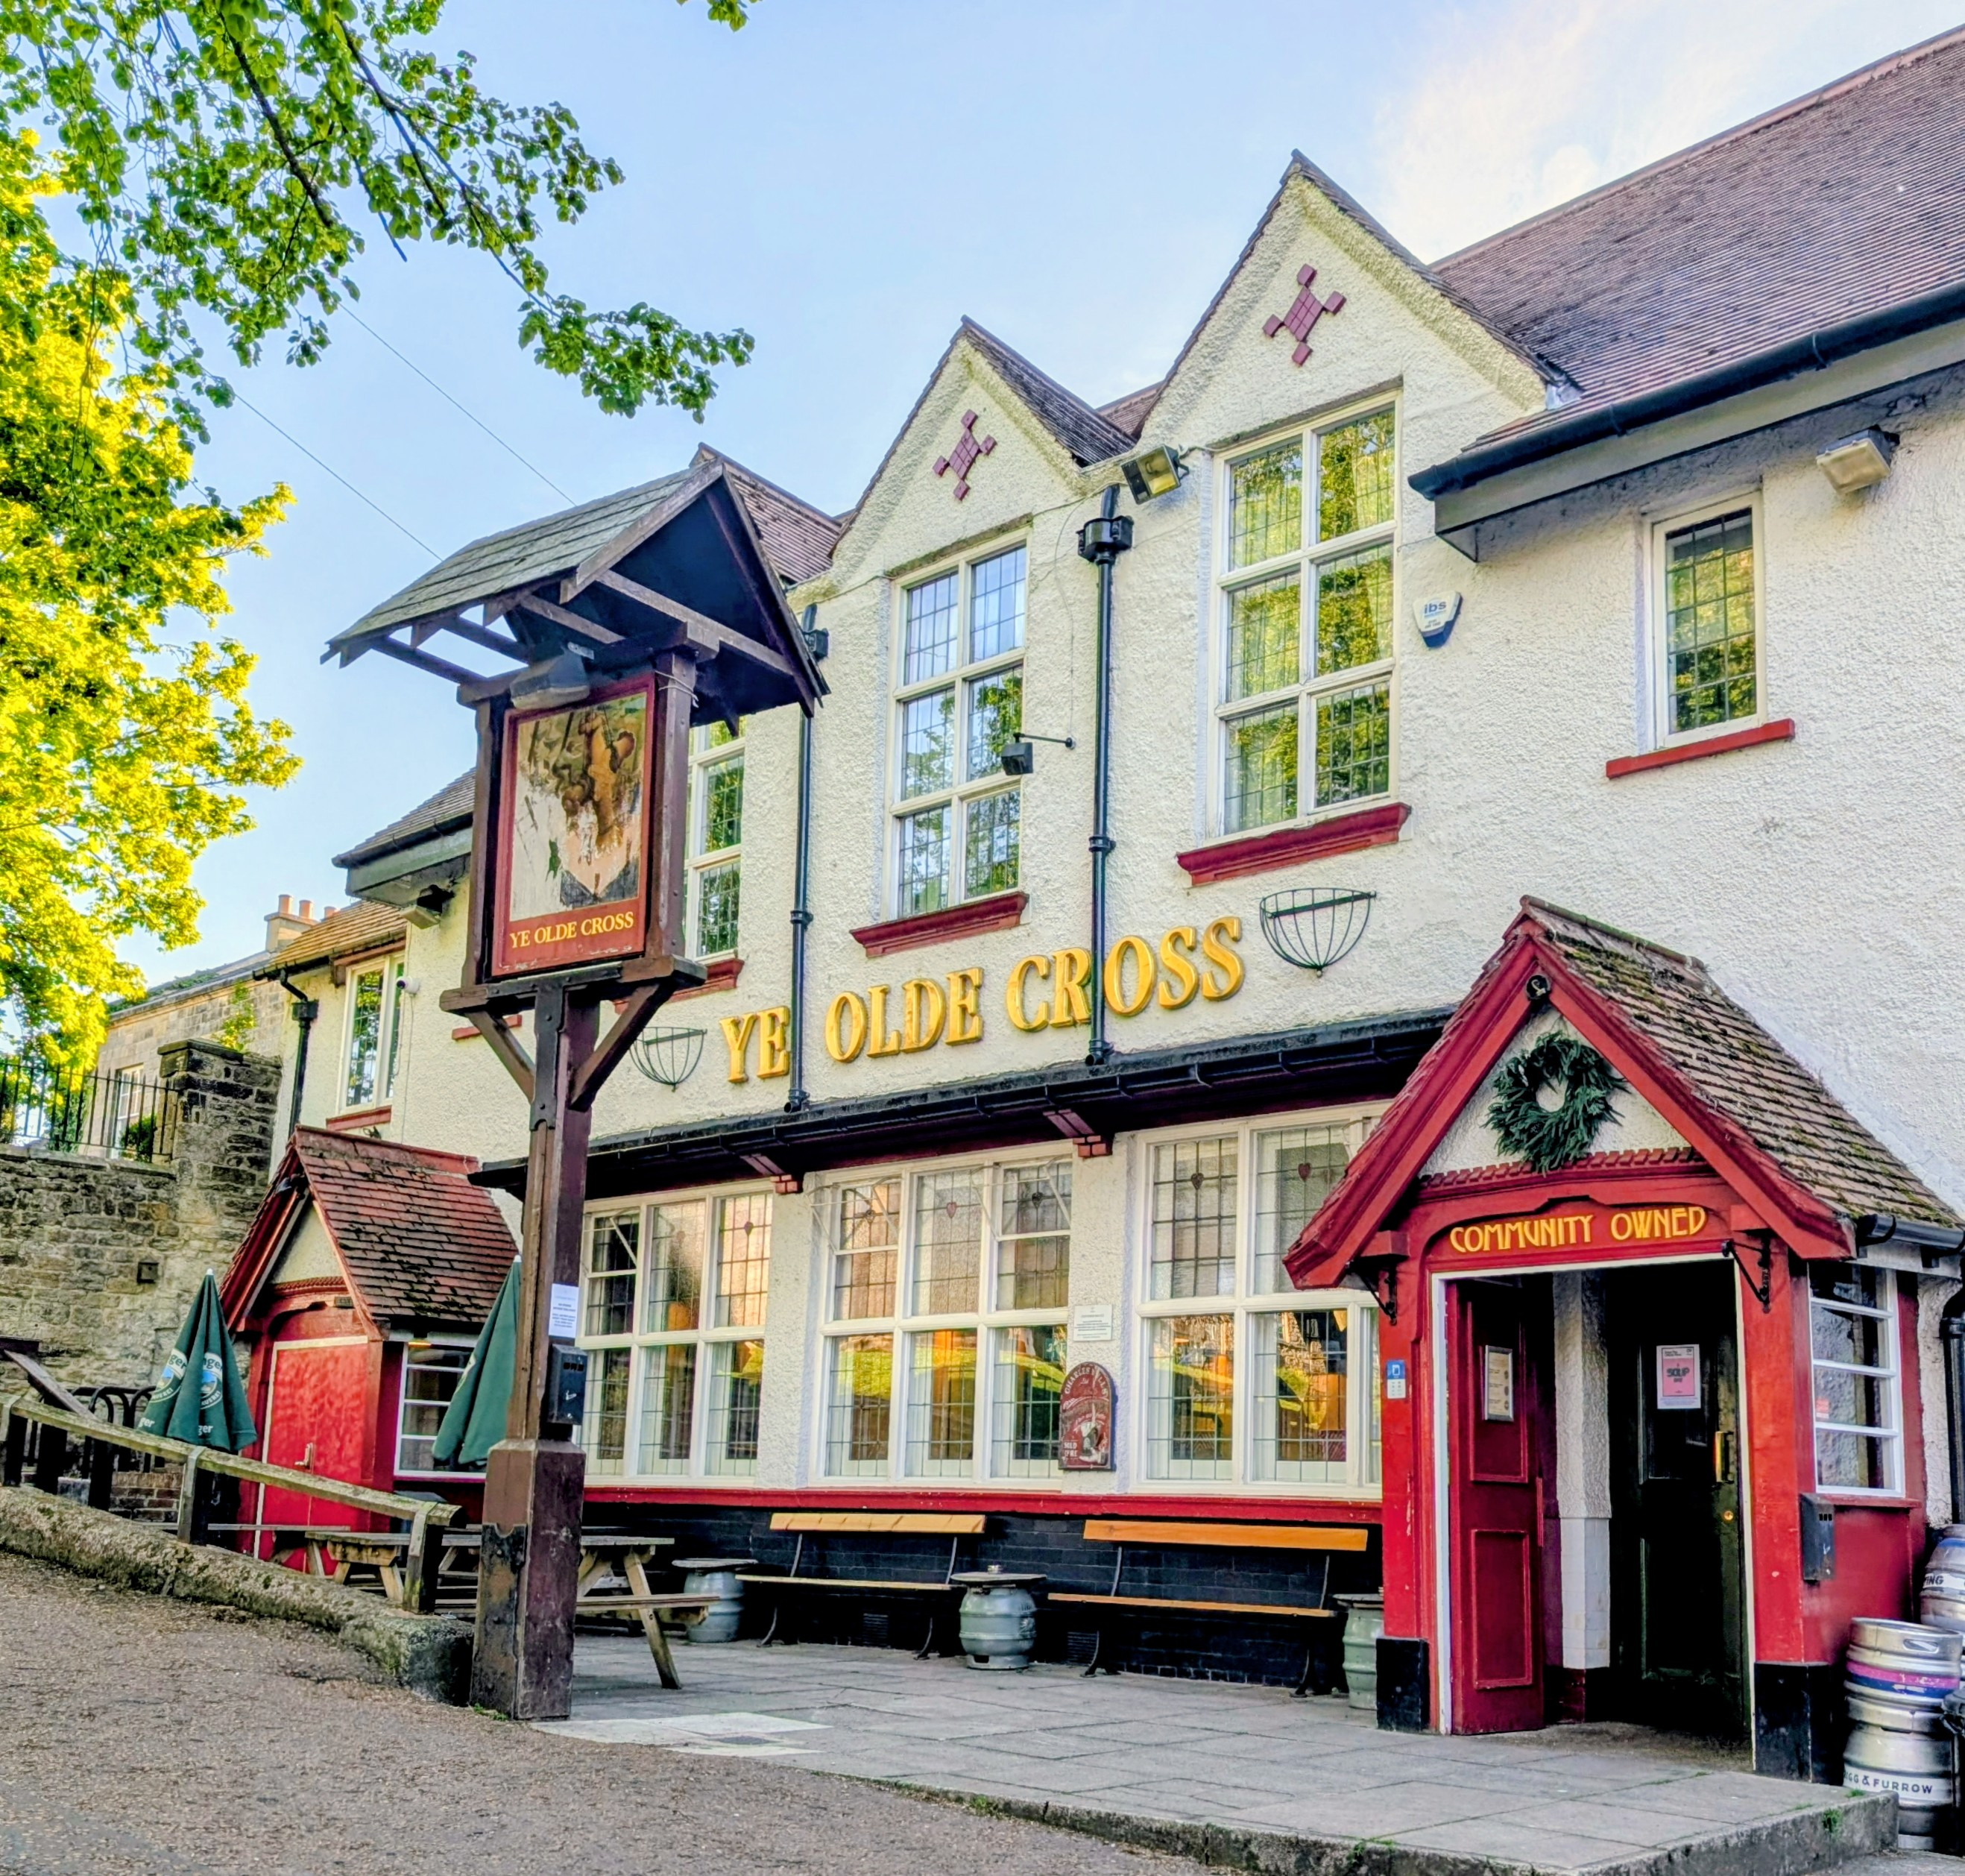
North East: Olde Cross, Old Ryton Village (above and top, photo by Paul Hillhouse) This community-owned pub opened in 2019 just 18 months after it closed its doors. It's an attractive Edwardian, half-timbered local in a beautiful setting by the village green and is very much a centre for the local community. It hosts events and local activities, such as street-food vendors on the weekends, as well as pop-up supper club events.
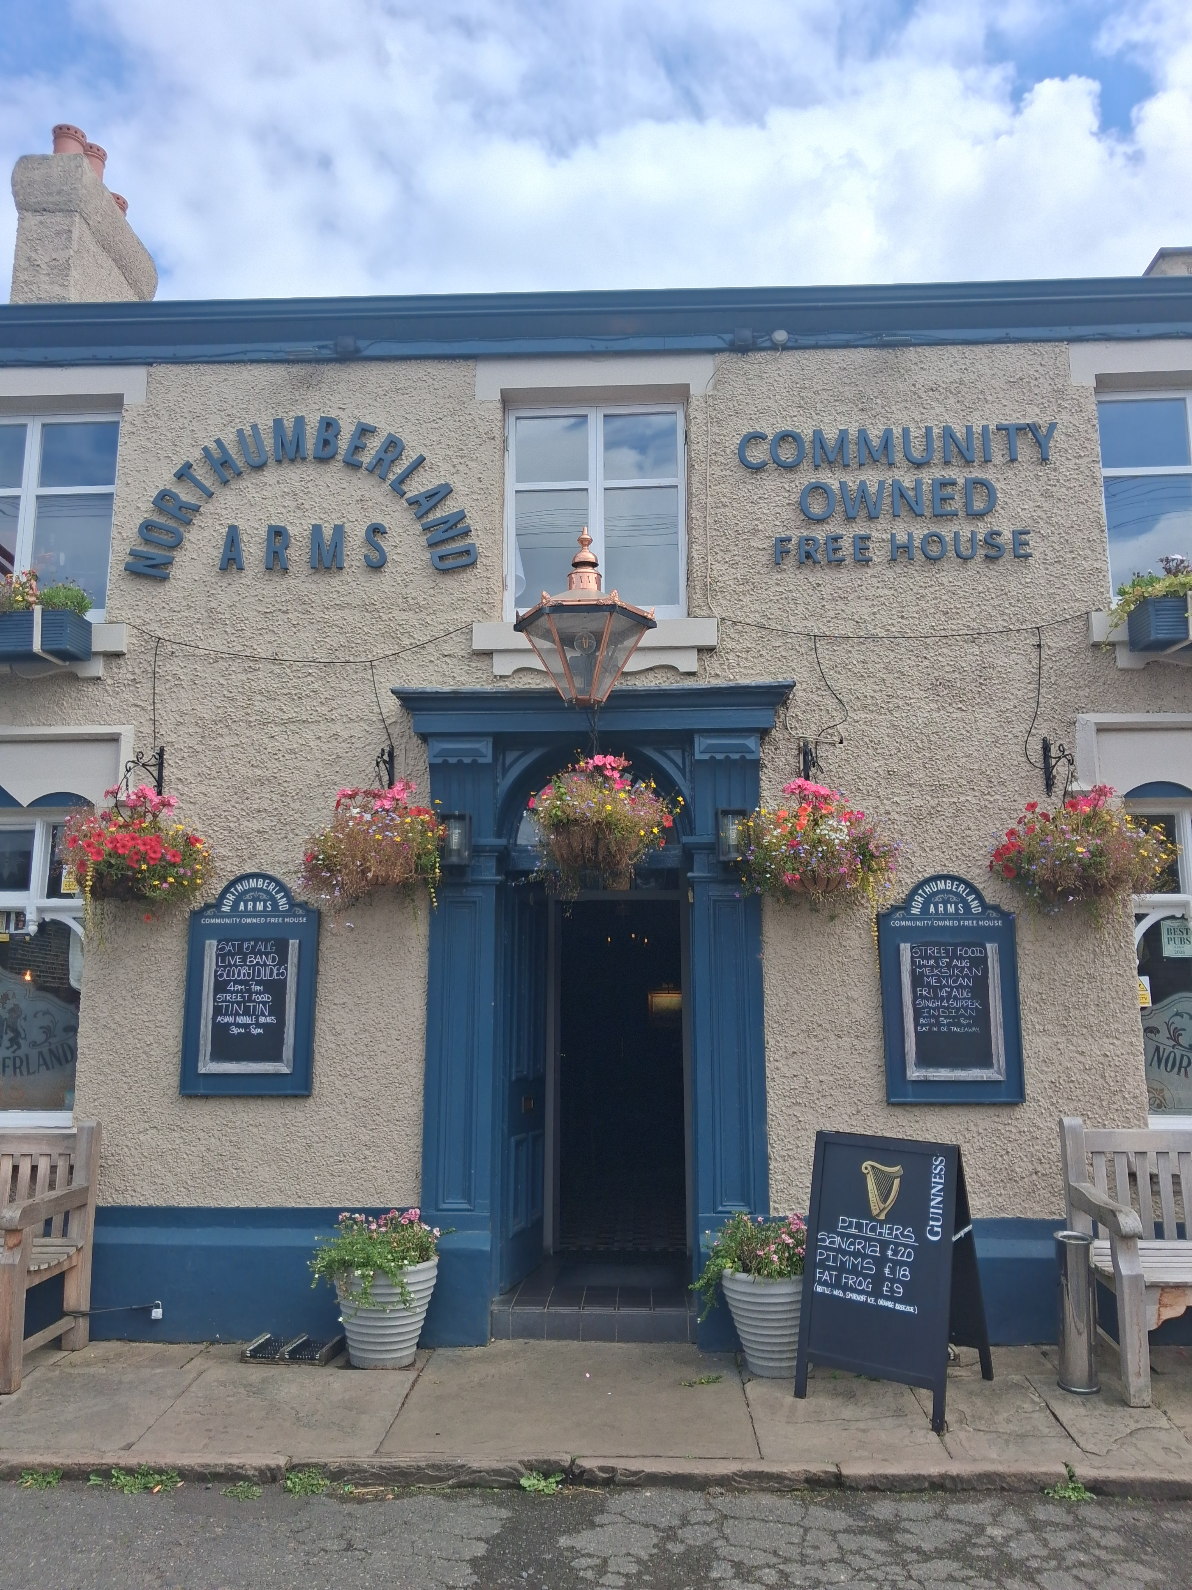
North West: Northumberland Arms, Marple Bridge (above, photo by Ben Zwierink) Saved from permanent closure in 2017 following a successful campaign by the local community, the pub has continued to flourish. Now run by a group of enthusiastic people who have worked hard to restore this cosy, welcoming pub to its former glory and a varied range of well-kept beers is always available. Becoming the beating heart of its community, the pub, locally dubbed the Thumb, is a hub for events and activities.
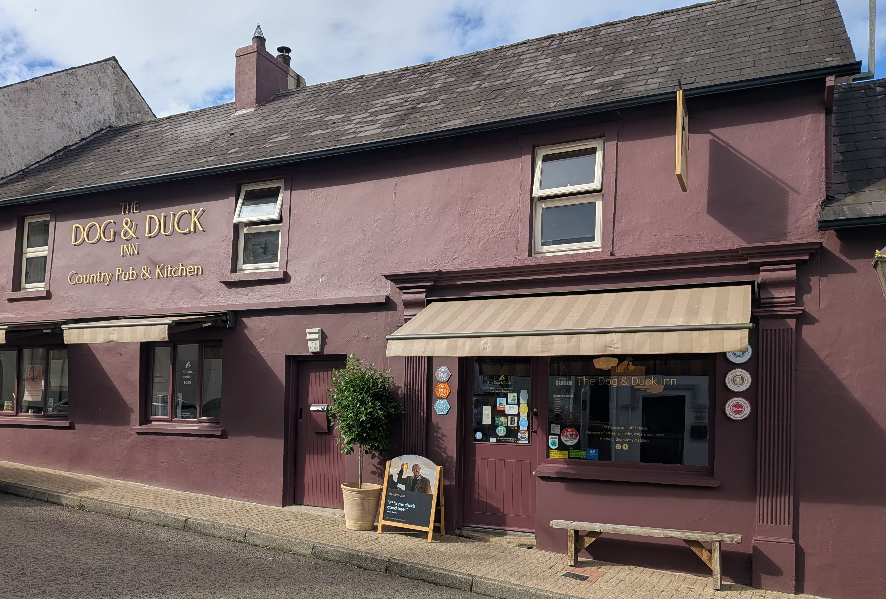
Northern Ireland: Dog & Duck Inn, Lisbellaw (above, photo by Margaret Elliott-Tredinnick) A family run, dog-friendly country pub, the Dog & Duck Inn is noted for its welcoming and cosy atmosphere. It specialises in independent beers, ciders and spirits with 13 guest spots, including four cask beer pumps and real ciders. The pub is also home to the Glenwinny Micro Distillery, which produces small-batch rum, brandy and whiskey.
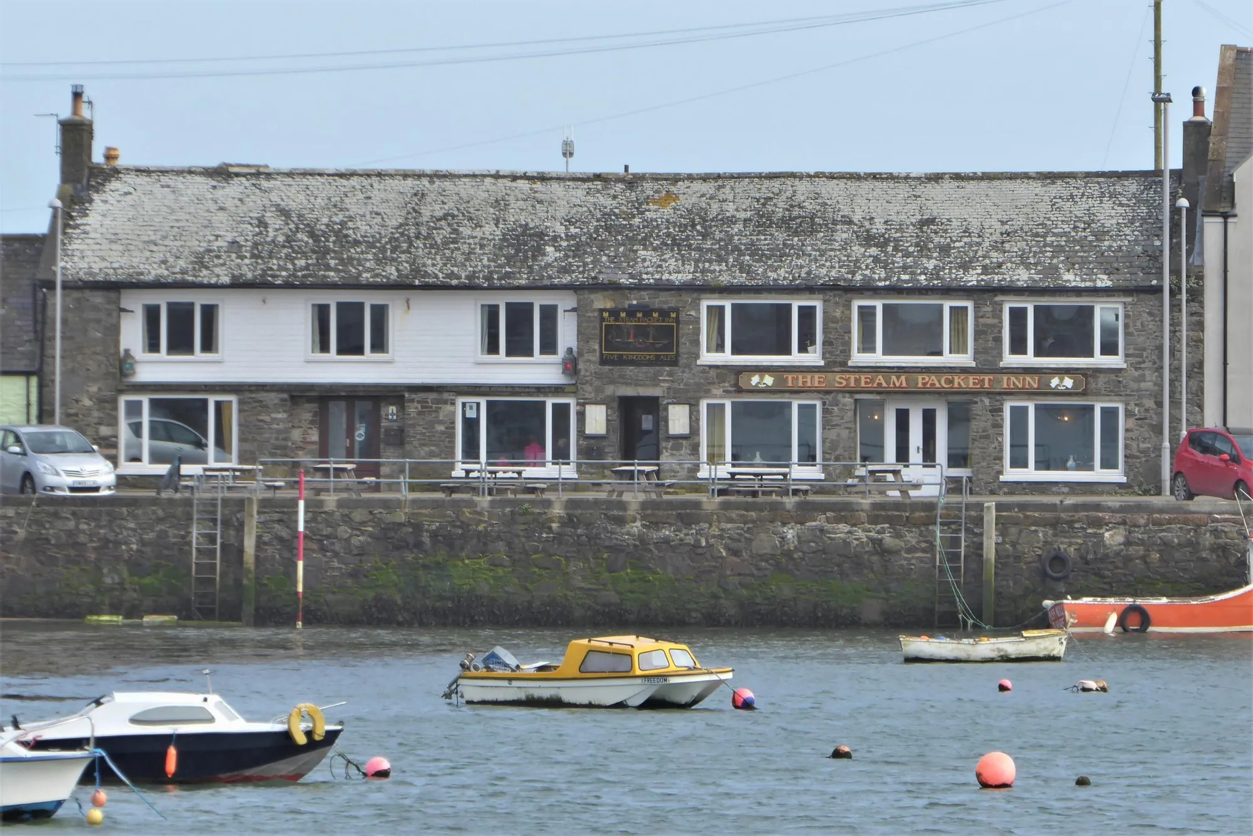
Scotland: Steam Packet Inn, Isle of Whithorn (above) This idyllic establishment overlooking the scenic harbour and surrounding area offers great food, good beer and quality accommodation. Find up to seven beers from the in-house brewery Five Kingdoms and one guest beer at the public bar with stone walls and a multi-fuel stove. They also serve great local produce from their fantastic kitchen team.
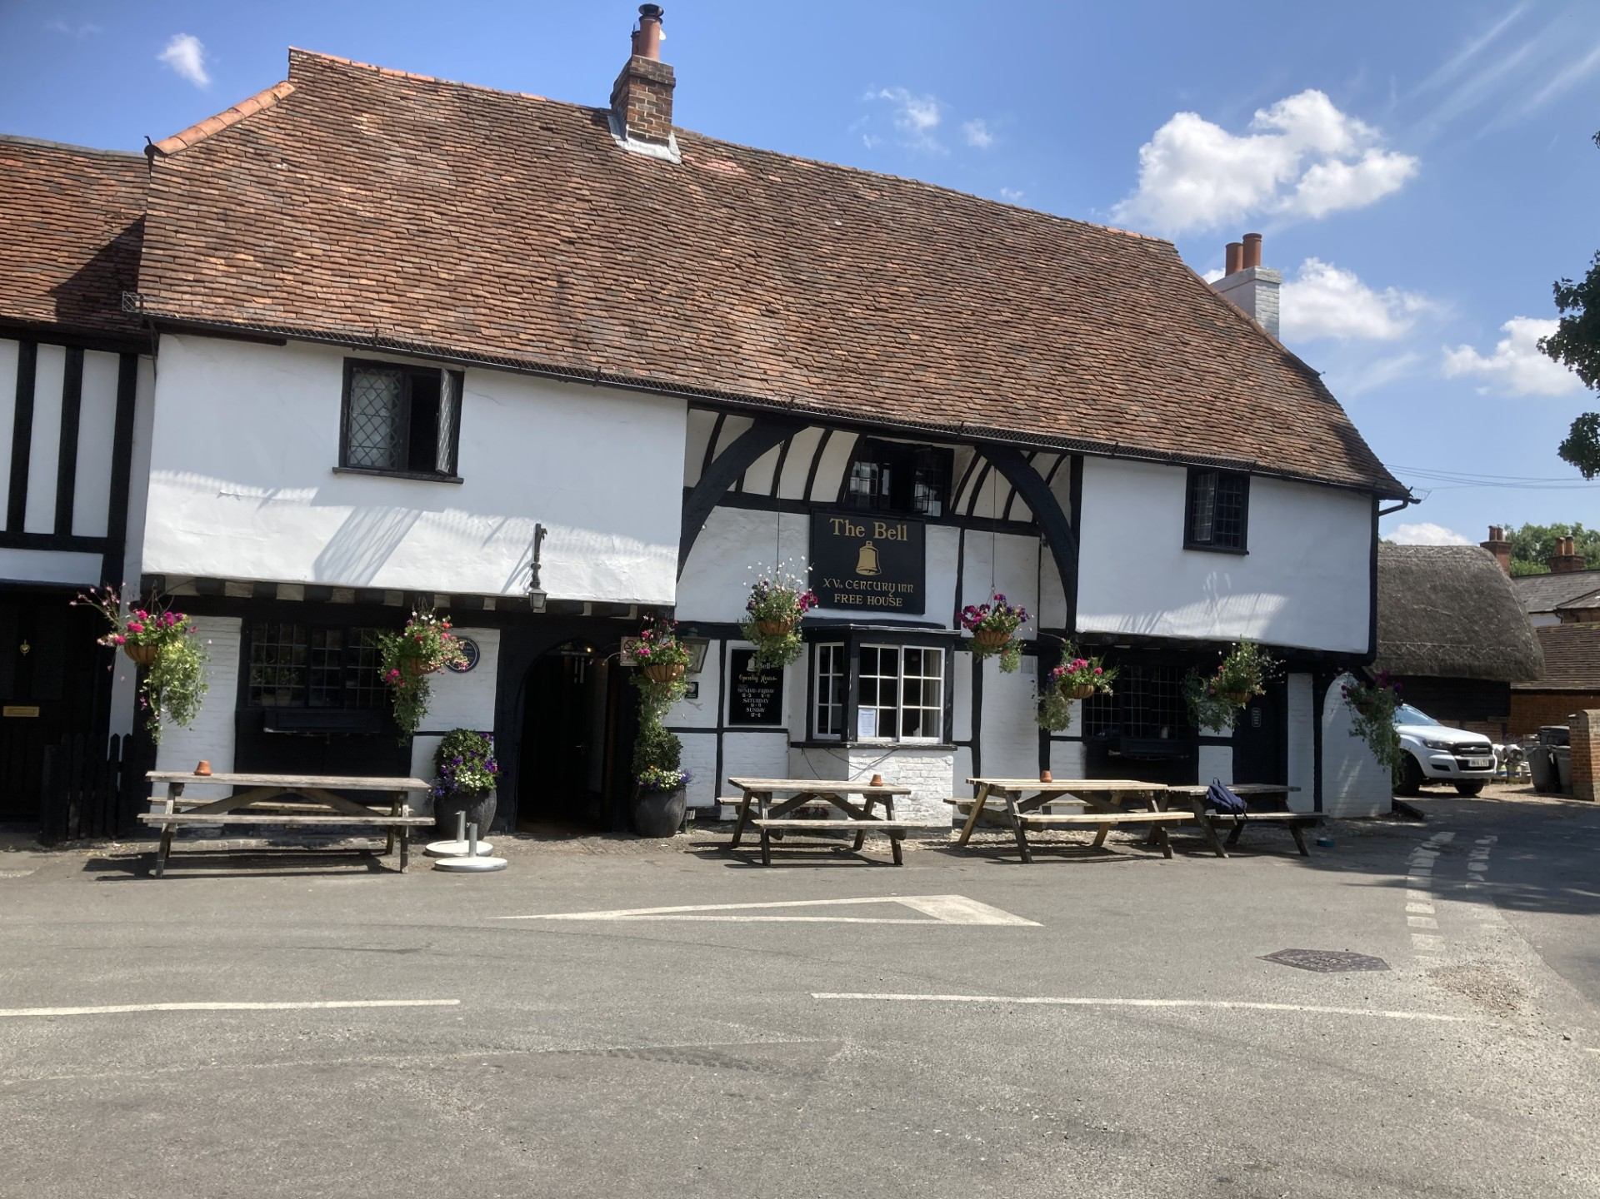
South Central: Bell, Waltham St Lawrence (above, photo by Norman Clinnick) A classic, half-timbered, 14th-century pub which doubles as the village local and a restaurant producing exceptionally good food from fresh, seasonal ingredients. It does a great job promoting cask beers from independent breweries and offers up to eight ciders and perries too. Find log fires in the winter, a good-sized beer garden in the summer and folk music on the first Thursday of each month.
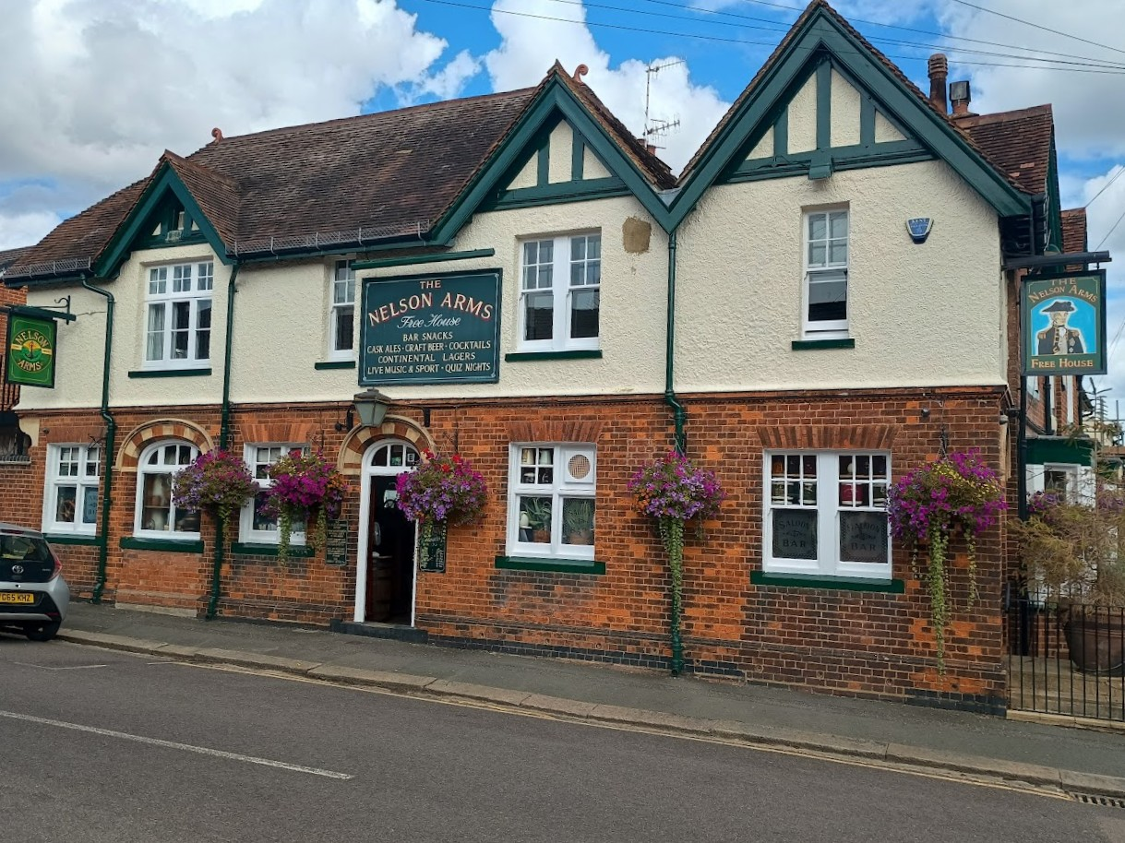
South East: Nelson Arms, Tonbridge (above, photo by Keith Ennis) A beautifully refurbished side street local, that serves a changing selection of up to nine cask and keg beers and ciders from national and local indie breweries. The pub’s spacious and comfortable interior displays a nautical theme, with decorations including a ship’s wheel, barometer and a painting of Lord Nelson, along with attractive breweriana.
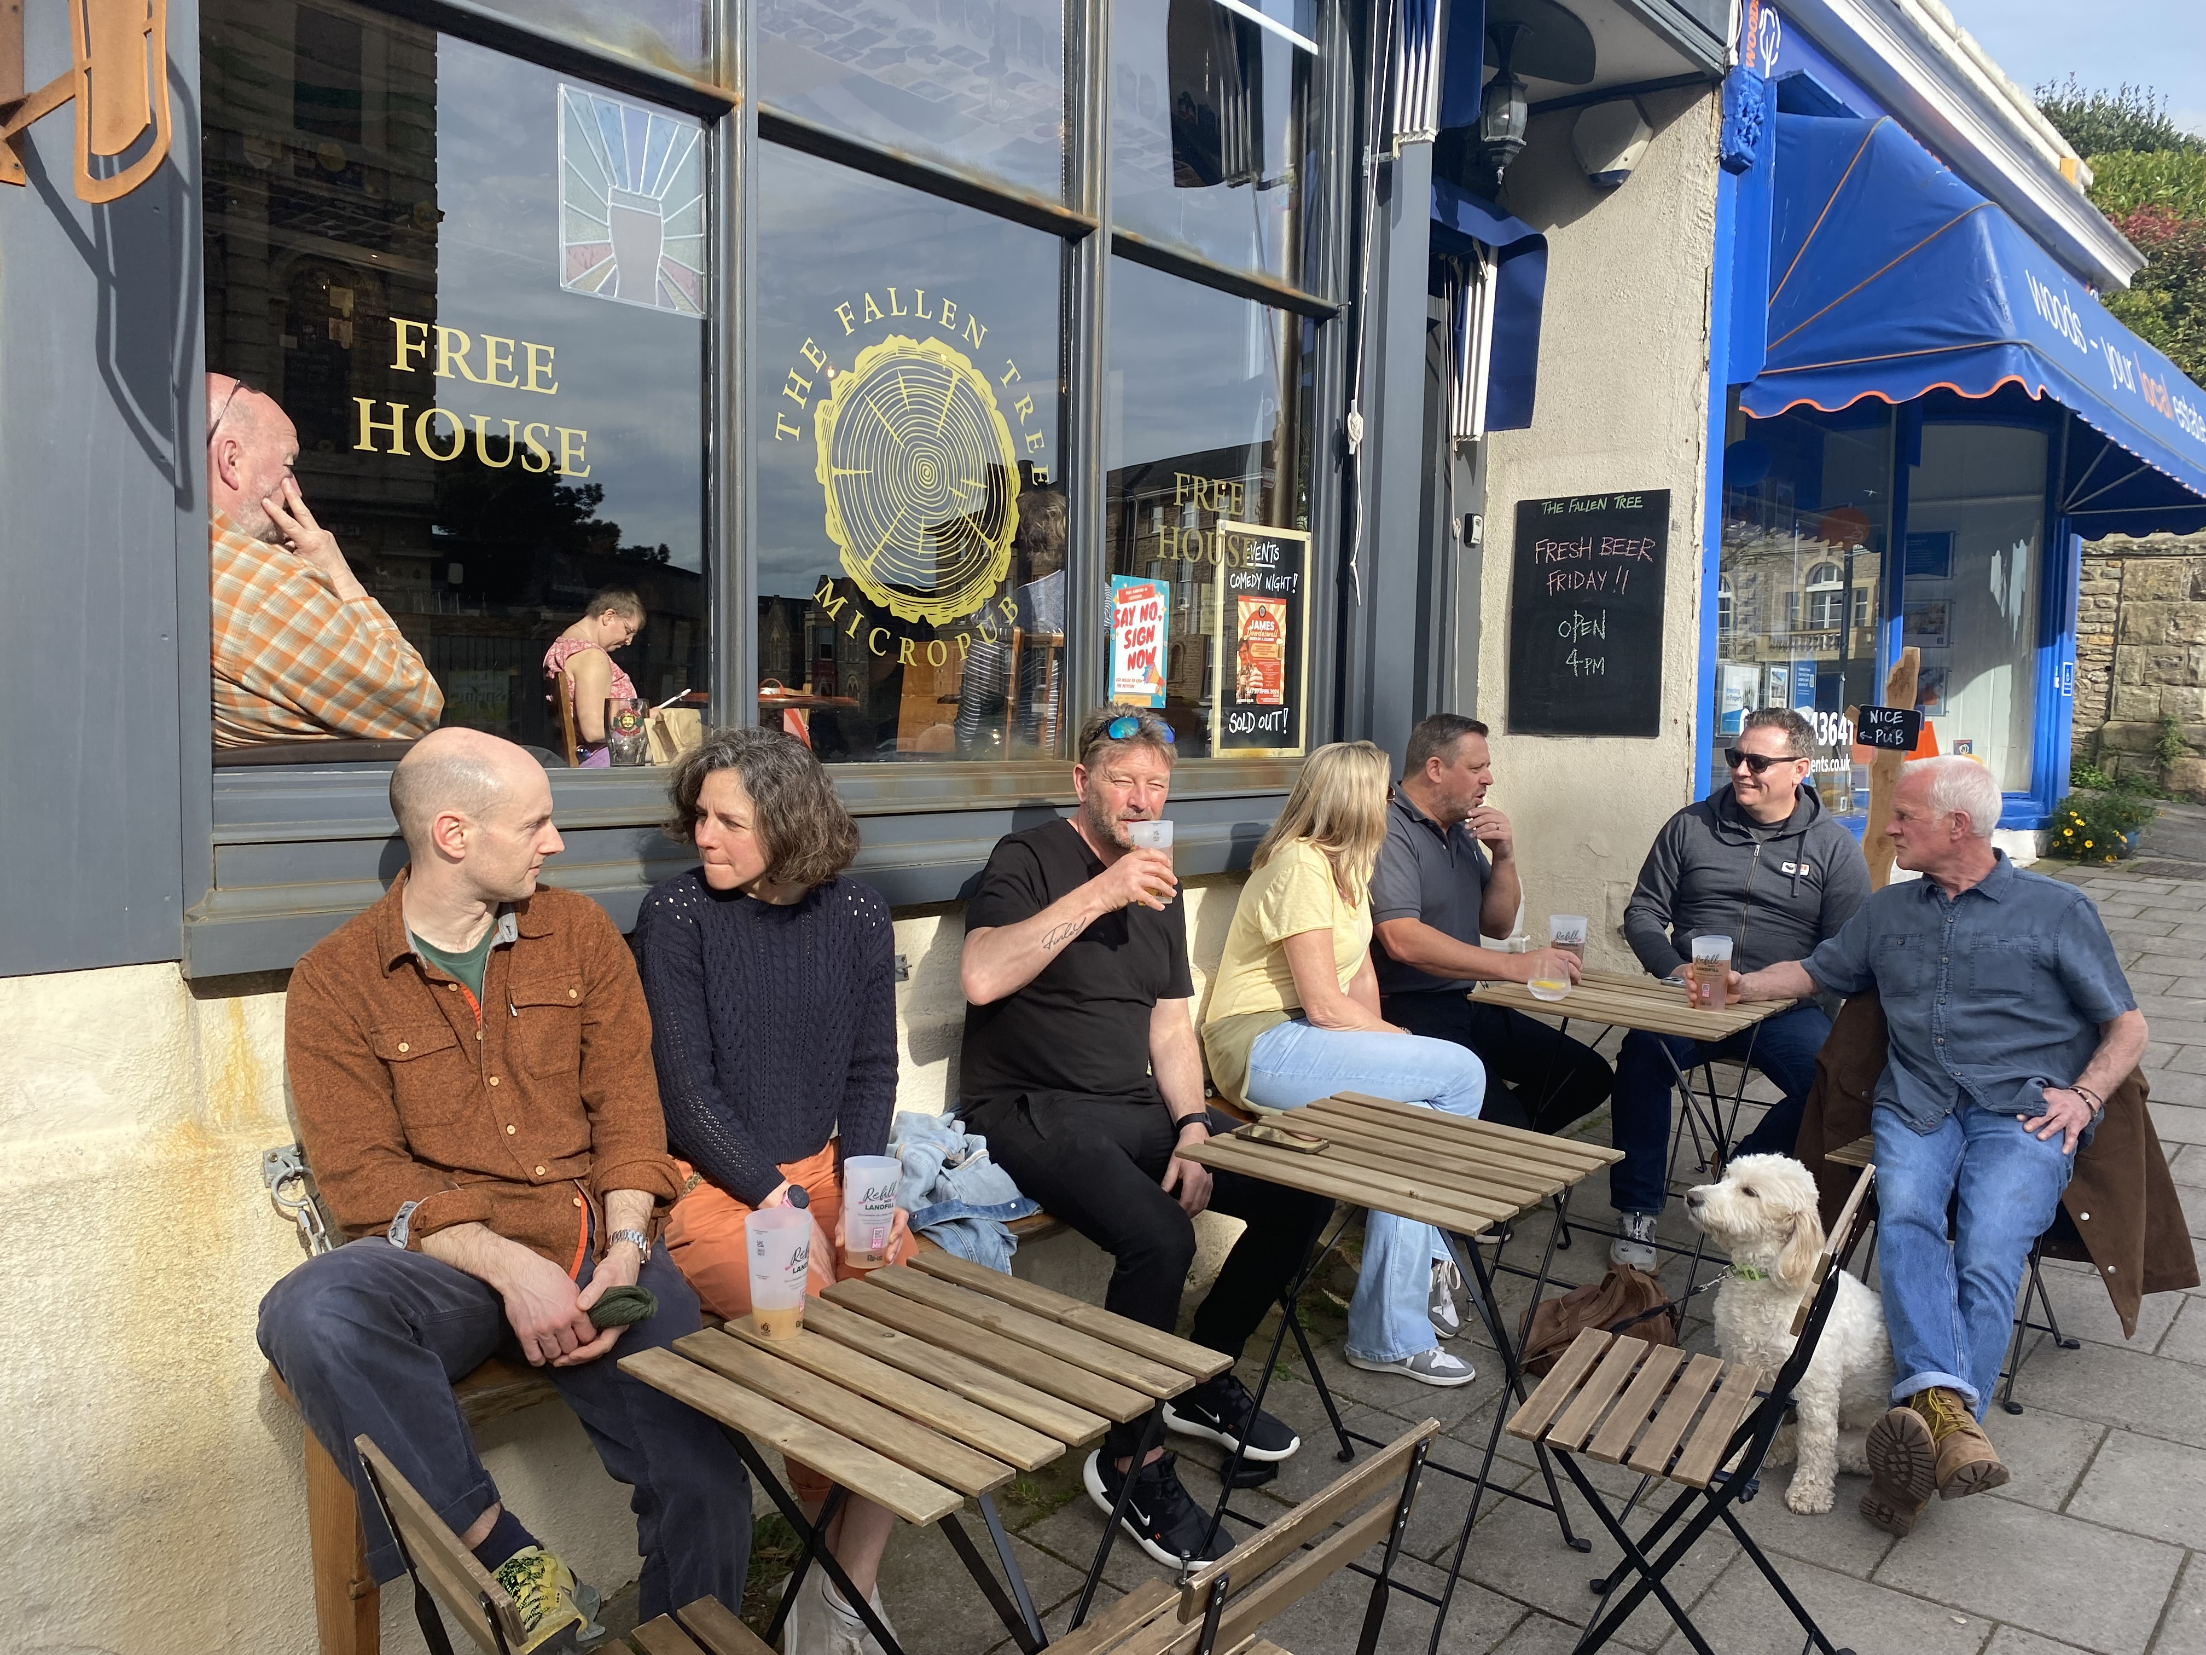
South West: Fallen Tree, Clevedon (above) This pub pours straight from the 10 casks in the wooden stillage behind the bar. The first micropub in North Somerset delivers quality, local beer and frequently quality conversation. The Fallen Tree also offers real cider, local gins, wines, prosecco and soft drinks as well. Additional seating is available on the pavement outside.
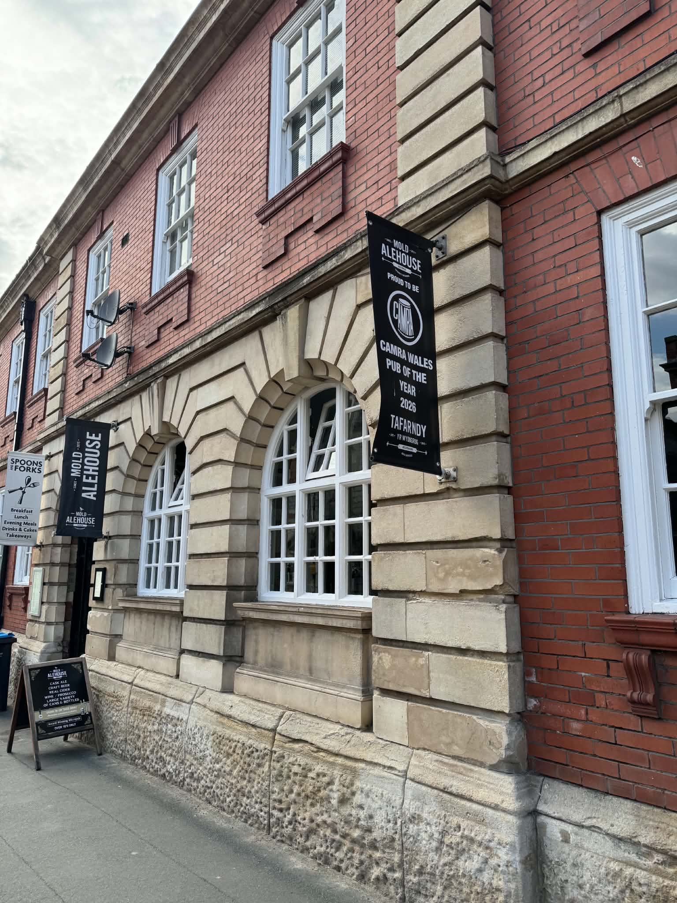
Wales: Mold Alehouse, Mold (above, picture by Gareth Jones) The ethos of this award-winning pub is based on the sound principles of good beer and conversation. The beers include four cask offerings, always including a dark beer, five KeyKeg lines and four ciders. It’s centrally situated in a Grade II-listed building opposite Daniel Owen Square.
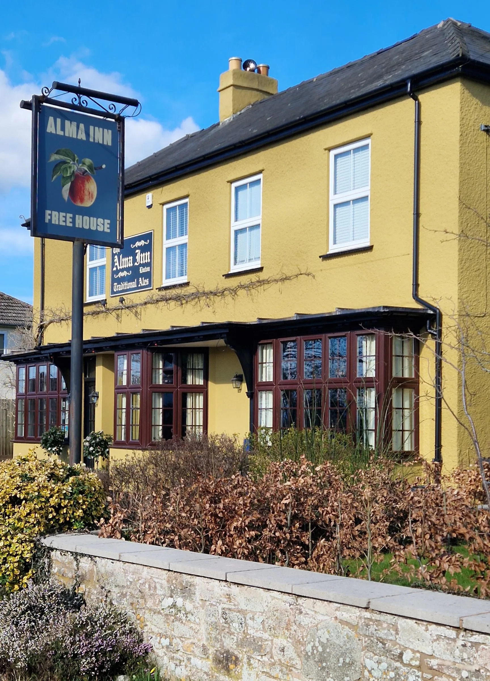
West Central: Alma Inn, Linton (above) This multi award-winnning pub features a convivial front bar with a wood burner, which contrasts with the rear pool room and a separate wood-panelled dining room. Find hearty, freshly prepared food and in July the Alma Inn hosts the Linton Music Festival in its gardens, along with a beer festival.
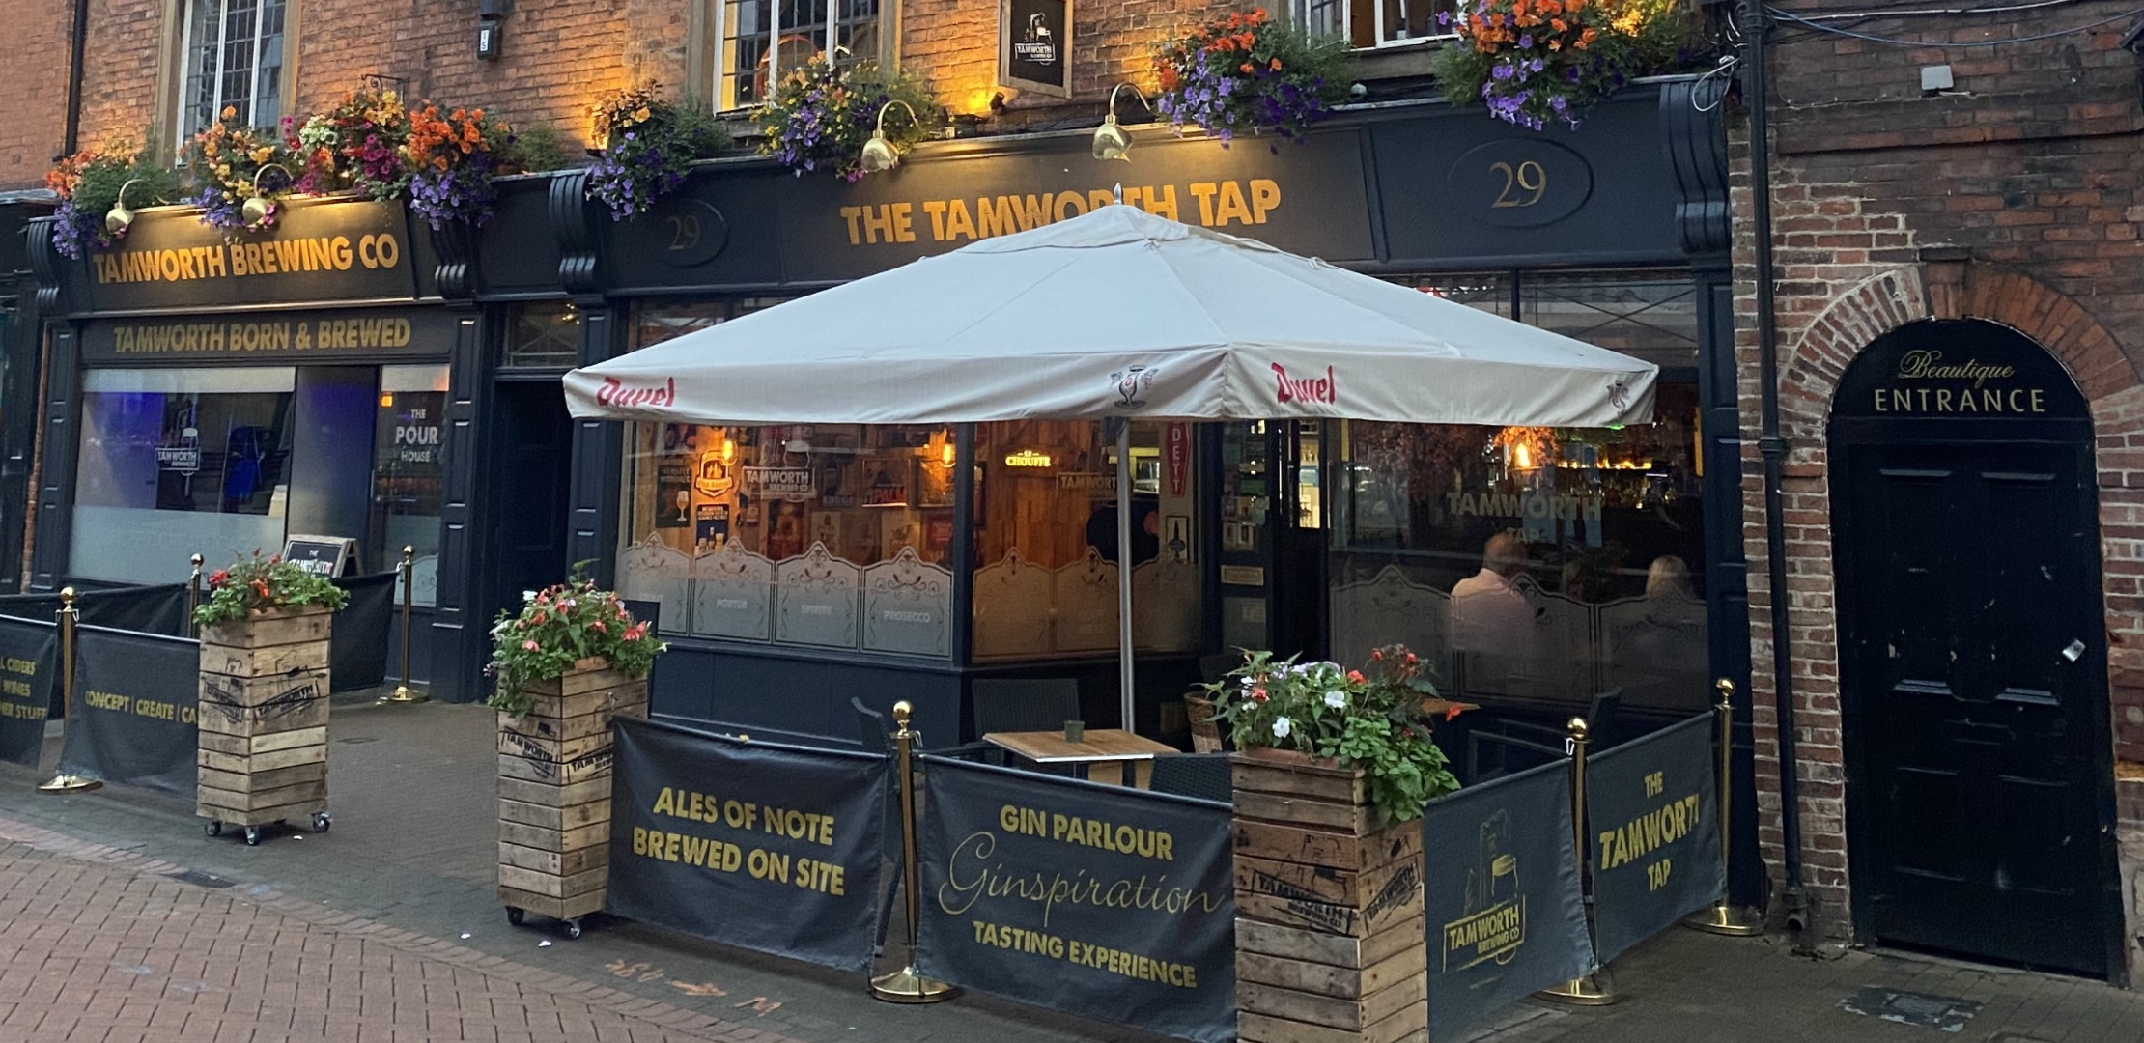
West Midlands: Tamworth Tap, Tamworth (above) The first pub to win our National Pub of the Year three times, the Tudor building and historic courtyard beer terrace offers striking views of Tamworth’s Norman Castle. Home to Tamworth Brewing Company and its tap, it features eight handpulls, with cask beer from near and far, alongside a wide range of ciders, gins, wines and bottled beers.
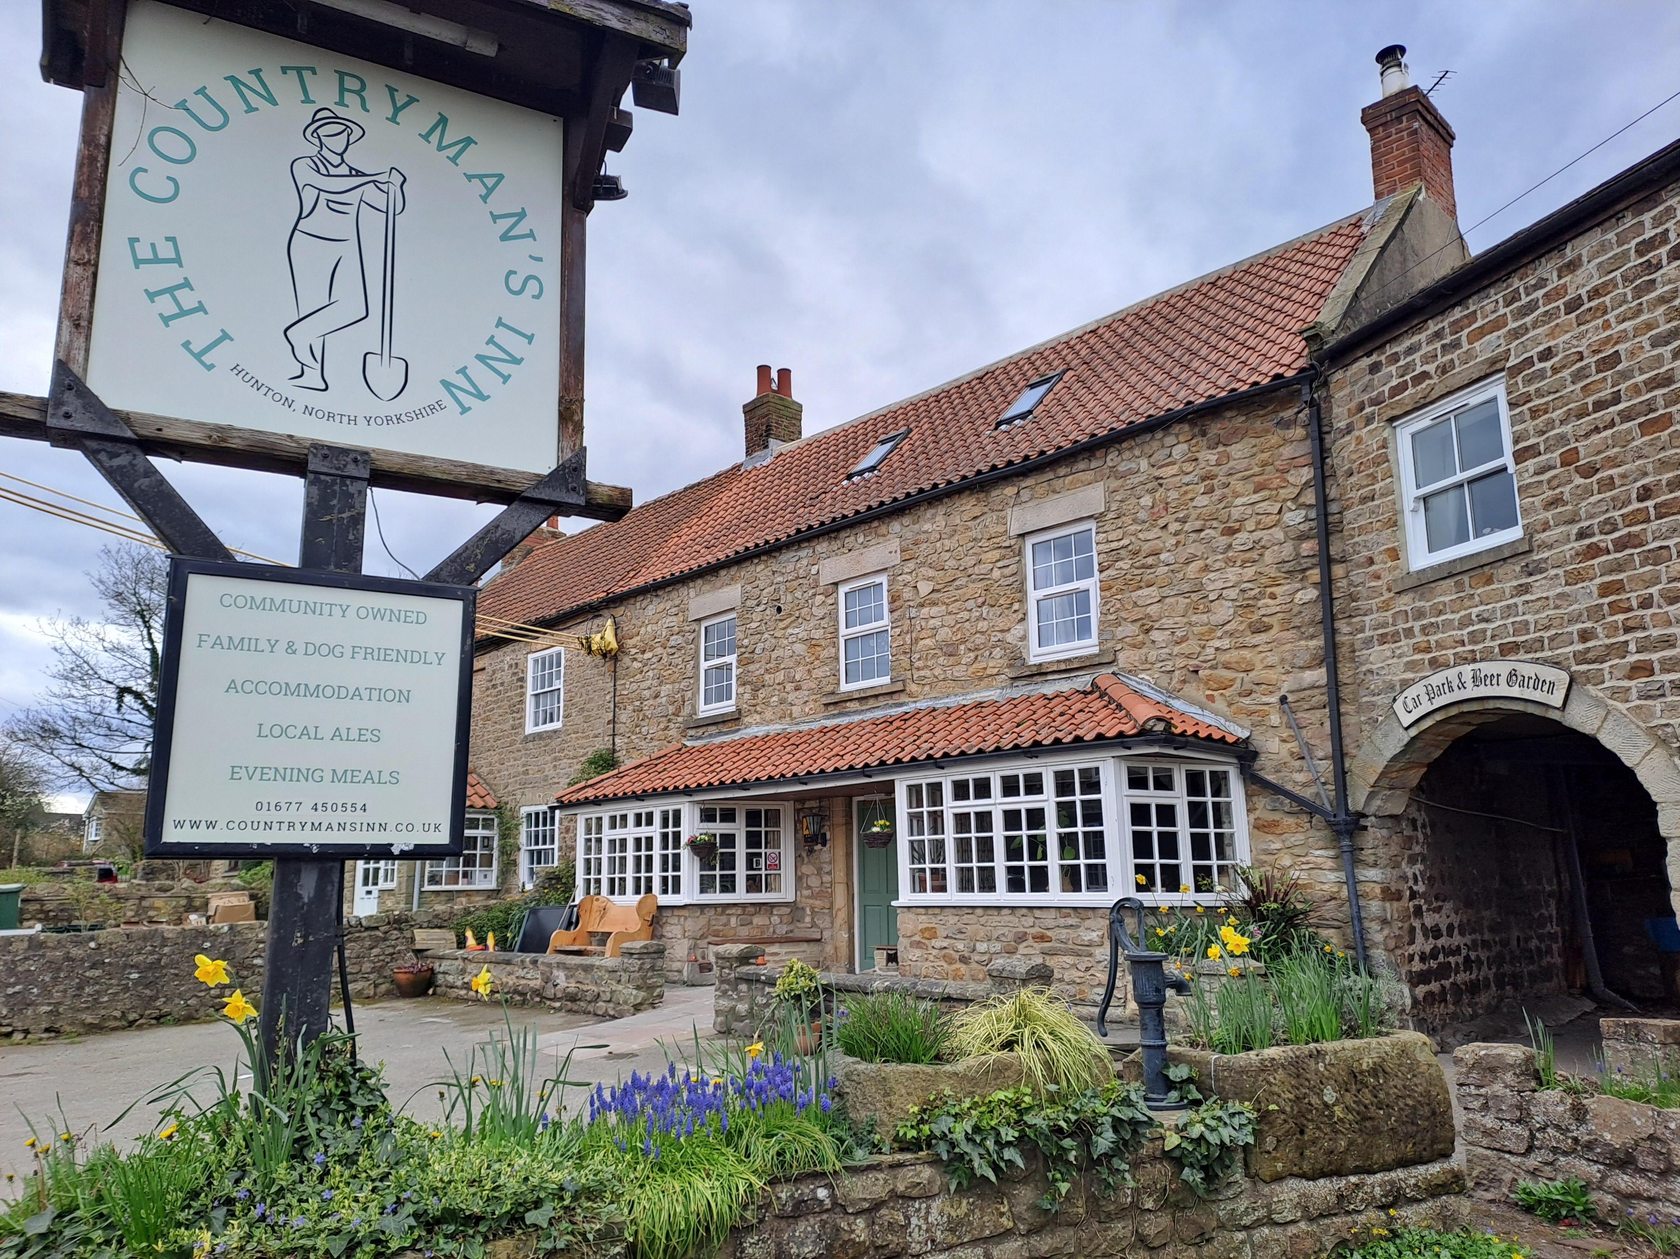
Yorkshire: Countryman's Inn, Hunton (above) The Countryman's Inn is a welcoming community-owned free house, which serves Yorkshire beers with at least one from Pennine brewery. Enjoy the a roaring stove in the winter, the great beer garden in the summer, bi-weekly coffee mornings and charity quizzes.

