‘Much-loved’ landlord dies
24/08/2026 by Malcolm Tattersall
Pub

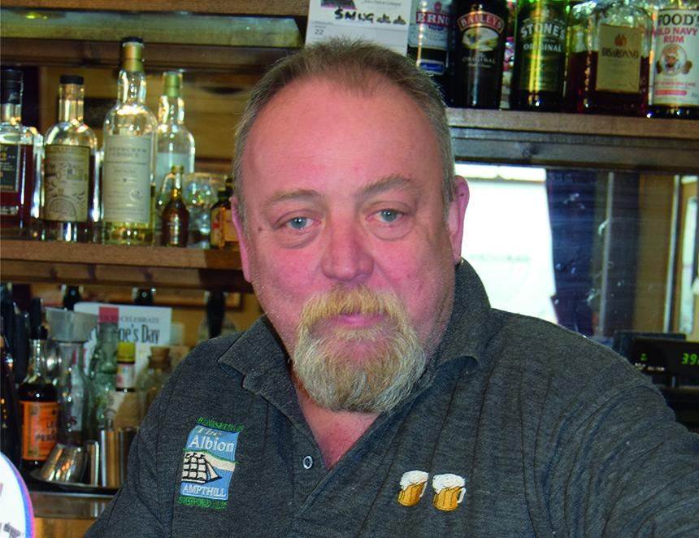

For several years, well-loved former landlord Russell Fletcher (above), who died recently, had the unique distinction of running the very first pub listed in each edition of CAMRA’s Good Beer Guide. Alphabetically, Bedfordshire was the first county, the first town in Bedfordshire was Ampthill, and, of course, the first pub in the town was the Albion, where he was the landlord. Former psychiatric nurse Russell took over running the place in 2010 after it was bought by the local B&T brewery in conjunction with Leicester brewers Everards. Once one of the town’s “less-desirable pubs” selling mainly fizzy lager, Russell soon put the “proper, narrow-fronted Victorian” boozer on the cask beer scene. Not only did the Albion win a place in the Good Beer Guide, but it went on to be named CAMRA’s Bedfordshire Pub of the Year in 2012 and 2013 during Russell’s first three years there. He frequently found himself featured in both local and national newspapers including the time he didn’t shave for a year to raise money for charity. Then he hit the headlines again by serving the world’s biggest Bedfordshire clanger (a local suet delicacy with meat at one end and a sweet filling at the other). Unfortunately, Russell was forced to give up the pub because of ill health but in recent years he did a sterling job as president of Ampthill’s Wingfield Club, which prides itself as serving the cheapest beer in the Georgian market town. He was taken ill during the summer and died in Bedford Hospital at the age of 68. A Wingfield Club spokesman said: “Russell was a much-loved friend, respected leader, and valued member of our club and the wider community. “His kindness, generosity, good humour and unwavering dedication touched the lives of so many. His friendship and presence will be deeply missed by everyone who had the privilege of knowing him.” TV actor Robert Daws, who lives in Ampthill, was among those who paid tribute to Russell, saying: “He was a kind and generous man who deserves to be remembered as a fine and much-loved member of our community.” Among the music played during a packed funeral service at the crematorium in nearby Flitwick was Pink Floyd's "Wish You Were Here". One mourner said sadly: "We certainly wish that Russ was still here."

