PUBlic Affairs update – August
21/08/2026 by Tori Wood
Campaign

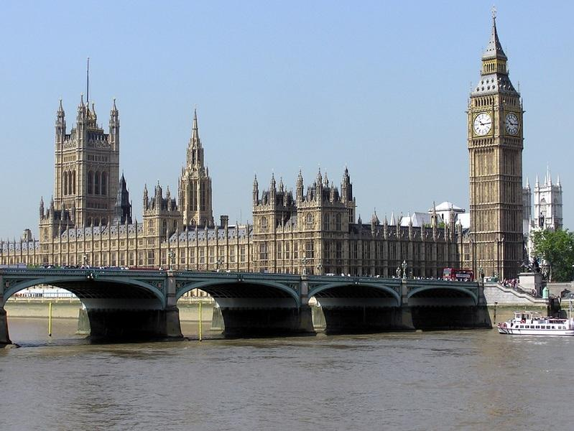

The regular series returns to What’s Brewing with the Campaigns and Communications team’s latest campaigning for pubs, pints and people across Westminster, devolved parliaments and local government. Westminster Planning [England only] On Monday 17 August the government announced stronger planning protections for pubs in England after months of considering watering them down. The government was looking at protecting only the last pub in an area, instead of all, making it easier for greedy developers to convert locals into houses, shops and takeaways. Thanks to our dedicated members who sent thousands of emails to their MPs using our e-lobby and our conversations with civil servants and parliamentarians, CAMRA has secured a huge campaign win for vulnerable pubs and communities who want to save their locals. Read what chairman Ash Corbett-Collins said here. The Ministry of Housing, Communities and Local Government is also looking at restrictive covenants (legal conditions within a property’s contract) when pubs in England are sold to check if this practice is preventing communities from running community-owned locals. If you know any locals that are sold with restrictive covenants that stop the building from being used as a pub, email campaigns@camra.org.uk Access to Market review The government carried out an Access to Market review for independent brewers who struggle to get their beers in to pubs due to the stranglehold global brewers have over bars. Ash Corbett-Collins (chairman), Ellie Hudspith (senior campaigns and communications manager) and Tom Stainer (chief executive) met with the Business and Trade minister Kate Dearden MP to discuss plans for publication of the review, which has been delayed due to the change of prime minister and his government. In parliament, the minister mentioned the engagement with MPs and breweries continues “as the government considers the evidence ahead of any announcements”. More here. The team will continue to talk to the government about the review and reform needed for independent brewers’ access to market. Beer in the UK report CAMRA published its ground-breaking report Beer in the UK, which launched its campaign to get the Competitions and Markets Authority (CMA) to investigate the beer market, while calling on government to fix labelling and tax issues. Read the report here. In the coming weeks, CAMRA will continue to speak with MPs and government ministers about the report and the need for bold action from government to empower consumers, fix the UK beer market and give independent breweries real access to the pubs market. Budget 2026 New chancellor (and CAMRA member!), John Healey, announced the Budget will take place on Wednesday 28 October. CAMRA will be calling for action on VAT, beer and cider duty, business rates, energy costs and Employer National Insurance contributions for pubs, pints and people. Watch this space for how to get involved in our Budget campaign. Business rates [England only] New prime minister Andy Burnham announced a 20 per cent business rates discount for pubs and social clubs in England from 2027. In the 2026/27 financial year, pubs are receiving a 15 per cent discount on business rates bills on top of any other transitional cuts. The previous chancellor announced a “real terms” freeze (inflation-only rise) in business rates bills in 2027/28 and 2028/29. But after the prime minister’s announcement, business rates bills will be cut from 15 to 20 per cent instead of this freeze. The team is urging governments in Northern Ireland, Scotland and Wales to deliver business rates relief for pubs in those nations too. Parliamentary debates Cask beer The team is still awaiting a date for Baggy Shanker MP’s debate to explore cask beer’s importance to our national heritage and protections in law for its dispense to stop misleading practices like Carlsberg's Fresh Ale, a kegged beer served through traditional cask beer handpulls. Extended Producer Responsibility Rotherham MP Sarah Champion held an Extended Producer Responsibility debate in July, a scheme where manufacturers must pay towards their packaging recycling, leaving costs passed onto consumers. Champion spoke about the impact on consumers, glass manufacturers, breweries and pubs which already handle their own recycling and will end up paying twice due to the scheme. Read it here. Fiscal support for rural pubs Meriden and Solihull East MP Saqib Bhatti held a fiscal support for rural pubs debate in June. Read it here. Cider definition CAMRA celebrates Cider and Perry Month every July and this year it launched an e-lobby so people could ask their MP to back our campaign to change the definition of cider to include products with a minimum juice content of 50 per cent. The UK and EU are talking about a deal on trade including food standards and labelling, while the EU is considering similar minimum juice contents for products labelled as cider. More here. UK government Andy Burnham has appointed his new government. Here we look at their commitments to beer and pub issues, and what each are responsible for. Burnham has said: he wants to cut business rates for pubs, clubs and music venues

people deserve to be able to look forward to a night out

increased Employer National Insurance contributions should be reviewed, recognising the pressure the extra costs placed on businesses in hospitality

previously backed calls for a cut in VAT for hospitality businesses but has stopped short of making a promise to act on this. The team will be raising the following beer and pub issues with the relevant cabinet minister: Chancellor of the Exchequer: John Healey MP Healey has previously supported our campaigns, including draught duty cuts to beer and cider served in pubs and clubs. permanently making the business rates system in England fairer

reducing VAT for beer and pub businesses

cutting beer and cider duty on pints in pubs compared to duty charged on cheap supermarket alcohol

taking action on high energy bills for pubs

reviewing increased Employer National Insurance contributions which are hurting beer and pub businesses. Secretary of state for Business, Innovation, Science and Trade: Jonathan Reynolds MP he will have a key role, along with the chancellor and prime minister, in making the business rates system fairer in the longer term

CAMRA will be pushing for action on fair access for independent brewers and producers into the UK’s pub market, including an investigation by the Competition and Markets Authority

the department will also have to publish and respond to the government’s review of Access to Market for independent breweries, as well as make decisions about the future of the Pubs Code for England and Wales which CAMRA wants to be strengthened to deliver better results for tied tenants and consumers. Secretary of state for Culture, Media and Sport: Lisa Nandy MP seeking support for the bid for UNESCO Intangible Cultural Heritage status for cask beer. Secretary of state for Environment, Food and Rural Affairs: Angela Eagle MP will also have a role in the bid for UNESCO Intangible Cultural Heritage status for cask beer

implementation of the incoming Deposit Return Scheme designed to encourage recycling of cans and the Extended Producer Responsibility Scheme on packaging including glass bottles

decisions over the minimum juice content for cider. Secretary of state for Health and Social Care: Yvette Cooper MP decisions on new alcohol labelling rules and health warnings. Secretary of state for Housing, Communities and Local Government: Angela Rayner MP Implementing the new Community Right to Buy for community assets, including pubs, in England. This could transform the ability of communities to save their local. The team has written to each minister outlining our key asks. More engagement with relevant ministers to push our campaigns will happen in the coming months. Heritage Public Houses Bill Kingswinford and South Staffordshire MP Mike Wood previously secured a slot in the House of Commons for a piece of legislation of his choice, guaranteeing time for debates and votes. He has since introduced the Heritage Public Houses Bill, aiming to restrict sales and provide extra safeguards in the planning system for any pub on a future Heritage Public Houses register. A debate is set on Friday 16 October in the House of Commons, as well as the crunch vote that will determine if the bill proceeds. CAMRA will support the bill as well as MPs to help it become law. Wood continues to discuss final text of the legislation with government, including changes that restrict the sale of heritage pubs to bring provisions in sync with the Community Right to Buy fund. Community Right to Buy [England] The government has announced a new Community Right to Buy fund giving communities opportunities to buy under-threat community assets like pubs. Following the government closing its Community Ownership Fund in 2024, ensuring communities get access to pub-saving funds was one of CAMRA’s campaigning priorities. The team is waiting for more details on the fund’s criteria and when communities can start applying. Read CAMRA’s response here. Digital ID for alcohol age checks [England and Wales] The Home Office announced digital ID from a registered digital verification service (DVS) will be accepted when purchasing alcohol in England and Wales. More here. Pubs Code adjudicator (PCA) investigation into Stonegate [England and Wales] The PCA for England and Wales is investigating Stonegate after suspected breaches to the Pubs Code. CAMRA encouraged Stonegate tenants from July 2021-July 2026 to submit evidence to the investigation. Thank you to everyone who did. Scottish government and parliament Business rates [Scotland] Since the prime minister has announced a 20 per cent business rates discount for pubs in England, more money will be given to the Northern Ireland, Scottish and Welsh governments. These governments will decide what they use the extra funding for, so CAMRA has written to finance ministers asking for their commitment to use the money for extra business rates relief for pubs in their nations. Read CAMRA’s statement after writing to deputy first minister Jenny Gilruth MSP. PCA investigation Since Stonegate is being investigated by the PCA for England and Wales, the team written to Scottish PCA Sarah Havlin asking her to look into any similar concerns in Scotland. Welsh parliament / senedd Cymru Business rates [Wales] Since the prime minister has announced a 20 per cent business rates discount for pubs in England, the team has written to finance ministers asking for their commitment to use the extra money for extra business rates relief for pubs in their nations. Read CAMRA’s statements after writing to the Cabinet secretary for Finance Elin Jones MS. Community Right to Buy [Wales only] The Welsh government announced its first legislation to be introduced to the senedd Cymru/Welsh parliament will be a commitment to a Community Right to Buy. It said it will “enable eligible community groups to nominate and register valuable community assets and be given the right of first refusal when the owners decide to sell”, to “make sure these places remain in the hands of communities”. No draft legislation has been published yet. CAMRA sent a briefing to all MSs arguing for a funding pot for community-owned pubs and reforms of the planning system to protect all locals from conversion or demolition, instead of just those listed as community assets. CAMRA Wales director Chris Charters’ statement is here. Northern Ireland assembly and executive Business rates [Northern Ireland, Scotland and Wales] As in Scotland and Wales, CAMRA has written to finance minister John O’Dowd MLA seeking his commitment to use the additional money from central government for extra business rates relief for pubs in Northern Ireland. Read CAMRA’s statement here. Licensing Nightlife charity Free the Night filed legal actions against NI’s communities minister, Gordon Lyons MLA, after no recommendations were implemented after the University of Stirling’s independent review into the outdated alcohol licensing system. The Department for Communities has yet to respond to these legal actions. As a result, CAMRA’s meeting with the minister has been delayed until legal proceedings have ended. The department previously launched a consultation into the number of categories of alcohol licences, so businesses can apply for one as a “cultural venue”. Submitting to the consultation, CAMRA argued tinkering with licence categories under the existing system will not modernise the system that desperately needs reform. Read CAMRA’s submission here.

