North Wales hat-trick for branch
14/08/2026 by WB Reporter
Campaign

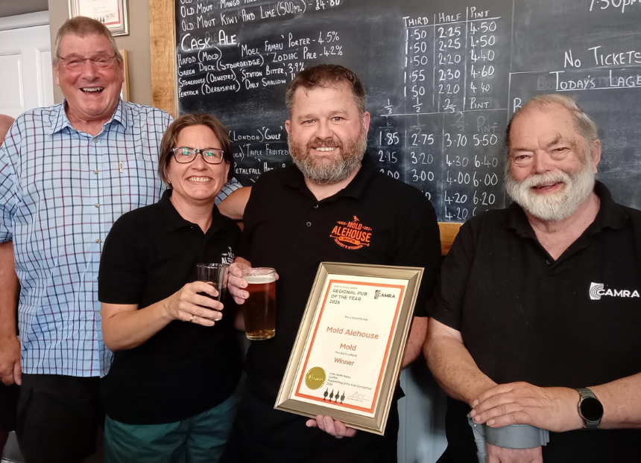

It’s three cheers for the pubs and clubs in the Vale of Clwyd branch area as three of its cask beer establishments have won CAMRA’s North Wales region pub awards. The Mold Alehouse (above, from left, David Tullett, Rebecca and Gareth Jones, Chris Charters) was named the North Wales Region Pub of the Year, the Beer Lab, Mold won the North Wales Cider Pub of the Year, and the Esplanade Club, Rhyl took home the North Wales Club of the Year title. There are four branches in the North Wales region – Vale of Clwyd, Gwynedd a Môn, Abercolwyn and Dee Valley. This is the first time in the Vale of Clwyd CAMRA’s 35-year history its branch selections have swept the board by winning all three of CAMRA’s North Wales region 2026 awards. Vale of Clwyd chairman David Tullett said: “I am delighted that in our branch area we have such excellent establishments, that provide top-quality beers and ciders in comfortable and welcoming surroundings.” Certificates were recently presented by CAMRA Wales director Chris Charters. To crown it all, the Mold Alehouse went on to win the overall Wales Pub of the Year 2026. Mold Alehouse co-owner Rebecca Jones said: “When we opened Mold Alehouse 10 years ago, awards were the furthest thing from our minds. It was a career change for Gareth following his passion for real ale and we were praying it would make us a living. “There’s a lot of great competition out there, so we were really surprised and chuffed when we found out we had won CAMRA North Wales Pub of the Year again. “We appreciate all the hard work that the Vale of Clwyd CAMRA branch does to promote real ale in the area.”
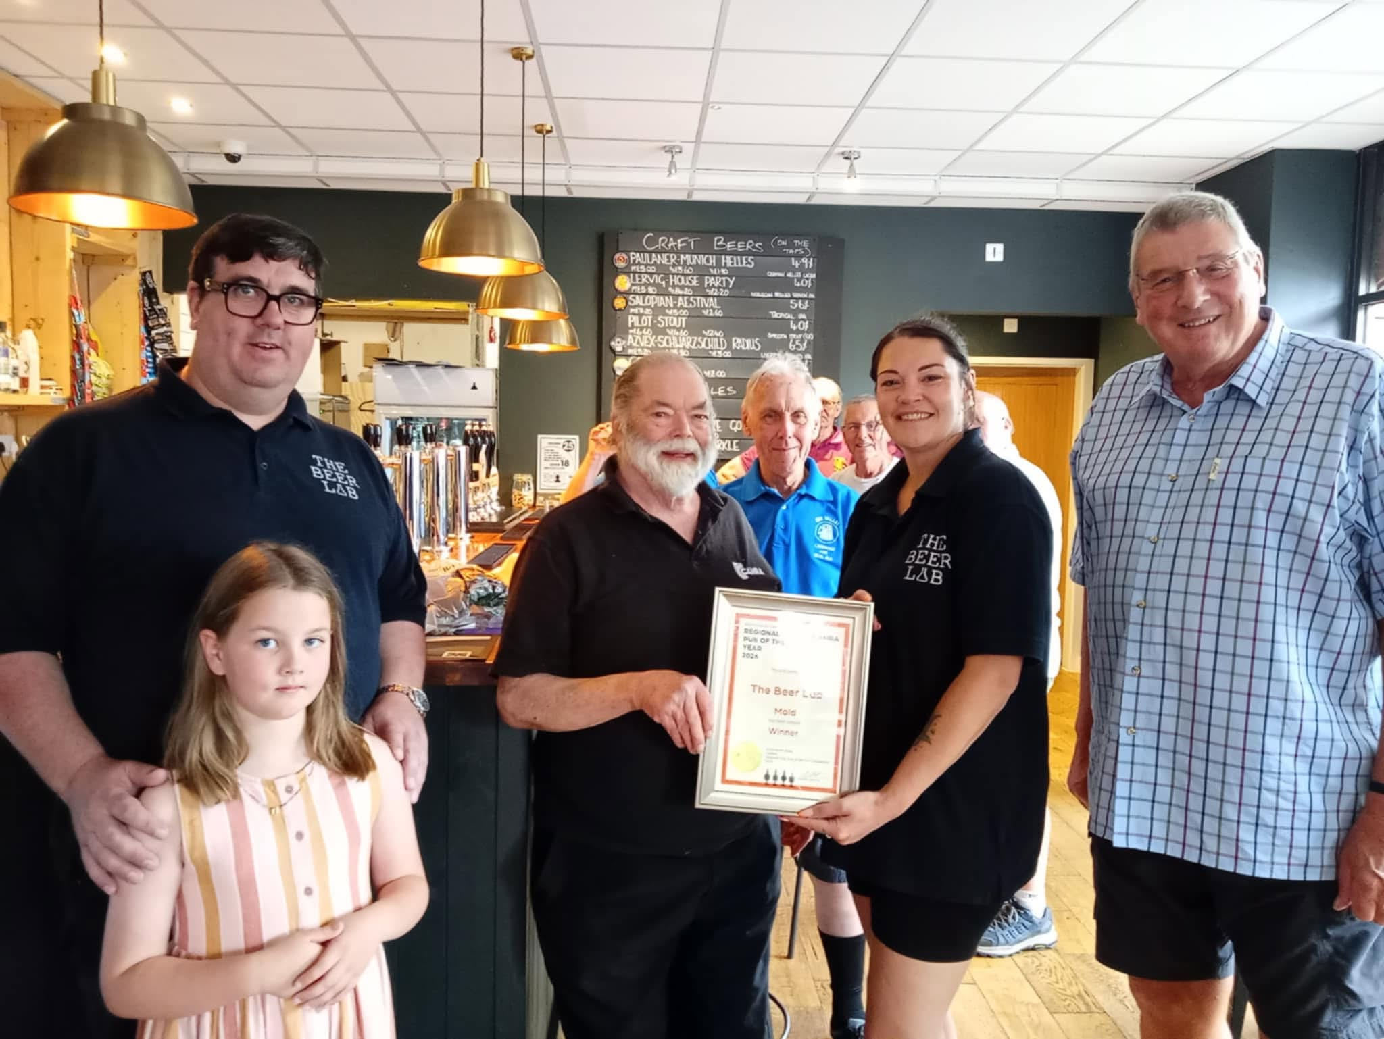
Pictured, from left, Ryan Pickering with daughter Nell, Chris Charters, Elved Gray-Jones, Kay Griffiths and David Tullett Beer Lab owner Ryan Pickering said: “It’s with enormous pride that we accept this award from CAMRA for the quality and diversity of cider that we sell. With some great Welsh producers supplying us too, alongside many other UK ciders, the range we keep has something for everyone’s taste buds. “To have all three of the main Welsh category winners coming from the Vale of Clwyd branch just shows how strong the drinks offering is in these parts and it’s that competition which strives us forward every day to do our best. “So, I would like to thank the local CAMRA branch for its continued support through the two and a half years we’ve been in Mold, as well as our great customers who patronise our place, and finally the staff for all their hard work and dedication to the service of great cider.”
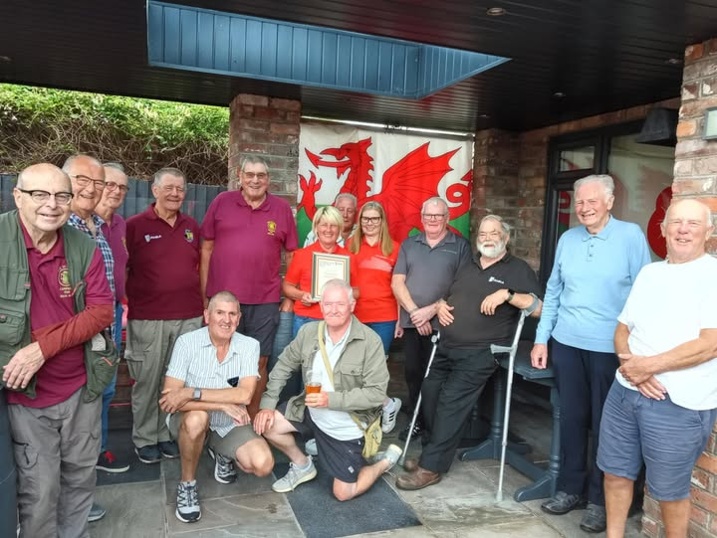
Pictured: Hilary Wright-Jones (centre), with councillor Barry Mellor and bar lady Elaine Hughes with members of Vale of Clwyd CAMRA and Chris Charters. Esplanade Club manager Hilary Wright-Jones said: “We are overwhelmed having won North Wales Club of the year for the third time. “We strive to maintain our cask beers to a high standard and have a variety of local and large brewery ales. From the team and our customers, we’d like to say thank you for choosing us once again.” Denbighshire County Council lead member for environment and transport Barry Mellor said: “Here we are again celebrating the Esplanade Club Rhyl winning the CAMRA North Wales Club of the Year award. “I have lived in Rhyl some 45 years and have been a member of the Esplanade for many of them. The Esplanade club will have to find a bigger wall to hang all the certificates! But it is no surprise that the ESP, that’s what us locals call the Esplanade club, has won this prestige award again. “Hilary Wright-Jones really does know how to keep real ale at its peak, and throughout the year keeps a real mixture coming through the club. “I would just like to thank the Vale of Clwyd CAMRA branch for choosing the Esplanade Club once again. It is always nice to welcome you to the Esplanade to taste what’s on offer.”

