The Crooked House - a modern tragedy
13/08/2026 by Roger Protz
Pub

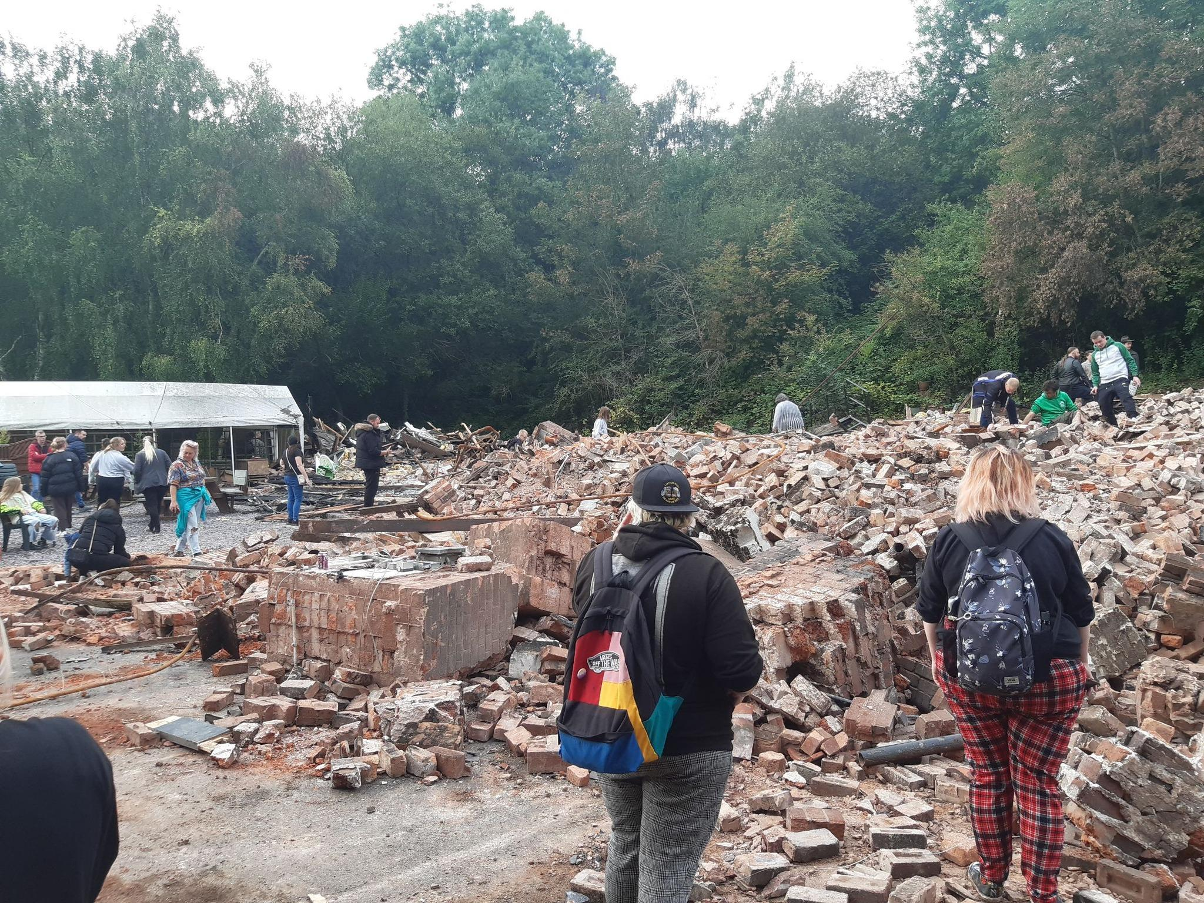

The destruction of the Crooked House pub, a much-loved Black Country tavern that was a victim of arson on 5 August 2023 and then bulldozed, is now told in a new film which records that no legal action has been taken three years after the shocking events. The documentary directed by Luke Reader can be viewed on YouTube: The Crooked House, A Black Country Tragedy. The pub in Himley near Dudley, famous the world over for its wonky appearance, dates from the 18th century. It was sold by brewer Marston’s in July 2023 to ATE Farms which owned a landfill site next door. ATE said the Crooked House would no longer operate as a pub. Less than two weeks after the sale, on 5 August 2023, the pub was consumed by fire. Two days later workers acting for ATE used a mechanical excavator to demolish the remains, machinery delivered to the site prior to the blaze. The documentary charts the destruction of the pub and the campaign to have it rebuilt. The film had its premiere at the Mill pub in Upper Gornal. The Crooked House was built in 1756 as a farmhouse. It became a pub, the Glynne Arms, in the 1830s to serve miners working on the estates of Sir Stephen Glynne and the Earl of Dudley. Working the mines caused the pub to tilt by 15 degrees and the name was changed to the Crooked House to reflect its appearance. Matt Wright, one of the local people campaigning to restore the Crooked House, said: “It’s the only pub in the world where you could walk out feeling more sober than when you went in.” Ian Sandall, who helped found the campaign group that grew to more than 13,000 members, added: “The demolition was devastating – a stab in the heart.” Fellow campaigner Phil Turner said: “It was a Black Country icon – people came from all round the world to visit it.” In 1952 the pub was declared to be structurally unsafe. In order to save it, Wolverhampton and Dudley Breweries (W&D) bought it for £3,250 and spent a further £10,000 to strengthen the buttresses that held the building in place. The name of Banks’s, the Wolverhampton section of W&D, was placed on the façade. Banks’s was celebrated for its Black Country Mild. As a result of a merger and takeover, W&D became part of Marston’s, the Burton-on-Trent brewer. In July 2023 Marston’s took the fateful decision to sell the Crooked House to ATE Farms. On the night of the fire in August 2023, locals said piles of earth had been placed on the path that led to the pub. Six fire crews attended the scene, but they had difficulty getting their trucks and hoses to the site. Two days later the fire-gutted building was bulldozed. A campaign group sprang up, made up of local people who used and loved the old pub. Their aim was a simple one: to prosecute those responsible for the destruction of the pub and to have it rebuilt without delay. Sandall said: “The demolition of the building was covered all over the world.” It was reported in Germany, Australia and Japan. The Washington Post noted that the building predated American Independence. Following the demolition, a woman and two men were arrested on suspicion of conspiracy to commit arson. Three other men were held on suspicion of aiding arson. All were released on bail. South Staffordshire Council took enforcement proceedings ordering ATE Farms to rebuild the pub “brick by brick”. ATE lodged an appeal that was due to be heard in March 2025, but all proceedings were postponed by a Crown Prosecution Service ruling that nothing could be heard until criminal proceedings were finished. ATE was run by George Adam Taylor and his wife and fellow director Carly Taylor, but she stood down as a director in December 2023. The company went into liquidation in April 2025 with debts of £1.2 million. As the film shows, the Crooked House remains a pile of rubble. Luke Reader makes the point that the Carlton Tavern in North-West London was also bulldozed illegally, and Westminster City Council successfully ruled it should be rebuilt “brick by brick”. The campaign believes the same rules should apply in the Black Country. Former Dudley North MP Marco Longhi, now a councillor, said when he was in parliament: “A pub has been senselessly destroyed in the ruthless pursuit of profit over preservation.”

