Manchester loses the Pev matriarch
12/08/2026 by Sean O&#039;Mahoney
Pub

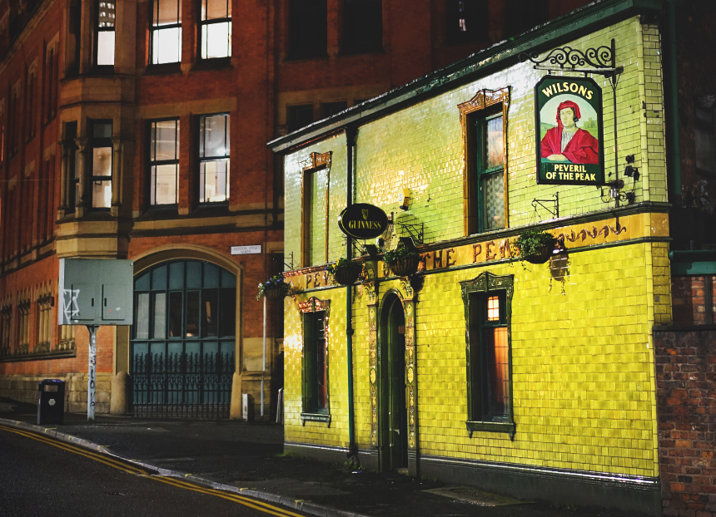

The Peveril of the Peak (pictured) has lost its matriarch and Manchester one of its great characters. Nancy Swanick, landlady of the Grade II-listed pub on Great Bridgewater Street in Manchester, died peacefully on 28 July, aged 96. She had held the licence since 1971, a run of 55 years that is believed to have made her both the oldest and the longest serving landlady in Britain. Her death came four days after the Pev was named the Britain's best pub by Time Out. In a statement, the Swanick family said: “We are sad to say that our beloved Nancy, landlady for over 55 years, passed away peacefully on 28 July. Nancy always kept up to date with news about the Pev and we told her about our new accolade of Best Pub in the UK a few days ago. The Pev will stay in the Swanick family, and we will continue to cherish it as we did Nancy. The pub will remain open thanks to our brilliant staff and, if you pop in anytime soon, please raise your glass to the wonder that was Nancy.” Born Nancy Murray in Muff, County Donegal, she came to Manchester in 1950 and worked as a mental health nurse before taking on the Pev with her husband Tommy, a former foundry foreman, in 1971. Her first answer was no. The pub then sat among textile warehouses and print works and had a difficult reputation. She changed her mind the evening Tommy took her to see it, and the couple moved into the flat above the bar with their three sons, Paul, Thomas and Maurice. Tommy died in 1981, and Nancy carried on. Her two eldest sons later died of cancer in their 50s. Maurice, who was nine when the family moved in, ran the pub alongside his mother until his own death in September 2025. The Pev remains in the Swanick family, now in the hands of Nancy's grandson Michael and his wife Rachael, with Samuel Hunter as general manager. Arthritis kept Nancy off the bar in her final years, but she remained the decision maker upstairs. CAMRA members have particular reason to mark her passing. The Peveril of the Peak is one of a small number of pubs on CAMRA’s National Inventory of Historic Pub Interiors carrying the top Three Star rating. It is also registered as an Asset of Community Value. The building dates from around 1820 and was remodelled inside and out around 1900 giving it the coloured faience tiling that makes it one of the most photographed pubs in the country. Behind the tiles sits the part that matters most – a dog-leg corridor serving as a drinking lobby, dado of green-and-cream tiling, a glazed screen at the back of the servery, fixed seating, quality woodwork and stained glass. Historic England listed the building at Grade II in June 1988. That interior exists today in large part because Nancy Swanick refused to let it go. In the 1990s the brewery that then owned the pub proposed turning it into a themed bar, complete with plastic palm trees. She called the idea vandalism and said it would not be happening. The brewery backed down and funded a sympathetic refurbishment and restoration instead. Over five decades she also saw off redevelopment interest in a site that grew steadily more valuable as the industrial city around it was cleared. The Atlas Works, once one of the largest engineering works in the kingdom, stood nearby from 1828. Today the pub is detached on its own plot amid the Bridgewater Hall, convention centre, hotels and apartment blocks. Her recipe for running a pub was short – no airs and graces, always be ready for a chat and look after your beer the way you would look after a baby. The framed Pub of the Year awards on the wall, accumulated across decades, are the receipt for that last instruction. Generations of drinkers passed through, from lunchtime shift workers in the 1970s to students, office workers and visitors from across the world. Eric Cantona and the Gallagher brothers drank there. Robbie Coltrane was a regular while Cracker was filming in the city. Oasis were photographed outside before their first album. Mike Kane MP paid tribute, recalling good pints, Irish music sessions and taking table football far too seriously, saying Nancy was the reason the Pev felt like a special place. The Pev is one of the amazing pubs within our branch area and I am proud to say so. The pub remains in the Swanick family and continues to charm pubgoers. CAMRA members spend a great deal of campaigning effort on listings, Assets of Community Value and planning objections, and rightly so. None of it is what actually makes a pub. A pub is made by somebody standing behind the bar, year after year, deciding what kind of room it is going to be. Nancy Swanick made that decision in 1971 and held the line for 55 years. The Central Manchester branch is hosting a social on Thursday 13 August to raise a glass to Nancy. The branch is first meeting at the Grey Horse on Portland Street at 18:30 and then heading across to the Pev at 19:15. All members and non-members are welcome. There is a Facebook event here. The Pev has lost its matriarch. Manchester has lost one of its great characters. Thank you, Nancy. Manchester won't forget you. Sean O'Mahoney is the chair of Central Manchester branch. Photo by Matthew Curtis, author of Manchester's Best Pubs and Bars. This article was updated 14 August 2026 to correct a reference to Maurice Swanick, who died in September 2025.

