Anti-pub Westminster under fire
12/08/2026 by WB Reporter
Industry

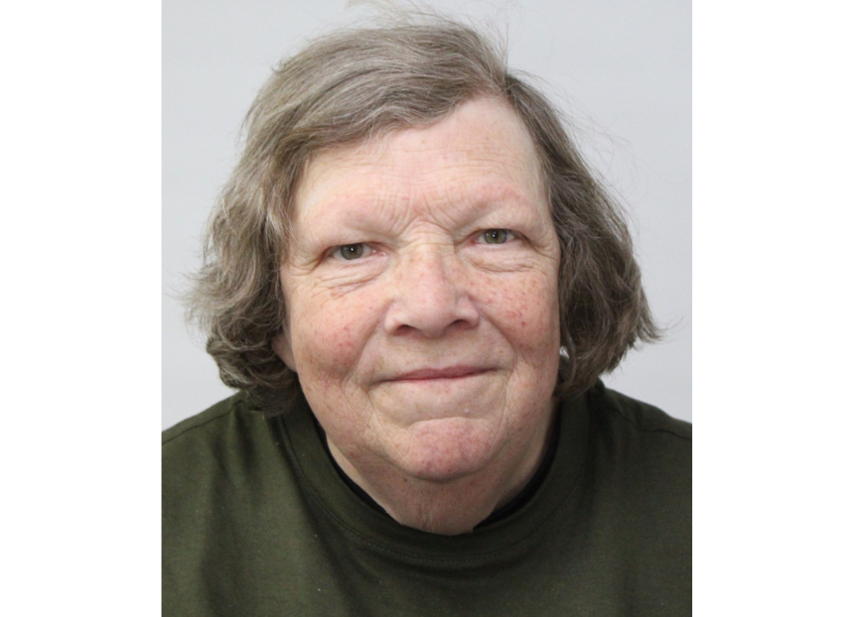

CAMRA has branded Westminster City Council anti-pub following the launch of its “absurd” draft licensing policy. The council, which oversees pubs in Soho and the West End, has proposed dramatic changes to licensing laws, similar to the restrictions seen during the Covid pandemic. The Conservative-led council has released a draft licensing policy for consultation, recommending pubgoers should not queue at the bar, but return to table service. This would include the introduction of fixed seating and a minimum number of them to limit pubgoers from enjoying a pint standing up – bizarrely described as “vertical drinking”. Since writing this article, Westminster City Council has disputed this, however, paragraph D171 of the draft licensing policy states: "The introduction of measures to reduce the extent of, or to remove opportunities for, vertical drinking could address the underlying reasons for the policy. This could be by introducing fixed seating and conditions to provide a minimum number of seats at all times and requiring sales to be by waiter or waitress service only." Most troubling of all are the plans to ban the opening of new pubs and bars in Soho and the West End, in what has been described as a “cumulative impact zone”. CAMRA’s Greater London director Ellie Eames (above) said: “Banning the opening of pubs in Soho and the West End is absolutely absurd, especially when the country is losing more of these valued community spaces at an alarming rate. “Licensees are in a position to judge what’s best for their business, staff and customers. It’s always been part of British culture to order pints at the bar without the requirement to remain seated. How else are consumers meant to make the most of wellbeing benefits pubs offer with a ‘vertical drinking’ ban? “With the government already trying to weaken planning protections for pubs in England, Westminster council must recognise the contributions local pubs make to the economy and reconsider this decision before we lose any more.” Westminster City Council's full Consultation Draft Statement of Licensing Policy Review 2026 can be read here.

