Head brewer steps down after 40 years
10/08/2026 by Timothy Hampson
Industry

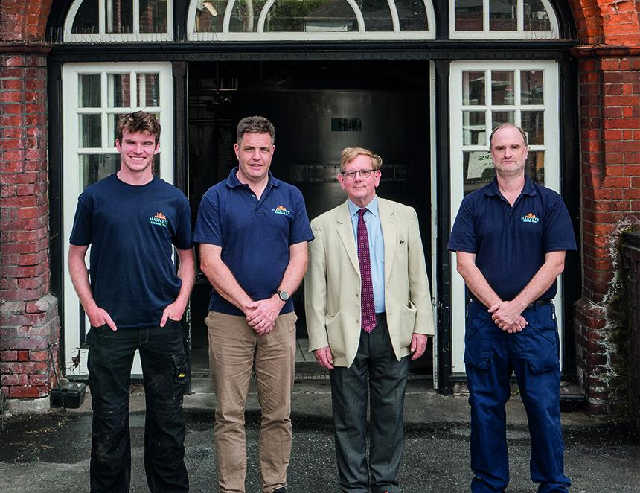

Sussex brewery Harvey’s has announced a series of appointments within its brewing team, marking the next chapter in the brewery’s long-term succession plan. After 40 years as head brewer, Miles Jenner will now lead the brewery in the role of production director, while continuing as joint MD. Jenner will initially head the production function supporting the next generation of brewers as they step into senior leadership roles and ensuring the continuity of the brewery's distinctive brewing tradition. As part of these changes, Peter Yarlett has been appointed head brewer. Yarlett first joined Harvey’s in 1995 in what began as a holiday job, returning during university vacations while studying chemistry at the University of Exeter. After graduating, he spent a gap year with Harvey’s before going on to complete a master’s degree in brewing and distilling at Heriot Watt University in Edinburgh. Seven years later, following employment as a brewer at Meantime in London and Hogs Back in Surrey, he returned to Harvey’s as third brewer. He was promoted to second brewer in 2010 and has now stepped up to head brewer. Jenner said: “Our aim was to ensure continuity, while encouraging innovation and it is exciting to see this long-term objective come to fruition. I could not wish for a more capable or enthusiastic brewing team.” Pictured, from left, Cameron Elder, Peter Yarlett, Miles Jenner and Henry Kirk

