Popular city fest is back on the Embankment
09/08/2026 by Timothy Hampson
Campaign

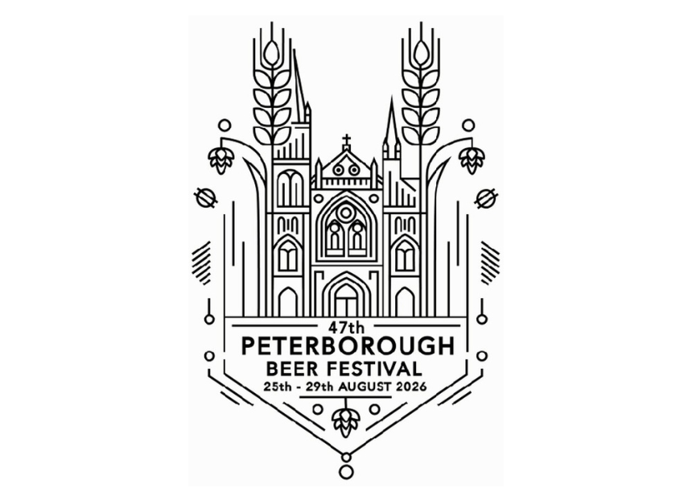

Peterborough Beer Festival returns to the Embankment from 25-29 August for one of the city's best-loved summer events. Organised by CAMRA and held in large outdoor marquees, the festival is expected to welcome around 25,000 visitors across the week. The 2026 event continues the festival’s proud cask beer tradition while introducing broader drink choices designed to make the event welcoming for all. Alongside the core cask beer range on offer, the festival will feature new additions, including an Independent UK Lager Bar and a US Cask Bar with more than 50 beers to choose from. There will also be brewery bars. Opening hours are 5.30-11pm on the Tuesday, then noon-11pm from Wednesday through to Saturday. Admission is £3 before 3pm and £7 after with CAMRA members able to enter free at all times. Advance tickets are available for evening sessions, while afternoon entry can be paid at the door. Before the festival opens to the public on Tuesday evening, there will be an industry and trade session sponsored by Small Beer. This is followed by the preview session from 3-5.30pm, giving pub supporters and invited guests the chance to sample the beers ahead of general admission. Live music will once again form a major part of the festival experience, with entertainment scheduled across the week and a full programme showcasing local live bands, acoustic performers and festival favourites. Festival PR officer Raeanne Elliott said: “Peterborough Beer Festival has always been about more than what is in the glass. It is about people, friendships, volunteers and the shared moments that make it such a special part of the city's summer. This year we are proud to celebrate our real ale roots while offering more choice, more reasons to visit and a warm welcome for everyone.” The festival is a short walk from Peterborough railway station and the city’s bus and coach stations. Visitors are encouraged to check the official festival website and social media channels for the latest details on tickets, opening times, music, food vendors and festival updates.

