Wind in Ship campaign’s sails
07/08/2026 by Timothy Hampson
Pub

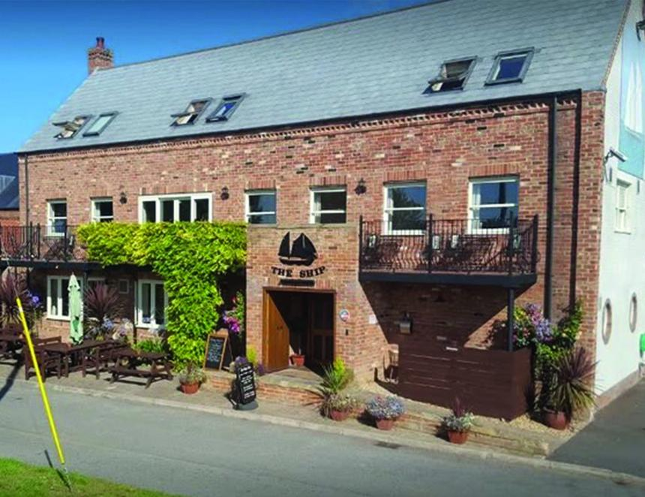

Campaigners fighting to reopen their Lincolnshire village pub are celebrating making a significant step forward. The Ship Inn (pictured) of Surfleet Seas End, which closed more than a year ago, has now been registered as an Asset of Community Value (ACV) following application to South Holland District Council by the Shipmates community group. The Shipmates now want more people with an interest in seeing the pub reopen get on board. There has been a pub on the site since 1642. A meeting to provide more details is being held at the Fraser Rooms in St Laurence Church, Surfleet, at 7pm on Wednesday 12 August. Shipmates chairman Mark Newlands said: “The Ship Inn will now remain an Asset of Community Value for five years and it is possible that any future planning application to change it from a pub to a dwelling or some other use could be denied because of this. “This is an important first step towards getting our pub back. What happens now is the owner cannot sell it without first giving the community six months to prepare and submit a bid.” The open meeting will be a chance for people to say how they want the community pub to develop. It will also be an opportunity to give the group an idea of fundraising support. Newlands stressed this would not commit anyone but would help guide the way forward. He added: “We also want to share the good ideas revealed by a recent survey we organised. We will also be discussing the work ahead and the type of society we want to own and run the pub.” The Shipmates will also be at Ayscoughfee Fest at Ayscoughfee Hall on Saturday 15 August and will have a stand at Celebrate Surfleet on Sunday 6 September at Glen Park, Surfleet. Find out more at surfleetshipmates.org.uk

