CAMRA’s pub campaigning award returns
06/08/2026 by WB Reporter
Campaign

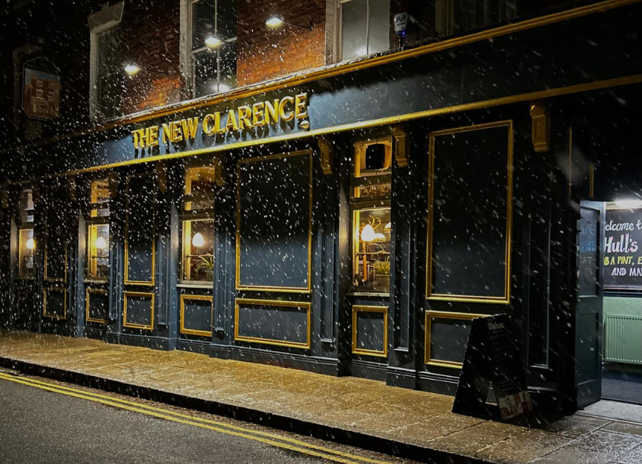

Nominations are now open for CAMRA’s Pub Saving Award, which celebrates groups that have fought for their pub, saving it from demolition or conversion. The award is more important than ever following the three-year anniversary of the unlawful demolition of the iconic wonky pub, the Crooked House in Himley, South Staffordshire. The competition thrusts pub-saving campaigns into the national spotlight, inspiring others to investigate community ownership for their own local. CAMRA supports community pubs and is keen to assist groups interested in going down this road. Pub Saving Award coordinator Paul Ainsworth said: “The return of the Pub Saving Award coincides with the grim third-year anniversary of the fire and complete demolition of the Crooked House, which shocked the nation. It is bitterly disappointing that we are still waiting for justice. “The Crooked House saga unveiled a wider scandal of potentially unlawful pub conversions and demolitions across the UK, and we continue to demand tighter, stronger planning policies and a requirement in law to rebuild pubs brick-by-brick. “Instead of recognising their essential contributions to local economies and the wellbeing benefits pubs provide, the UK government has the audacity to try to water down planning protections in England, which would make it easier for greedy developers to convert pubs into houses, shops or takeaways – or to demolish them entirely. “The industry needs meaningful support, including better planning protections in each nation of the UK, or we risk losing thousands more pubs. “When a local closes its doors, it is incredibly difficult to open them again, which is why these community champions and selfless volunteers, who dedicate years to save much-loved pubs, deserve to be applauded.” Last year’s winner was the New Clarence (above) in Hull. Judges were impressed with the Hull Community Pub Society’s achievement of saving the New Clarence, which is not only Hull's first community-owned pub but the first city-centre pub to win the award. The high land value of high streets and city centres makes pubs an enticing target for greedy developers and, as a result, much harder to save than their rural counterparts. The award can be made to any group which has carried out campaigning activity to save a pub from closure over the last 12 months. Nominations close on 12 November 2026. The nomination form and eligibility criteria is on CAMRA’s website here. In England, CAMRA is campaigning to stop the government weakening planning protections. At the moment, protections to stop locals being converted apply to all pubs – but the government is thinking about watering these down, so it only applies to the last one in an area. In Northern Ireland, CAMRA is campaigning to get the devolved government to introduce better planning protections for pubs following the demolition of Finn MacCool’s pub in Bushmills in 2025. In Scotland, CAMRA recently welcomed the Scottish government’s decision to U-turn on plans to allow pubs in town centres to be converted without the need for planning permission. CAMRA still wants a loophole in Scottish law, which allows freestanding pubs to be demolished without planning permission, to be closed. In Wales, the Campaign welcomes the Welsh government’s commitment to introduce a Community Right to Buy to help communities save their local. CAMRA also wants Welsh ministers to introduce planning protections to stop pubs being converted or demolished to give people a better chance of saving them and converting them into a community-owned business. CAMRA has resources and guides to support anybody looking to save their local, including information on community ownership here: camra.org.uk/save-your-local-pub

