Councillors back local pubs
06/08/2026 by Timothy Hampson
Pub

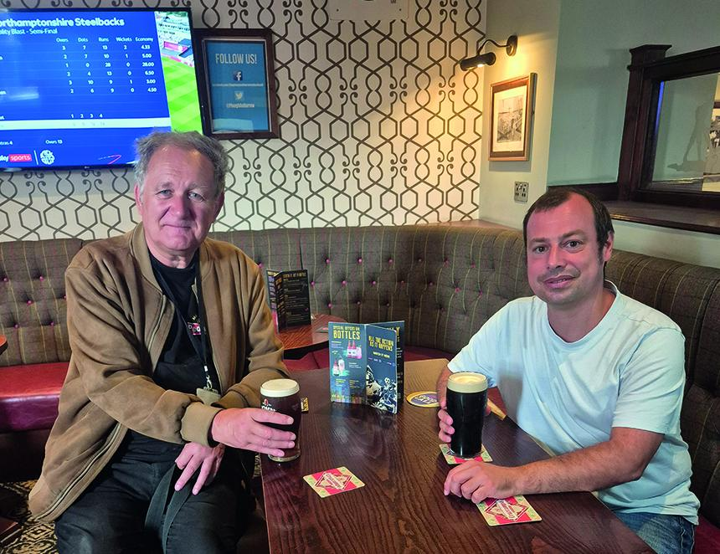

Ashfield’s pubs are set to receive more support after councillors unanimously backed a cross-party motion aimed at helping the trade prosper. The Protecting Ashfield’s Pubs motion was proposed by Hucknall North councillor Gordon Mann (pictured on left) and seconded by Hucknall Central councillor Lee Waters (above on right). Every councillor present voted in favour, sending a positive message that protecting pubs, local jobs and community life goes beyond party politics. The council will now look at creating an Ashfield Pub Protection Plan. This would make it easier for landlords to find grants, get help with licensing and access other advice and assistance available through the council. Pubs could also be promoted through local events, tourism, town centred activities and council communications, helping them reach more customers and play a bigger role in community life. Mann said: “A good pub brings the community together through quiz nights, live music, celebrations, weddings and many other events. “When a pub closes, it is not just the bar staff who lose their jobs. There are delivery drivers, food suppliers, entertainers, tradespeople and many other local businesses that depend on the pub trade.” He also highlighted the many small breweries and suppliers supported by pubs across Ashfield and the wider area. He said: “There are 56 microbreweries within 22 miles of Ashfield district’s boundaries. That shows the scale of the local brewing industry and how many jobs, suppliers and small businesses rely on pubs continuing to thrive. “Ashfield pubs also like to source locally produced food. Money spent in a local pub can support farmers, food producers, breweries, delivery drivers and other businesses nearby.” The motion will also help residents understand what they can do when a valued pub is at risk of closure or sale. This could include applying for the pub to be listed as an Asset of Community Value, which may give the community more time to organise and consider its options. Mann also spoke about the important part pubs and clubs have played in British music. “In 1974, I remember seeing a then unknown heavy rock band called Judas Priest at the Plough and Harrow in Hucknall. “Three years later, they were selling millions of records and performing to huge crowds around the world. Pubs and clubs give new performers somewhere to learn their trade, build confidence and find an audience.” The council will also write to the government and local MPs calling for long-term changes to VAT, beer duty, business rates and other taxes affecting pubs and hospitality. Waters said: “This was a positive, common-sense motion and it was excellent to see every party support it. “Our landlords work hard, create jobs and bring people together. We will now look at what more we can do locally, while pressing the government to give pubs a fairer deal nationally.” Councillors say the aim is to help Ashfield’s pubs attract customers, grow their businesses and remain at the heart of their communities for years to come.

