CAMRA festival update – August
02/08/2026 by Matthew Rogers
Campaign

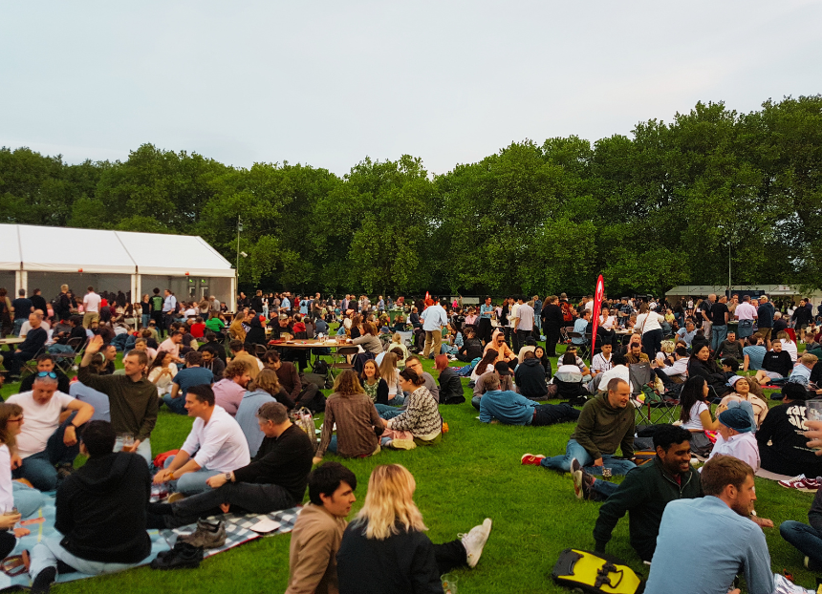

As the summer rolls on, make sure to catch a festival near you! Members can enjoy free entry to many CAMRA festivals (not including souvenir glass and programmes) when booking tickets in advance. For more information and to see all upcoming CAMRA activities visit the events webpage. Glasgow Real Ale Festival (G-RAF), 6-8 August The Briggait, 141 Bridgegate, Glasgow, G1 5HZ Worcester Beer, Cider and Perry Festival, 13-15 August The Grandstand, Worcester Racecourse, Grand Stand Road, Worcester, WR1 3EJ Peterborough Beer Festival, 25-29 August The Embankment (Behind Key Theatre), Embankment Road, Peterborough, PE1 1EF Clacton Beer and Cider Festival, 26-29 August St James Hall, 56 Tower Road, Clacton-on-Sea, CO15 1LE East Anglian Beer and Cider Festival, 26-31 August St Edmundsbury Cathedral, Angel Hill, Bury St Edmunds, IP33 1LS Durham Beer Festival, 3-6 September Durham City Rugby Football Club, Hollow Drift, Green Lane, Durham, DH1 3JU Harbury Beer and Cider Festival, 4-5 September Harbury Village Hall, South Parade, Leamington Spa, CV33 9JE Crewe Rail Ale Festival, 4-6 September Crewe Heritage Centre, Vernon Way, Crewe, CW1 2DB Basingstoke Beer Festival, 4-6 September Basingstoke Sports and Social Club, Fairfields Road, Basingstoke, RG21 3DR East Malling Beer and Cider Festival, 5 September East Malling Research Centre, New Road, East Malling, ME19 6BJ CAMRA Bar at Faversham Hop Festival, 5-6 September East Street, Faversham, ME13 8AF Tamworth Beer Festival, 10-12 September Tamworth Assembly Rooms, Corporation Street, Tamworth, B79 7DN York Beer and Cider Festival, 16-19 September St Lawrence Parish Church, Lawrence Street, York, YO10 3WP Shrewsbury Beer and Cider Festival, 23-26 September The Church of St Mary the Virgin, St Mary’s Street, Shrewsbury, SY1 1DX Calderdale Beer and Cider Festival, 24-26 September Arden Road Social Club, Arden Road, Halifax, HX1 3AG Ayrshire Beer and Cider Festival, 1-3 October Troon Concert Hall, South Beach, Troon, KA10 6EF Carmarthenshire CAMRA Beer and Cider Festival, 1-3 October St Peter’s Civic Hall, 1 Nott Square, Carmarthen, SA31 1BA Nottingham Robin Hood Beer and Cider Festival, 7-10 October Trent Bridge Cricket Ground, Bridgford Road, West Bridgford, NG2 6AG Steel City Beer and Cider Festival, 21-24 October Kelham Island Museum, Alma Street, Sheffield, S3 8RY Redhill Beer Festival, 29-31 October Merstham Village Hall, Station Road North, Merstham, RH1 3ED Carlisle Beer and Cider Festival, 29-31 October Station Hotel, Court Square, Carlisle, CA1 1QY Belfast Beer and Cider Festival, 5-7 November Banana Block, PortView Trade Centre, Belfast, BT4 1HE Cambridge Beer Festival, 24-29 May 2027 Jesus Green, Cambridge, CB4 3AX

