What can we expect from new PM?
21/07/2026 by Paul Edgeworth
Campaign

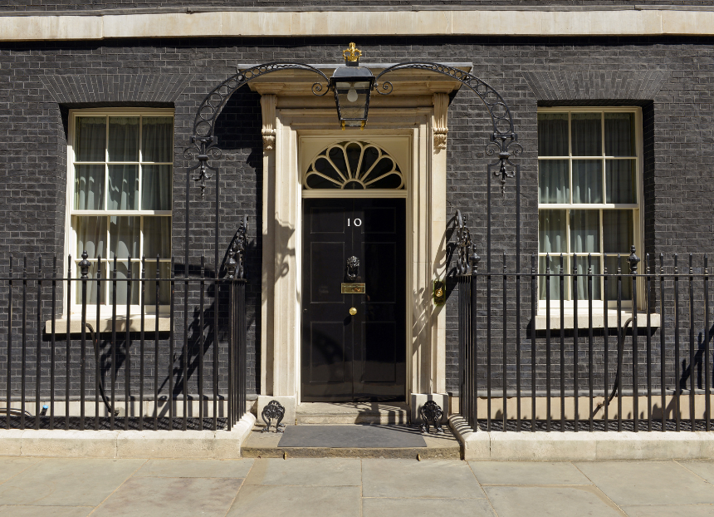

With a new prime minister in Downing Street this week, we take a look at who the key players are for beer, pubs and consumers and what we know so far about what Andy Burnham’s government might do differently. Prime minister The prime minister recently revealed he was against single-file queuing in pubs, which gives me confidence that he spends time in them and knows how they are meant to work! Of course, as mayor of Greater Manchester, he has championed beer and pubs in that region, not least by penning the foreword to the first edition of Matthew Curtis’ CAMRA-published Manchester’s Best Beer, Pubs and Bars. More recently, Burnham has said: he wants to cut business rates for pubs, clubs and music venues

people deserve to be able to look forward to a night out

increased Employer National Insurance contributions should be reviewed, recognising the pressure that extra costs have placed on businesses like hospitality. The new PM has previously backed calls for a cut in VAT for hospitality businesses but has stopped short of making a promise to act on this. Since taking office, he hasn’t specifically said anything on pubs, but it is early days and CAMRA is hoping for some positive announcements in the coming weeks. Top of that list must be action to properly investigate the beer market in the UK, including the findings of CAMRA’s Beer in the UK report, to protect, support and promote independent breweries, great pubs and our country’s brewing heritage. On fiscal issues it may be that we have to wait until the next Budget before any announcements on things like business rates, employment taxes and alcohol duties are concerned. Who else is joining Burnham’s government and what will be on their to-do lists for pubs and pubgoers? Chancellor John Healey is the new chancellor of the Exchequer. The South Yorkshire MP has previously backed CAMRA’s campaign for a lower rate of beer and cider duty to be charged on pints in pubs, has said he is a CAMRA member and has served as minister for community pubs under Gordon Brown. Together with a pro-pub outlook from the PM, his de facto deputy Louise Haigh (first secretary of state and Cabinet Office minister) and from the deputy leader of the Labour Party Lucy Powell, this could bode well for the industry in the coming months and years. Ahead of his first Budget (expected in November, but it could come sooner) CAMRA will be pushing for action to help our pubs, social clubs and breweries to survive and thrive, including by: permanently making the business rates system in England fairer

reducing VAT for beer and pub businesses

further cutting beer and cider duty on pints in pubs compared to duty charged on cheap supermarket alcohol

taking action on sky high energy bills for businesses

reviewing increased Employer National Insurance contributions which are hurting beer and pub businesses. Business secretary Greater Manchester MP Jonathan Reynolds is returning as the government’s secretary of state for business, science, innovation and trade. He will have a key role, along with the chancellor and prime minister, in making our business rates system fairer. But the number one issue CAMRA will be pushing for action is fair access to market for independent brewers and producers into the UK’s pub market, including an investigation by the Competition and Markets Authority, as mentioned in our Beer in the UK report. The Business Department will also have to publish and respond to the government’s review of access to market for independent breweries, as well as make decisions about the future of the Pubs Code for England and Wales which CAMRA wants to be strengthened to deliver better results for tied tenants and consumers. Housing secretary Angela Rayner returns to the Ministry of Housing, Communities and Local Government where she will oversee implementation of the government’s new Community Right to Buy for community assets, including pubs, in England. This could transform the ability of communities to save their local. However, planning ministers also need to make a final decision on the new National Planning Policy Framework. Earlier in the year they proposed weakening planning protections for pubs by applying them only to the last one in an area. This would help greedy developers convert pubs into other uses against the wishes of the community unless it is the very last one in an area. CAMRA will keep up the pressure on the government to think again on this. If you live in England there’s still time to email your MP to ask for a U-turn and for the government to protect all pubs in the planning system. Who else will CAMRA be speaking to? Lisa Nandy: CAMRA wants the Culture secretary to support the bid for UNESCO Intangible Cultural Heritage status for cask beer. Angela Eagle: the new Environment secretary is responsible for the incoming Deposit Return Scheme designed to encourage recycling of cans. This mustn’t place onerous costs and burdens on small and independent breweries which don’t have the same resources as multinational brewing giants. CAMRA also wants her to commit to changing the law to require a minimum of 50 per cent juice content before a product can be called cider. You can email your MP about this campaign here. Yvette Cooper: the new Health secretary will be making decisions on new alcohol labelling rules and health warnings. What’s happening with other governments in the UK? Wales In Wales, Plaid Cymru is now in charge of the Welsh government following May’s elections, although it doesn't have a majority in the Senedd/Welsh parliament. The first minister, Rhun ap Iorwerth, has announced he will introduce legislation to deliver a Community Right to Buy. This will give communities the first right to buy a pub that has been listed as a community asset. CAMRA is awaiting further details and for legislation to be published, but this is a positive step forward in the nation with the weakest pub protection policies in the UK. As well as a Community Right to Buy, the Campaign will be pushing the Welsh government for stronger planning protections in law for all pubs – not just those listed as being of value to the community – to prevent them being lost to conversion into other uses. CAMRA also wants to see the Welsh government’s plans for a Deposit Return Scheme be fully aligned with the one operating in England, Scotland and Northern Ireland. If the separate Welsh scheme is too different to the rest of the UK and too costly to take part in, then we fear smaller and independent producers may have no choice but to stop selling their products into the Welsh market. Scotland In Scotland, the SNP remain in power after May’s elections. A review of the business rates system is under way where CAMRA wants to see fundamental reforms to the unfair system of business rates in Scotland, so pubs finally pay their fair share and not over the odds as they do at the moment. There was some good news a few months ago that the Scottish government ditched proposals to allow pubs in town and city centres to be converted into other uses without planning permission. CAMRA continues to call on Scottish ministers to strengthen planning laws for pubs, including by closing a loophole which means freestanding pubs in Scotland can be demolished without the need for planning permission. Consumers will also want to see the Scottish government rule out a return to its previous plans to ban all alcohol sponsorship and advertising which would benefit well-known brands while leaving independent breweries, pubs and festivals unable to advertise or bring new products to market successfully. Northern Ireland The next election for the Northern Ireland (NI) assembly isn’t until May next year. When it arrives, CAMRA will be putting its campaign for modernising NI’s totally ridiculous licensing laws front and centre of its conversations with political parties, MLAs and candidates. CAMRA believes it must have a commitment to bringing licensing laws into the 21st century to improve the choice of local beers at the bar, and so businesses have the freedom to open new bars, pubs, micropubs and taprooms without huge costs. Paul Edgeworth is CAMRA's Campaigns and Communications manager

